NICCY Summary: Written Assembly Questions Friday 25th July, 2014

Child Poverty

Childcare for Children with a Disability

Bright Start

Disability Strategy

Disability Strategy

Disability Strategy

Language Classes Replacing the Woodlands Speech and Language Unit

Average Cost of Educating a Child

Economically Inactive

Community Dietetic Referrals for Paediatric Patients

Public Protection Arrangements Northern Ireland

Serious Case Review

Serious Case Review

Office of the First and Deputy First Minister

Child Poverty
Mr Rogers asked the First Minister and deputy First Minister to outline the action plan to address Child Poverty under commitment 37 of the Programme for Government 2011-15.
(AQO 6406/11-15)

Mr P Robinson and Mr M McGuinness: We gave a Commitment in the Programme for Government to fulfil our statutory obligations under the Child Poverty Act.

The Strategy – Improving Children’s Life Chances – set the context for an action plan which all departments gave a commitment to contribute. In accordance with the requirements of the Act, we have conducted annual reviews of our Child Poverty Strategy, and we have laid reports emerging from those reviews in the Assembly.

The Child Poverty Act also requires that we revise the Strategy every three years. To help inform the revised Strategy, which we hope to lay in the Assembly shortly, we commissioned work from the National Children’s Bureau to establish a cross governmental approach in which every department understands its role in reducing child poverty and makes an effective contribution to improving outcomes. A Child Poverty Outcomes Framework was published last October. The framework is based on the key principles of Outcomes Based Accountability which has a track record of delivering improvements in outcomes internationally. Fulfilling our statutory requirements is clearly important, but it is only one element of our efforts to tackle child poverty and its impacts.

Our Department is driving the Delivering Social Change Framework to address priority social policy areas. Seven Signature Projects are being taken forward, across departments to:
- support families;
- address barriers to learning;
- improve literacy and numeracy; and
- support job creation within local communities.

Back to Top

Childcare for Children with a Disability
Mr Lyttle asked the First Minister and deputy First Minister what assurances they can give that childcare for children with a disability will remain a priority; and that the current and future funding allocation for summer schemes, training provision and small capital grants to cater for children with a disability will be guaranteed.
(AQW 35187/11-15)

Mr P Robinson and Mr M McGuinness: Childcare for children with a disability is and will remain a priority of the Bright Start Childcare Strategy. Childcare for children with a disability is currently addressed in the first phase of the Strategy under Key First Action 6, responsibility for which rests with DHSSPS.

To date, Bright Start has allocated approximately £500,000 to help childcare providers meet the needs of children with a disability. OFMDFM and DHSSPS officials are currently liaising to confirm the resources needed to deliver further assistance, including training, small grants and summer schemes, in the present financial year.

Back to Top

Bright Start
Mr Lyttle asked the First Minister and deputy First Minister to detail the current funding amount secured for the childcare strategy Bright Start; and how any shortfall will be found.
(AQW 35188/11-15)

Mr P Robinson and Mr M McGuinness: The first phase of the Bright Start Childcare Strategy, including 15 Key First Actions to address the main childcare priorities identified during consultation and research, was launched in September 2013. There is currently provision of £13 million to resource the Key First Actions up to 2017/18. OFMDFM will continue to liaise with the departments responsible for the Actions to confirm funding needs. Further resources will, if required, be secured under normal public expenditure processes.

Back to Top

Disability Strategy
Mr Lyttle asked the First Minister and deputy First Minister what projects the Department is prioritizing for children with disabilities through the disability strategy; and to list the projects funded as part of the disability strategy.
(AQW 35189/11-15)

Mr P Robinson and Mr M McGuinness: Since publication of the Executive’s Disability Strategy, we have taken forward several projects for children with disabilities. OFMDFM worked with Disability Action to develop a Schools Educational Resource Pack for teachers and youth workers to help teach pupils and young people about the rights of people with disabilities. We have also supported Special Olympics Ulster to provide young people with learning disabilities an opportunity to actively participate in public life.

We are currently considering a number of further projects submitted by Departments to deliver outcomes under the Strategy, to be taken forward within the Delivering Social Change Framework. An annual report on the Strategy will provide a full account of our work under the Strategy and will be published in due course.

Back to Top

Disability Strategy
Mr Lyttle asked the First Minister and deputy First Minister how much funding is available to realize the disability strategy, particularly for children and young people with disabilities.
(AQW 35190/11-15)

Mr P Robinson and Mr M McGuinness: We are currently considering a number of proposed projects submitted by departments to deliver outcomes under the Executive’s Disability Strategy, to be taken forward within the Delivering Social Change Framework. The proposed projects cover a range of disabilities and a range of ages from children through to older people. Funding for agreed projects will need to be bid for in the normal manner.

Back to Top

Disability Strategy
Mr Lyttle asked the First Minister and deputy First Minister how the disability strategy has improved the lives of children and young people with disabilities and their families.
(AQW 35191/11-15)

Mr P Robinson and Mr M McGuinness: Since the publication of the Executive’s Disability Strategy in February 2013, we have taken forward a number of actions that impact positively on the lives of children and young people with disabilities and their families.

On 2 May 2013, OFMDFM hosted a major, inclusive disability awareness conference with
representatives from across government and the disability sector to consider how current arrangements met the needs of all people with disabilities on the basis of equality. Our officials have worked in partnership with Disability Action to develop a resource pack for teachers and youth workers to assist in teaching pupils and young people about the rights of people with disabilities. The Resource Pack was issued to 341 schools and youth clubs in December 2013. Feedback has been very positive.

We have also provided funding to Special Olympics Ulster to give young people with learning disabilities with an opportunity to actively participate in public life. Participation in this programme has helped these young people to thrive and grow in confidence, improving their quality of life.

An annual report on the delivery of the Disability Strategy for 2013/2014 will be published setting out these and other actions that all departments have undertaken under the Strategy in its first year. We are currently considering a number of further projects submitted by departments to deliver outcomes under the Disability Strategy, to be taken forward within the Delivering Social Change Framework.

Back to Top

Department of Education

Language Classes Replacing the Woodlands Speech and Language Unit
Mr P Ramsey asked the Minister of Education, in relation to the language classes replacing the Woodlands Speech and Language unit,
(i) how many children require Speech and Language Therapy provision in the new proposed units;
(ii) how many children will require ongoing provision in the Woodlands Language Unit;
(iii) what speech and language therapy assistant provisions will be in place; and
(iv) what therapy resources and budget have been set aside for the new units to meet the needs of the children.
(AQW 35131/11-15)

Mr O’Dowd (The Minister of Education): The Western Education and Library Board (WELB) has advised as follows:
(i) 18 children will require speech and language therapy provision in the proposed new classes;
(ii) 20 children currently require ongoing provision at the Woodlands speech and language classes;
(iii) the provision of speech and language therapy will be determined by the Western Health and Social Care Trust (WHSCT) Speech and Language Therapy Department;
(iv) an allocation of £10k has been made to each of the three schools concerned from the WELB to facilitate the purchase of resources for the new speech and language classes. This will include the purchase of specific resources which have been recommended by the WHSCT Speech and Language Therapy Department.

Back to Top

Average Cost of Educating a Child
Mr Elliott asked the Minister of Education to detail the annual average cost of educating a child in
(i) primary;
(ii) post-primary schools in County Fermanagh in each of the last ten years, broken down by sector.
(AQW 35218/11-15)

Mr O’Dowd: The Department does not hold information on annual average costs at phase, region or sector level, as particular costs, including central costs, are not disaggregated to these levels. However, the specific costs of the schools are held and the tables below show average expenditure per pupil in County Fermanagh primary and post-primary schools, broken down by sector, in each of the ten financial years from 2004/05 to 2013/14 inclusive.

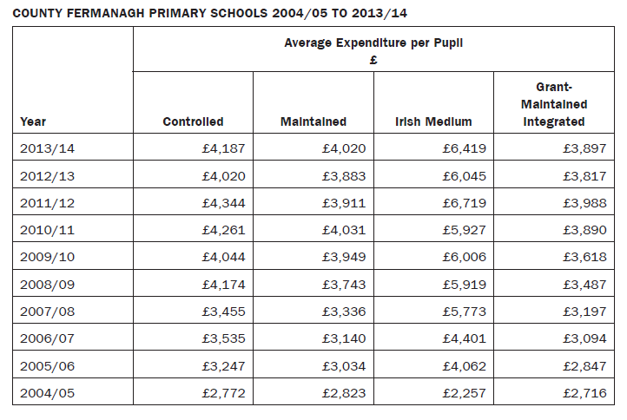

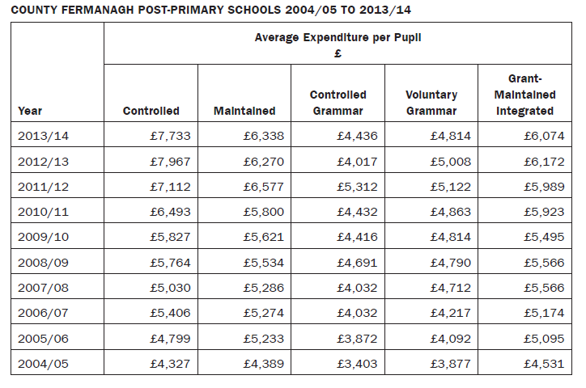
Notes:
(i) Data for Primary Schools include Nursery Classes within Primary Schools. It is not possible to disaggregate the costs of Nursery Class pupils from those of primary pupils in the parent school;
(ii) Data included for 2013-14 are still provisional pending publication of audited outturn statements by
the appropriate Funding Authority – the Western Education and Library Board, in respect of Controlled
and Maintained schools; and the Department of Education, in respect of Voluntary Grammar and Grant-
Maintained Integrated Schools.

Back to Top

Department of Enterprise, Trade and Investment

Economically Inactive
Mr Easton asked the Minister of Enterprise, Trade and Investment how her Department can assist people who are economically inactive.
(AQW 35155/11-15)

Mrs Foster: The Executive has recognised in the Programme for Government and Northern Ireland Economic Strategy that Economic Inactivity is one of the most persistent problems facing the local economy. It is only through adopting a coordinated and strategic approach across Departments that we can hope to address some of the structural issues which are restricting individual’s access to the labour market. I have been working with Minister Farry, supported by Ministers McCausland and Poots, to develop a strategy to reduce economic inactivity through skills, training, incentives and job creation.

A public consultation on a Strategic Framework was carried out earlier this year and officials are now working to finalise the Strategy which Minister Farry and I hope to bring to the Executive later in the year. The overarching strategic goal is to contribute towards a stable and competitive employment rate of over 70% by 2023. The Strategy will target two major inactive categories; individuals with family commitments and the long-term sick and disabled.

Within DETI, our focus is to improve the economic competitiveness of the Northern Ireland economy in line with the ultimate aim of the Executives’ Economic Strategy. We are doing this by supporting businesses to grow and to export more – this focus will increase employment and opportunity for all. Contributing to the rising number of employment opportunities, Invest NI has delivered its most successful year in 2013/14 in terms of job promotion. Over the course of the year, Invest NI promoted 10,800 jobs and secured investment totalling £775million in the Northern Ireland economy. Specifically there are elements of Invest NI’s Jobs Fund which are designed to provide opportunities for
the economically inactive. Since its introduction in April 2011, 2405 of the jobs created through the Jobs Fund have gone to people who were either unemployed or economically inactive. These jobs have been created in existing private sector businesses, social enterprises or through jobs created by new business start-ups by individuals living in a Neighbourhood Renewal Area and young people aged 16 – 24 not previously in employment, education or training (NEET).

Invest NI also provides sponsorship support to the Women in Business Network’s
Women into Business programme. The programme is aimed at promoting, supporting and empowering economically inactive women in Northern Ireland to start their own business or aid them into sustained employment.

Back to Top

Department of Health, Social Services and Public Safety

Community Dietetic Referrals for Pediatric Patients
Mr Givan asked the Minister of Health, Social Services and Public Safety what action
(i) his Department; and
(ii) Health and Social Care Trusts are taking to address pressures caused by an increase in community dietetic referrals for pediatric patients.
(AQW 34845/11-15)

Mr Poots (The Minister of Health, Social Services and Public Safety): The Public Health Agency (PHA) and Health and Social Care Board (HSCB) are leading a regional review of current demand patterns and trends across Northern Ireland for Allied Health Professional (AHP) services, including community dietetic referrals for paediatric patients and the capacity available in individual Trusts to meet the demand.

Following implementation of the recommendations from the review, concerning revised data definitions and performance monitoring processes, the HSCB, PHA and individual Trusts will be able to define whether there is any additional pressure in community dietetic referrals for pediatric patients and address it via the appropriate local commissioning groups.

Back to Top

Department of Justice

Public Protection Arrangements Northern Ireland
Lord Morrow asked the Minister of Justice to detail
(i) the recommendations by the Public Protection Arrangements in Northern Ireland that have been implemented following the conclusion of the Serious Case Reviews into Barry Johnston; Thomas Ward and David Paige, citing the changes and from which
review they originate; and
(ii) the recommendations that have not been implemented.
(AQW 35112/11-15)

Mr Ford:
(i) Recommendations following conclusion of PPANI Serious Case Reviews Table A below sets out the recommendations arising from the Serious Case Reviews commissioned (for
the cases listed) by the Strategic Management Board responsible for oversight of the Public Protection Arrangements Northern Ireland.

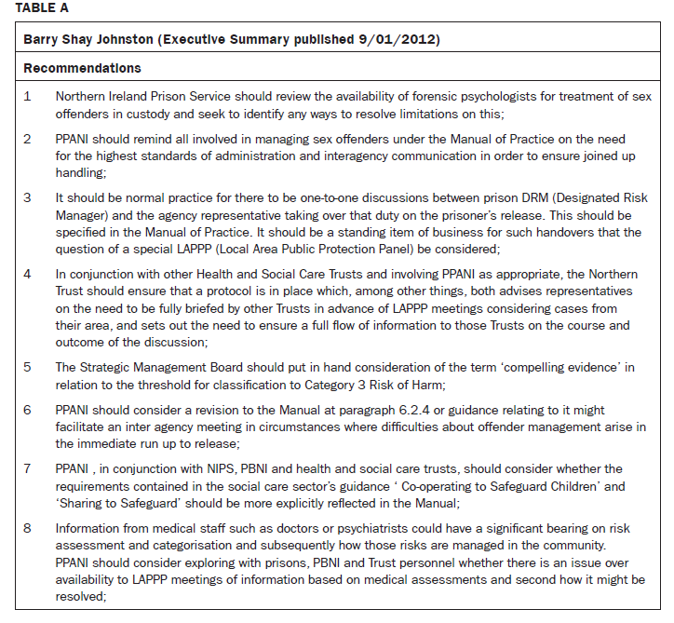

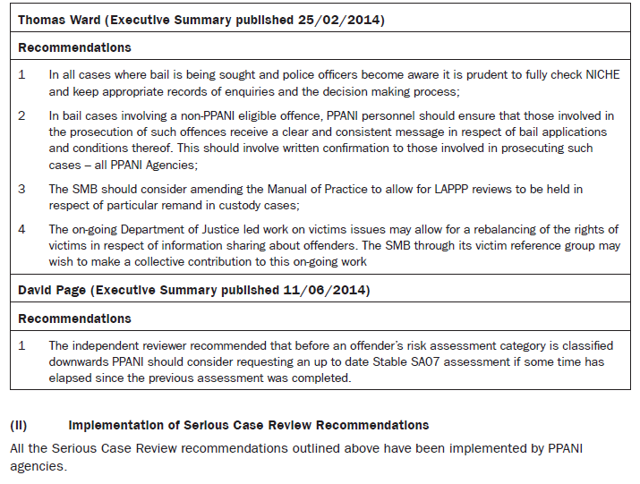

Back to Top

Serious Case Review
Lord Morrow asked the Minister of Justice, pursuant to AQW 34383/11-15, whether he will specifically address the point on the approved residence being in an area of families with young children, and given the victim in the case was a child of the neighborhood to detail whether
(i) this point was considered prior to the approval of residence and due cognisance given to the offender’s previous behaviour and targets;
(ii) he will amend risk assessments in these instances taking on board vulnerability of potential victims; and
(iii) he will tighten residence criteria to remove or reduce reoffending in similar instances.
(AQW 35113/11-15)

Mr Ford: I shall reply to the points raised as soon as possible.

Back to Top

Serious Case Review
Lord Morrow asked the Minister of Justice following the conclusion of a Serious Case Review, whether any departmental agency has found to have missed opportunities, neglected responsibilities, or defaulted in any way which could have prevented re-offending; and if so, to cite the relevant instances.
(AQW 35193/11-15)

Mr Ford: The Independent Reviewers conducting Serious Case Reviews commissioned by the Strategic Management Board responsible for oversight of Public Protection Arrangements Northern Ireland did not identify any failings in the management of the cases which could have prevented re-offending.

Back to Top

