Good Facilities & Services (GFS) Campaign Workshop (1 of 2)

Age: 12yrs +

Aim: In this first of two workshops, the aim is to explore the importance of including children and young people in forthcoming amendments to age discrimination legislation and to help guide the development of campaign plans.

Process: Facilitator(s) with large or small groups
N.B. Mind map and Power Map visual aids are based on actual group work with young people looking at negative stereotyping.

Time: 75 minutes (approx)

Materials: Flip Chart paper
Pens
Copies of the United Nations Convention on the Rights of the Child (UNCRC)
Copies of case studies (see appendix 1)

Method:

- Introduction (15minutes)
Introduce the background to the topic and why it is important to include children and young people, either through a presentation or by asking them to read the sections below:

Background
The Northern Ireland Government has said that it will develop and consult on proposals to improve age discrimination legislation so that it covers the provision of goods, facilities and services.

While this may appear to be a positive development, the Northern Ireland Commissioner for Children and Young People (NICCY) and the Equality Commission for Northern Ireland (ECNI) are concerned, based on information coming from the Assembly, that children and young people under the age of 18 may not be covered by the proposed changes to the law.
What are Goods, Facilities and Services?

The amended legislation would apply to anyone providing goods, facilities or services to the public; for example: hotels, shops, banks, insurance companies, financial services, cinemas, theatres, restaurants, places of entertainment or refreshment, transport and travel services, and services provided by any public authority e.g. health, education and leisure services.

Why is it important to include children and young people in the proposed extension of the law?
NICCY believe that children and young people should be protected by the proposed changes to the law because:
- There is clear evidence that children and young people experience less favourable treatment because of their age when accessing goods, facilities and services.
- It will help challenge the negative stereotypes and attitudes directed towards children and young people and will help build a culture where young people are treated with respect and feel valued when receiving a service.
- It would mean that service providers and public bodies would have to review their services to children and young people to make sure that their policies were non discriminatory.
- Not including children and young people would go against the expectation that they would be treated equally. Not including them could mean that the government is breeching the rights of children set out in the United Nations Convention on the Rights of the Child (UNCRC), and other international laws.
- The NI Assembly already has a number of policies in which they have agreed to protect children’s rights. This will give them the opportunity to lead the way in making sure that rights of children and young people are promoted and protected.
- It would build on and extend the existing responsibilities on public bodies towards children and young people under Section 75.
- Including children and young people in the changes to the law could have a positive impact for businesses and public bodies.

What areas should the proposed legislation cover?

- Access to general services: for example shops, public transport, entertainment venues etc. We have evidence from young people that they are often not allowed into shopping centres, that they have to leave their schoolbags outside shops or are not permitted to enter certain shops at certain times or in groups or that “mosquito devices” are used to stop young people gathering and meeting in certain areas. (A mosquito device is a gadget which makes a high-pitched noise that can most easily be heard by young people under the age of 20.)
- Provision of health and social care: for example accessing age appropriate services including mental health services. We have evidence from young people that they are still being admitted to adult mental health wards and that there are inconsistencies in the levels of health services that young people receive across Northern Ireland. Further, we know from independent reviews that services for children in Northern Ireland are significantly underfunded when compared to other parts of the UK.
- Financial services: for example banking and car insurance. We have evidence that young people experience great difficulty in obtaining car insurance at a fair price.
- Public bodies exercising public functions: for example the police or prison services. We have evidence that a large number of young people who have had contact with the police experienced what they viewed to be unacceptable police behaviour.
- Private clubs: for example golf clubs or private gyms. NICCY have received complaints that young people have been excluded from using certain facilities at certain times because of their age.
- Education: for example accessing age appropriate services within education particularly in the area of special educational needs. We have evidence that young people in certain year groups are either denied services or are given less priority because they are in that year group.
- Accommodation: for example renting properties. NICCY have received complaints that young people have difficulties in renting properties or rooms in shared properties because landlords unfairly believe that they will damage the property or disrupt other tenants.

If the law is extended to cover children and young people then we would expect all of the above areas to be covered so that young people could legally challenge the treatment or services that they receive.

- Case Studies (20 minutes)
Split the group into small sub groups and give each a case study to explore
(Appendix 1).

For each case study ask them to consider and make notes on the following:
- What is the problem?
- Who is affected by this issue?
- Which rights of the UNCRC could be affected?
- Who is responsible for doing something about this?

- Describe the problem (10 mins)
Based on what they have learned through the case studies and their own experiences as the group, highlight problems faced by young people which could be resolved by including them in age discrimination legislation on goods, facilities and services.

Build up a mind map to link these problems in to specific areas (see below for an example of a mind map for an exercise looking at the negative stereotyping of children and young people):

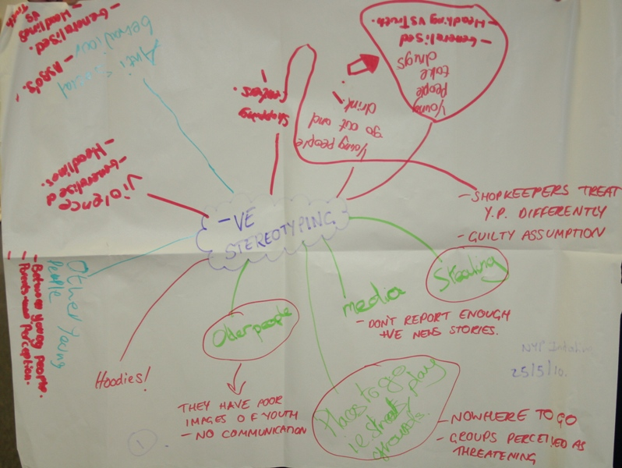

- What other important factors are there to consider? (10 mins)

What exceptions should be included in the legislation?
We recommend that some exceptions to this proposed extension to the law should be provided for including:
- Existing legislation: we recommend that where another existing law allows or requires people to be treated differently because of their age then this should continue to be allowed. For example, laws which ban the sale of alcohol to under 18’s.
- Age-based concessions: we recommend that the legislation allows age-based concessions such as discounts for people of a particular age group where this is justifiable. For example, giving young people discounted fares on public transport or in leisure centres.
- Proof of age: we recommend that the legislation allows businesses which sell age-restricted goods e.g. alcohol, cigarettes or fireworks, to continue to ask for proof of age where a customer appears to be younger than a particular age.
- Positive action: we recommend that public bodies should be allowed to treat people differently based on age if this will address a disadvantage. For example, vaccinations for certain ages.
- Sports: we recommend that sports providers are allowed to use age limits or age bands within sport at all levels. For example having restrictions that members of a team must be below a certain age i.e. under 10’s, 12’s etc.
- Other possible exceptions: So that the legislation can remain up to date and change to reflect changes in society e.g. new technological advances etc, we recommend that the legislation is flexible so that as new issues arise, new exceptions can be made where necessary.

- Decide what problem you want to tackle in your campaign (20 mins)
From the list of problems you have identified pick one area to work on and break in to groups to explore this more fully (e.g., negative stereotyping of young people in shops, transitions from youth to adult health services)

Ask each group to complete the following tasks for the problem that they have chosen.

Step 1: Power mapping
List the different people or organisations who will have an interest in this issue and which of them are likely to support or go against your campaign. This is what our list on negative stereotyping of children and young people looked like (see below):

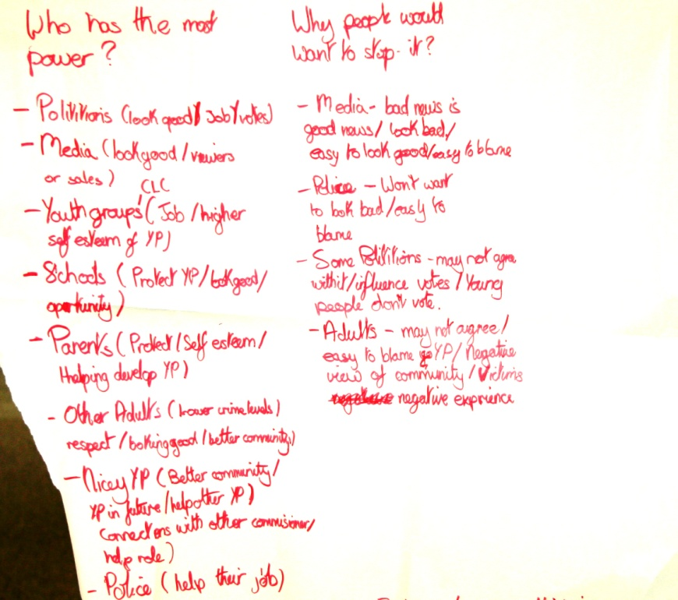:
Step 2: What message do you want to get across?

Ask the groups to decide who they want to target through their campaign and what the main message is:

E.g.: for Education the group might want to gather support from young people negatively affected by transitions from child to adult services, or they may want to campaign directly to the education minister to ask for his support as including young people in GFS could support his aims as Minister for Education

E.g.: in negative stereotyping in shops the group may want to campaign directly to the business community on the basis that young people are current and future consumers and it is in their best interest to built good relationships with customers, or they could lead an awareness raising campaign to highlight the issue.

Step 3: Decide who you could contact.
Once the group has decided the message they want to get across they should be able to identify which government department is responsible for dealing with this. A list of departments can be found here: http://www.northernireland.gov.uk/gov.htm

Local MLAs or councillors may also be able to help with campaigns on issues affecting their constituency. They can be found by typing post codes in to the WIMPS (Where is my public servant?) website: www.wimps.tv or on www.theyworkforyou.com.

It is important to think about who could have the most impact or influence and also who is most likely to listen to concerns and do something about it.

The second workshop in this series of two, addresses the next stages of campaigning: campaign tactics, communicating effectively and following up.

Appendix 1

GFS Case studies

- Alice is 15 years old and has been diagnosed with obsessive compulsive disorder (OCD). The waiting list for child psychiatric services is very long and Alice has been told she will be seen in 4 months by a psychiatrist. A friend of her mother who is in her 40s has a similar condition and has been told that she can be seen in 6 weeks. Alice is concerned as her school work is being affected.

- Brian is 16 years old; he has recently left home as he is unable to live with his parents. He has a full time job but is now living in a foyer for homeless young people where the rent is higher than he can afford. He has enough money to rent an apartment but any he has applied for won’t take people under 18 in case they disturb the neighbours.

- Claire is 5 years old; she was born with only one hand. As she is starting school soon she is worried about being bullied and wants to have a prosthetic hand fitted. The hospital she is referred to says they don’t do this for children. After her parents remind them about their duty to provide medical care for children they offer Claire a generic adult sized prosthetic hand. Adults are usually fitted for a correct sized prosthetic.

- Darren is in P3; his teachers have noticed that he has difficulty learning at the same rate as other children in his class. His parents have asked if he can see an educational psychologist but the Education and Library Board have written back to say that because of long waiting lists they are focusing on working with P7 children.

- Emma is 16 and is a keen athlete. She joined her local gym so she can train indoors in the evenings. The gym charges full adult prices for anyone aged 16 and over. Usually Emma finishes her homework in the library after school and then goes to the gym on her way home at about 6 pm. Yesterday when she arrived at the gym she was refused entry. A sign on the door said that under 18s were not permitted to use the gym between 5.30 – 7.00pm as they wanted to focus on places for people coming from work.

- Frank and his friends go to a youth club near their housing estate. Their parents always tell them to walk home together as the streets can be quite dangerous after 10pm on a Friday when they finish at the club. Several times after there has been trouble in the area Frank and his friends have been stopped and searched by Police. He knows they are doing nothing wrong and thinks they are just being targeted because they are a group of young people.

- Grainne lives in a rural area. She has just been offered a job in an office in a town nearby. She will have to drive there as there as there is no public transport that will get her there at the right time. Unfortunately Grainne had to turn down the job because she couldn’t afford the cost of car insurance which was so high because she is only 17.

- Harry is 14 and lives with his grandmother. He does a lot to help her around the house and she often asks him to pick up a few things from the local shop on his way home from school. The local shop doesn’t allow young people in school uniform in to the shop so he has to walk an extra mile out of his way to get to the supermarket instead. Harry hates going to the supermarket as they have a mosquito device the car park which plays a really annoying noise.

