Article 1

Definition of a Child

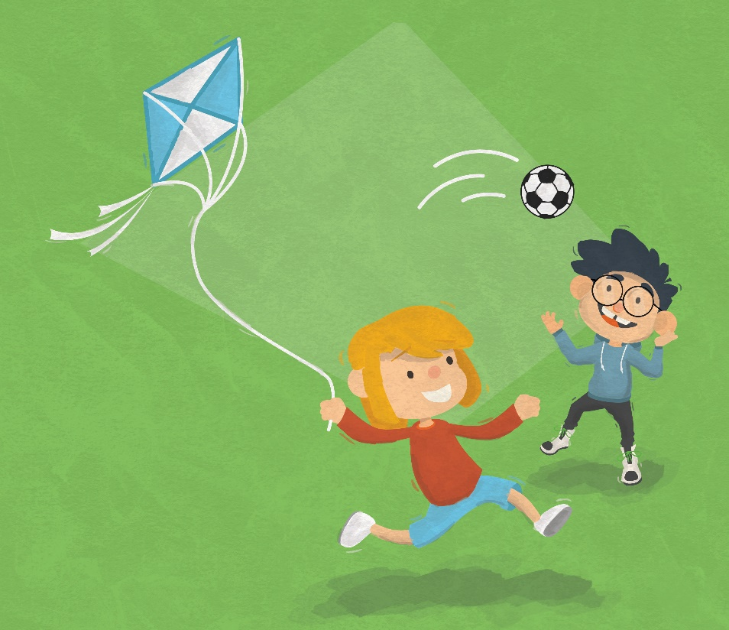

All children and young people have rights. If you are under 18, the Convention applies to you.

Article 2

No Discrimination

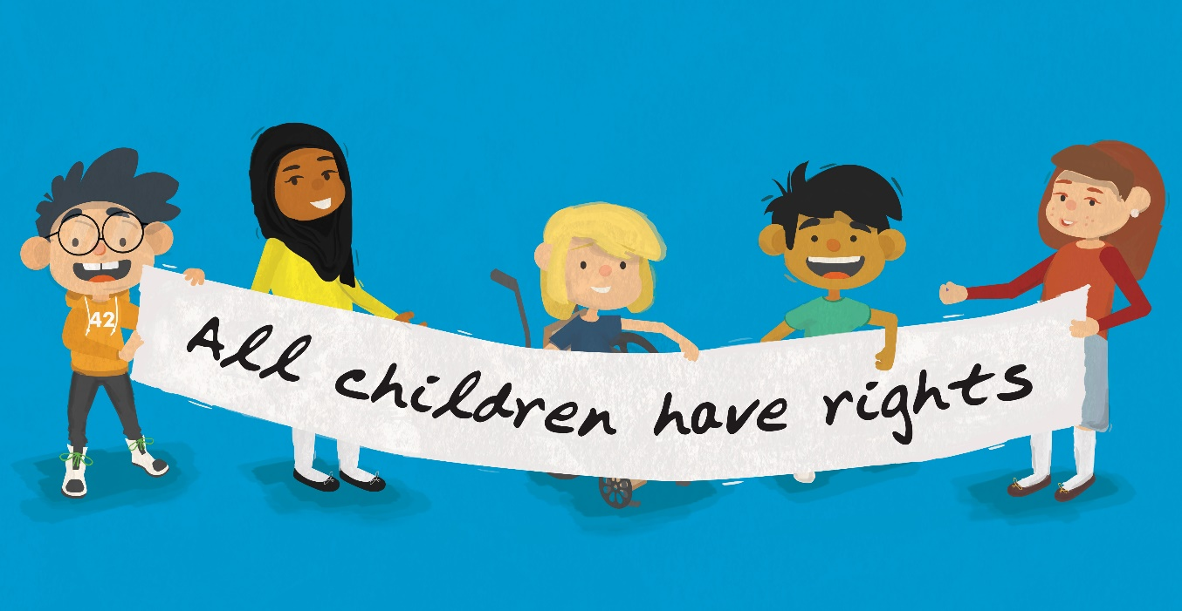

The rights in the Convention apply to everyone under the age of 18, no matter who you are, what your religion is, whether you have a disability, or what type of family you come from.

Article 3

Best Interests of the Child

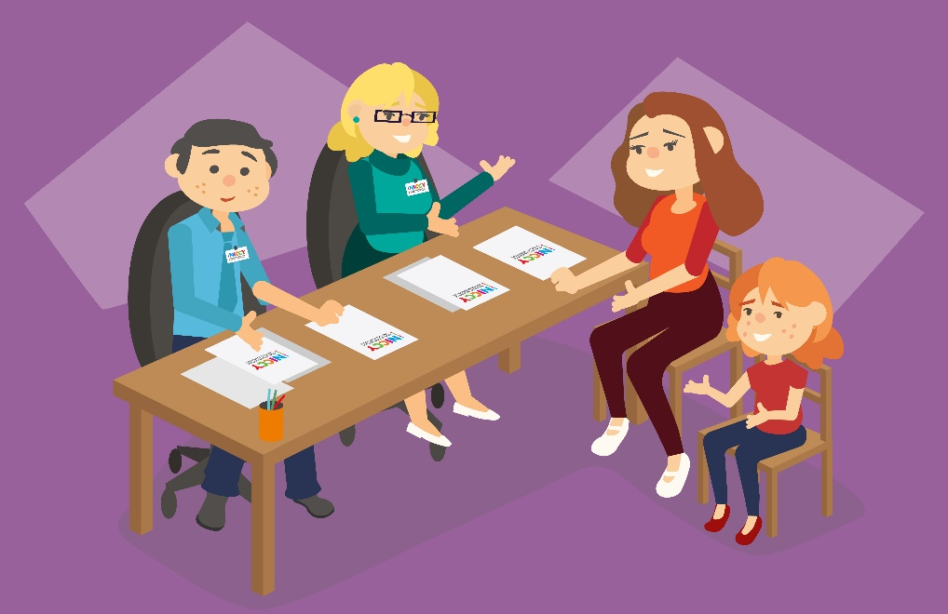

If a decision is being made by any person about you, then your best interests must be considered when making the final decision. What is best for YOU is what matters.

Article 4

Making Rights Real

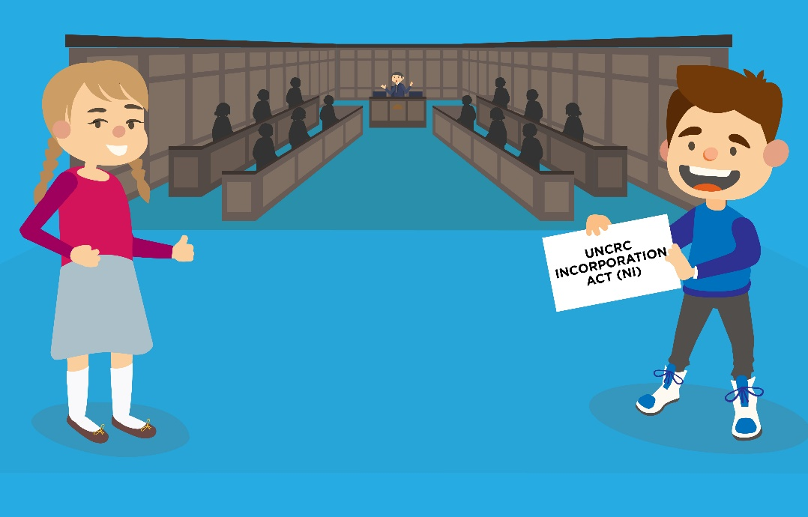

The Government has a responsibility to make sure these rights are a reality for all children and young people, and make sure people know about your rights.

Article 5
Family Guidance as Children Develop

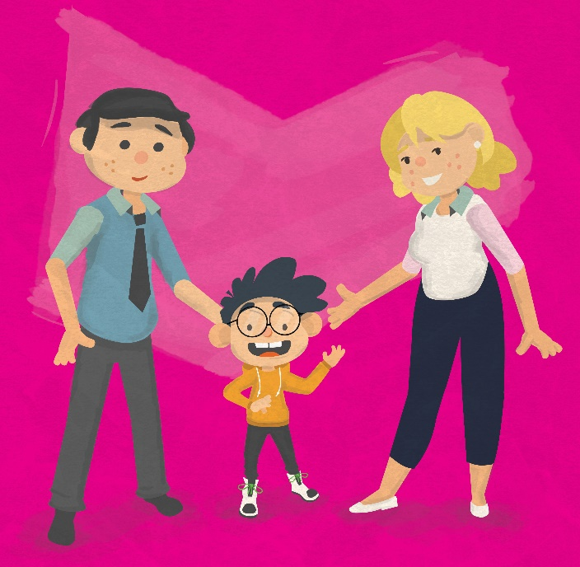

Parents and guardians have a responsibility to guide you through your childhood and help you learn how to use your rights. The Government must respect this important role that parents have.

Article 6

Family Life, Survival and Development

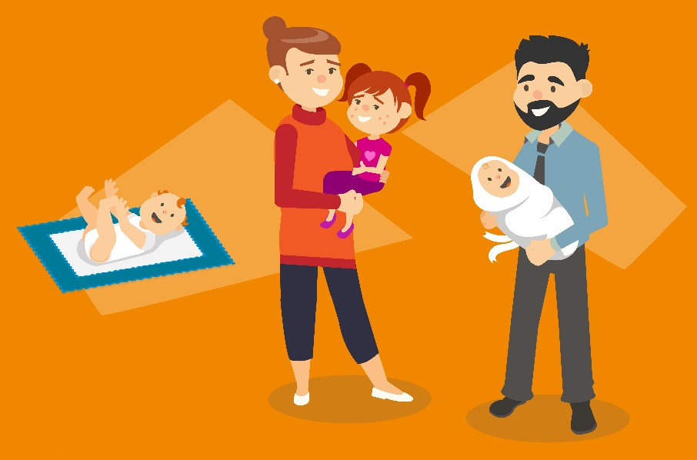

You have the right to be alive, survive and to develop through life. The Government must keep you safe from harm.

Article 7
Family Name and Nationality
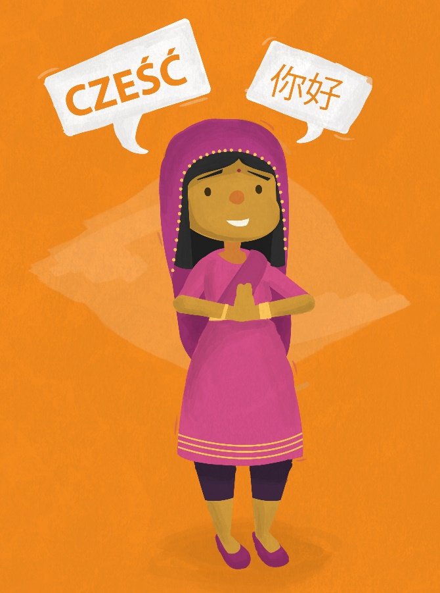

You have the right to a name at birth and the right to be a citizen of your country. You also have the right to be cared for by your parents, as far as possible.

Article 8

Identity
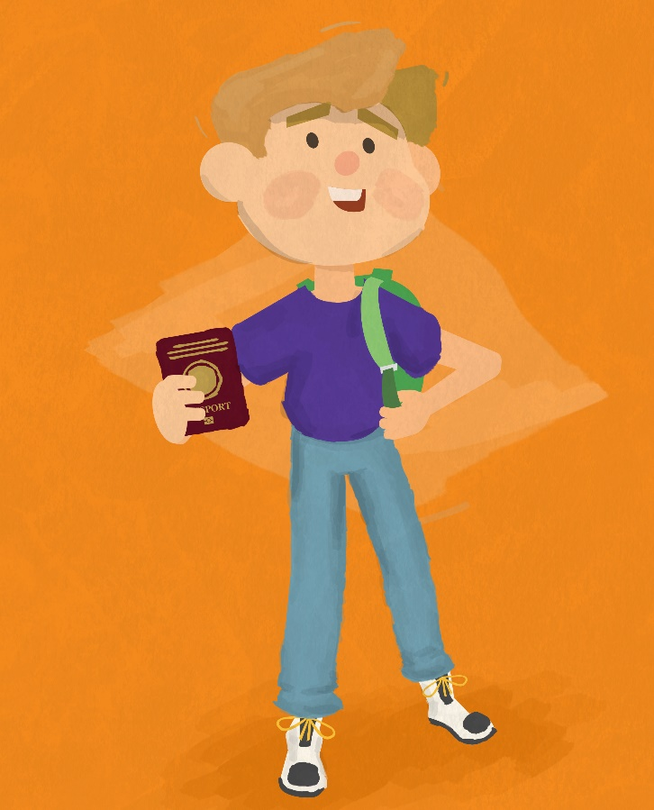

You have a right to an identity and to know who you are – official records should be kept. If you are over 18 years old and adopted, you can try to find out who your birth parents are.

Article 9
Keeping Families Together
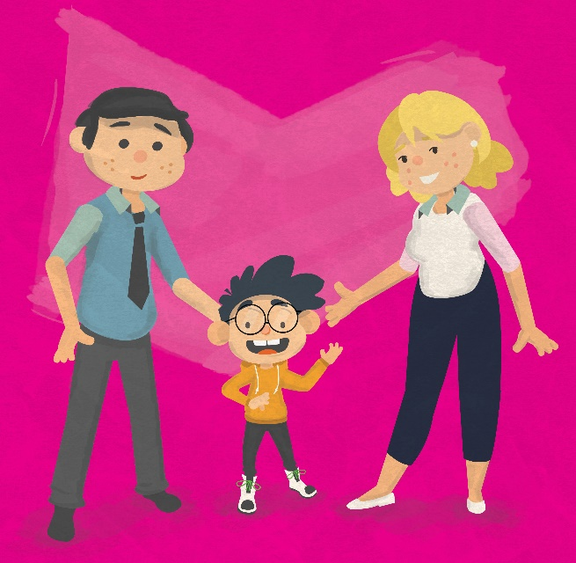

You should not be separated from your parents unless it is for your own good; for example, if a parent is mistreating you or neglecting you. If your parents have separated, you have the right to stay in contact with both parents unless this is not in your best interests.

Article 10

Contact with Parents Across Countries

If you and your parents live in different countries, you have the right to stay in touch or get back together as a family.

Article 11
Protection from Kidnapping
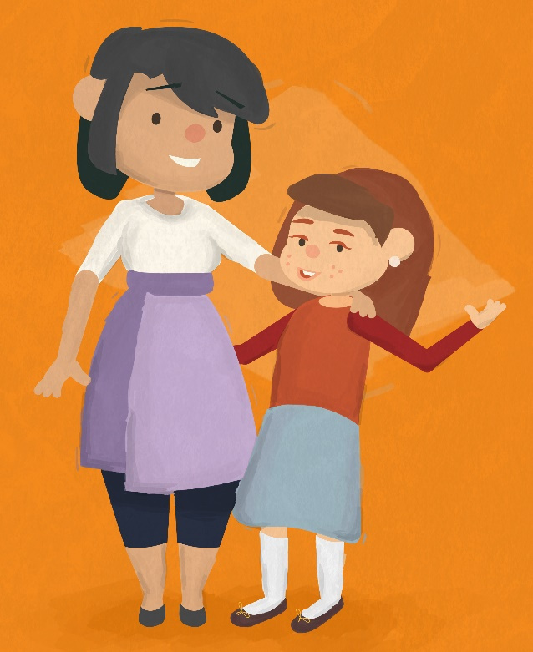

The Government must make sure you are protected from being kidnapped or taken out of the country when you shouldn’t be.

Article 12
Respect for Children’s Views
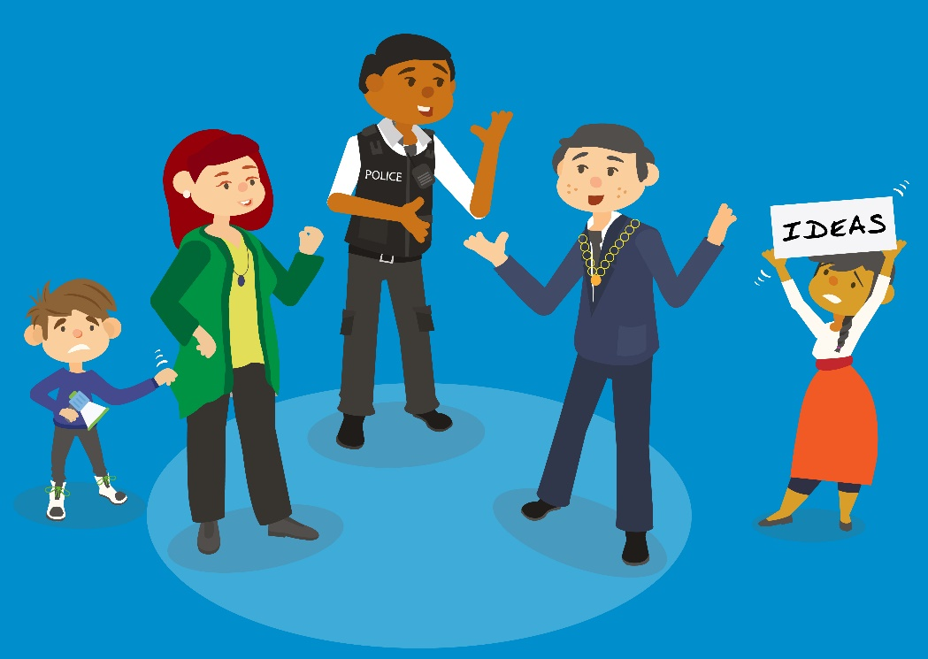

You have the right to speak up and have your opinions listened to and taken seriously by adults, on things that affect you.

Article 13
Sharing Thoughts Freely
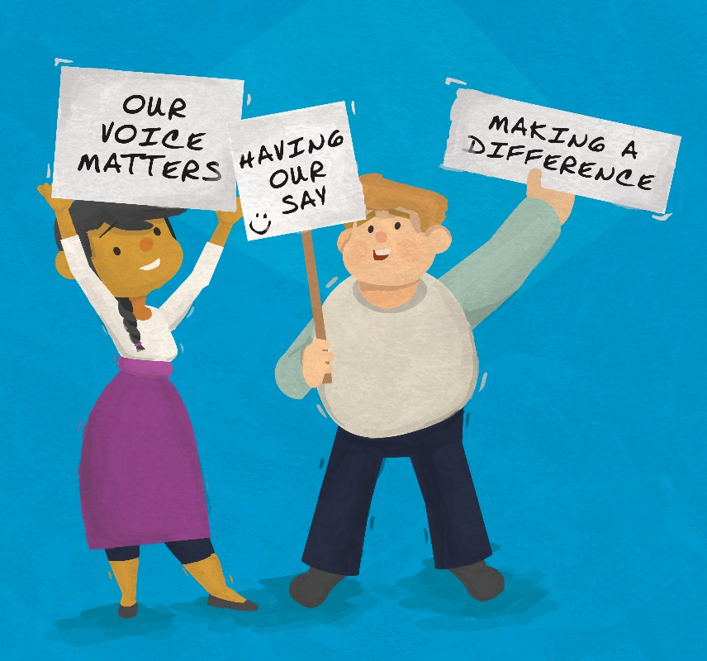

You have freedom of expression, or the right to say whatever you believe as long as it does not harm other people.

Article 14
Freedom of Thought and Religion
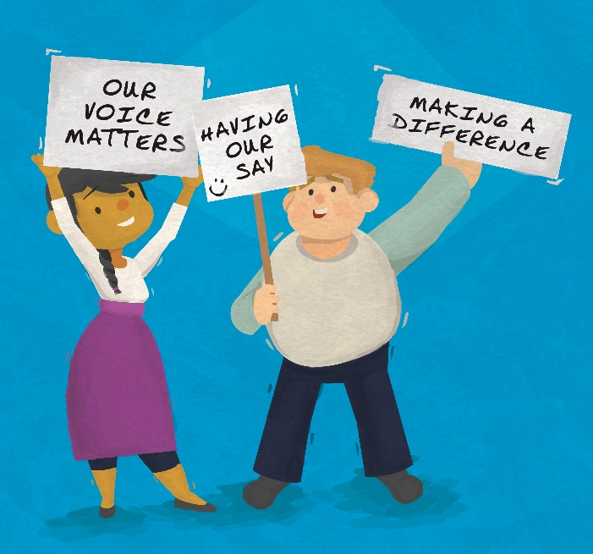
You have the freedom to have your own thoughts and beliefs and to choose your own religion. Government should recognise the role of your parents in providing you with guidance.

Article 15
Setting Up or Joining Groups
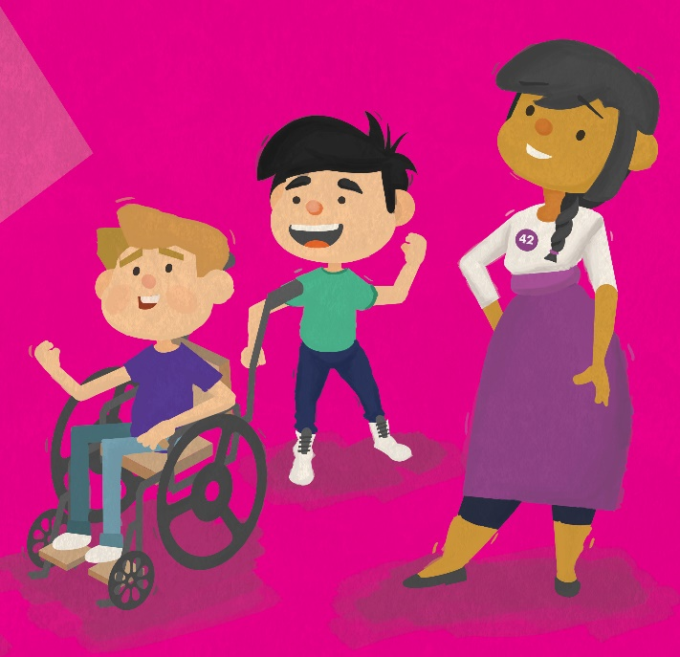

You have a right to freedom of association (to join and form groups and make friends) and to freedom of assembly (to meet together with others) as long as this does not harm other people.

Article 16
Protection of Privacy
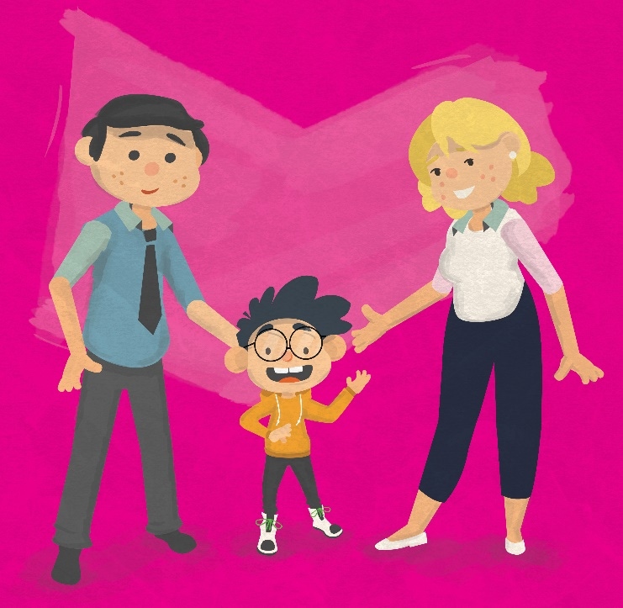

You have the right to your own space and privacy. For example, Government shouldn’t interfere with your family or home life, unless there is a legal reason for this.

Article 17
Access to Information
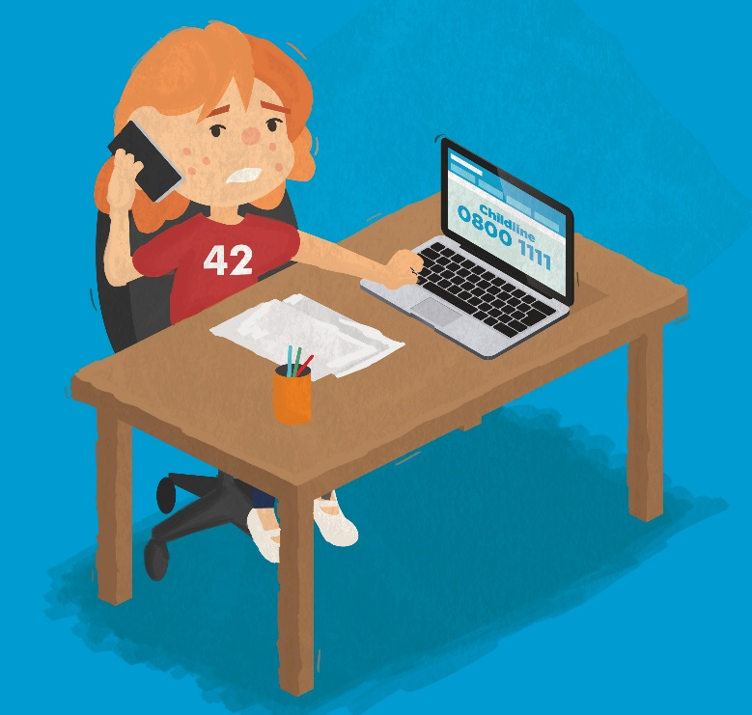

You have the right to access information which is important to your wellbeing, for example from newspapers, websites, TV, social media and radio.

Article 18
Responsibility of Parents
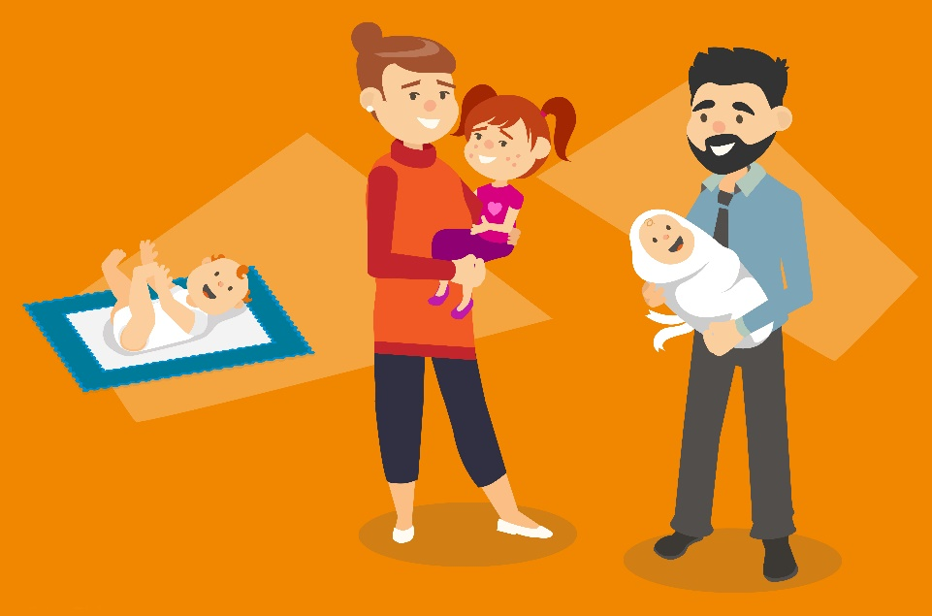

Government should make it clear that both parents share responsibility to raise you, and should always consider what is best for you. The Government should help your parents care for you properly, including helping them find childcare when they are working.

Article 19
Protection from Violence
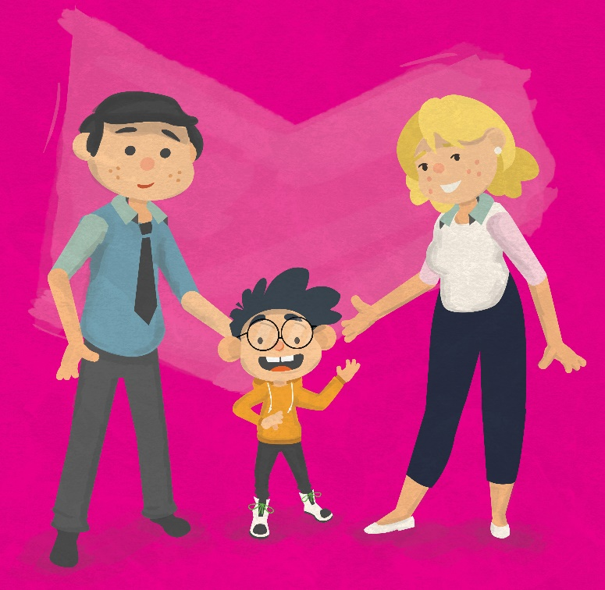

You must be kept safe from harm and protected against violence and abuse. You must be given proper care by those looking after you.

Article 20
Children Without Families

If you can’t live with your parents, then you have the right to special care. For example, you may be looked after by other members of your family or by a different family.

Article 21
Children Who are Adopted
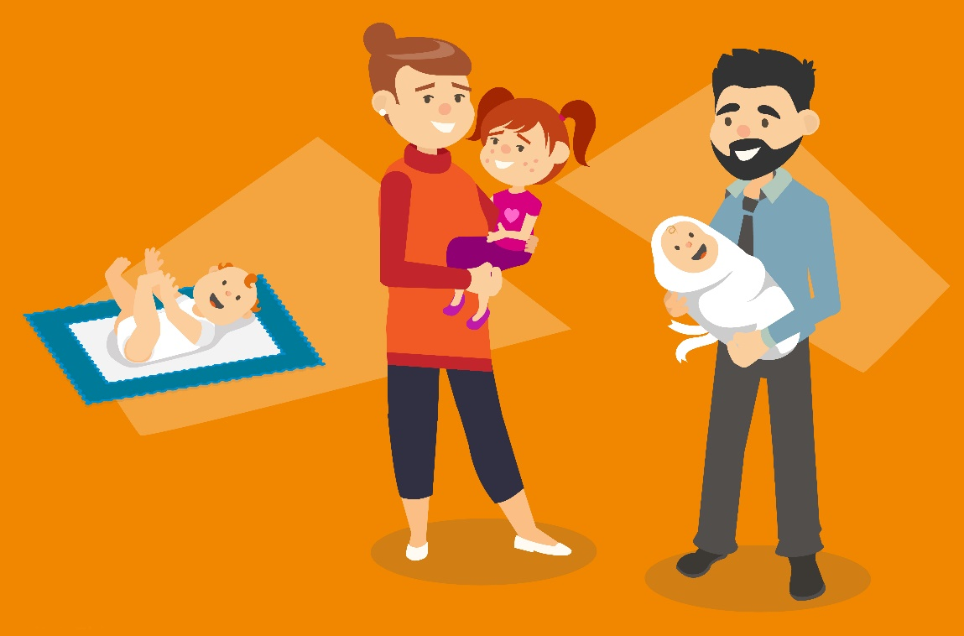

If you’re being adopted, this must only happen under very strict rules which make sure that what is happening is best for you.

Article 22
Refugee Children
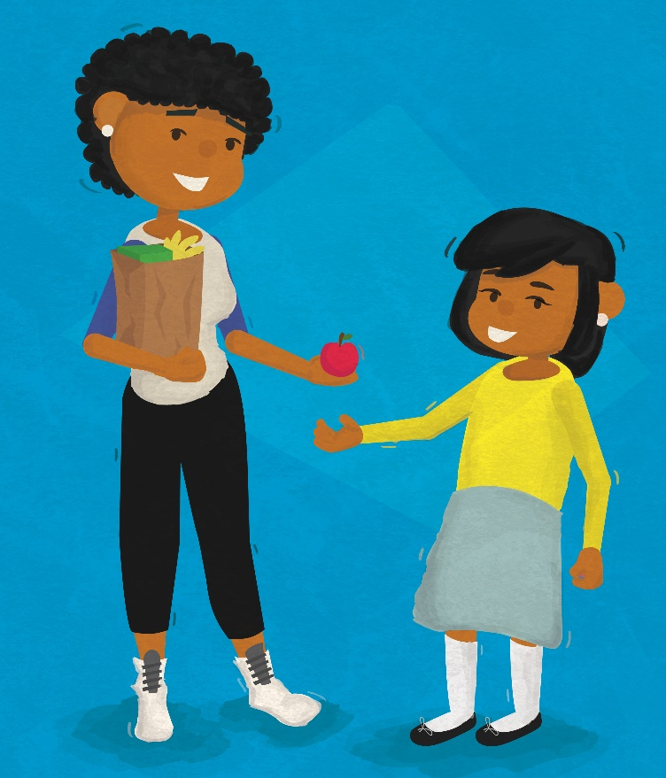

Refugees are people who have been forced to leave their country because it is not safe. If you are a refugee, you have a right to special help and to be allowed to live somewhere that is safe, particularly if you have been separated from your parents.

Article 23
Children with Disabilities
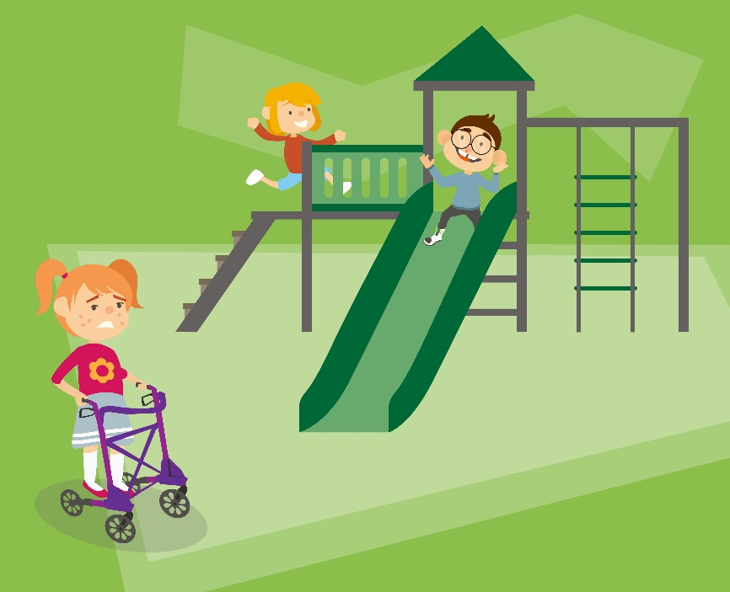

If you have any kind of disability, you have a right to special help to make sure you can live a full life and join in with things in your community. Money should not be a barrier to this.

Article 24
Health, Water, Food, Environment
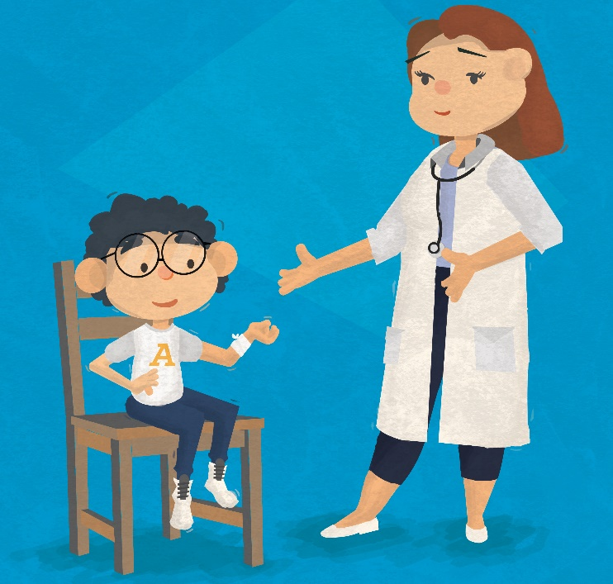

You have a right to be as healthy as possible, and if you are ill, you must be given good healthcare services. You have the right to live in a safe, healthy environment with good food and clean drinking water.

Article 25
Review of a Child’s Placement
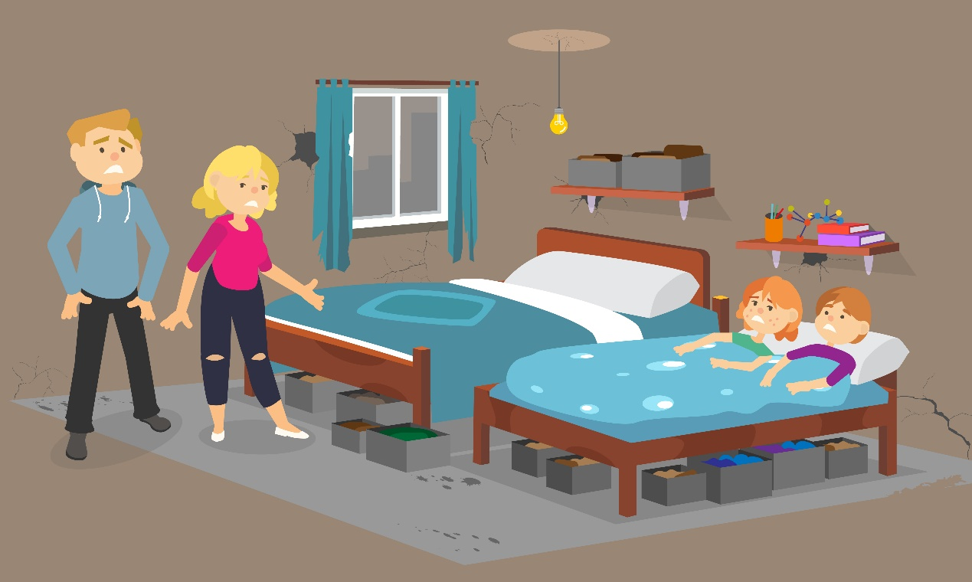
If you are looked after in a care home or somewhere else away from home for health treatment, you have the right to have your living arrangements checked regularly, to make sure they are still what’s best for you.

Article 26
Social and Economic Help
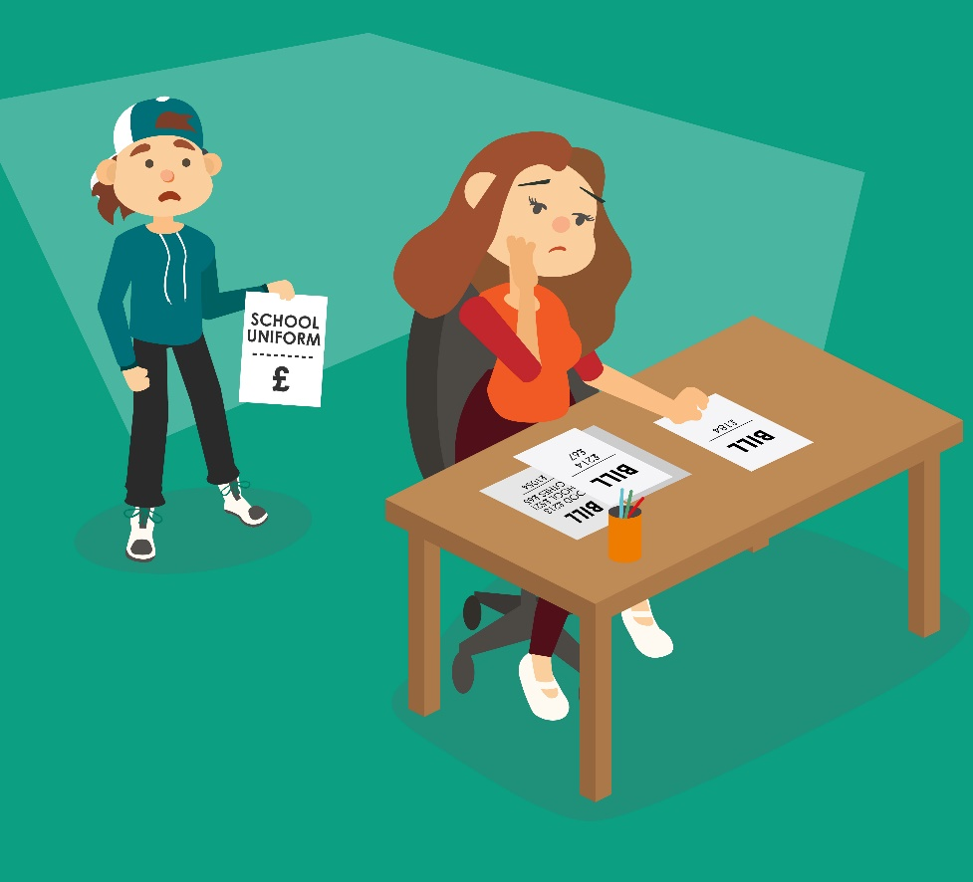

You have the right to social security benefits from the Government if you need them. This could mean money for housing or living costs.

Article 27
Food, Clothing, A Safe Home
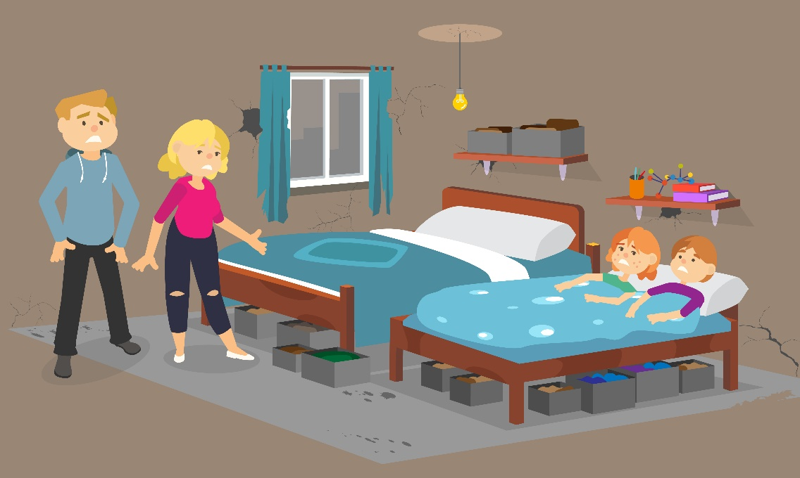

You have the right to an adequate standard of living for your physical, mental and social development. Your parents have the main responsibility to make sure you are provided for but, when necessary, Government should also help.

Article 28
Access to Education
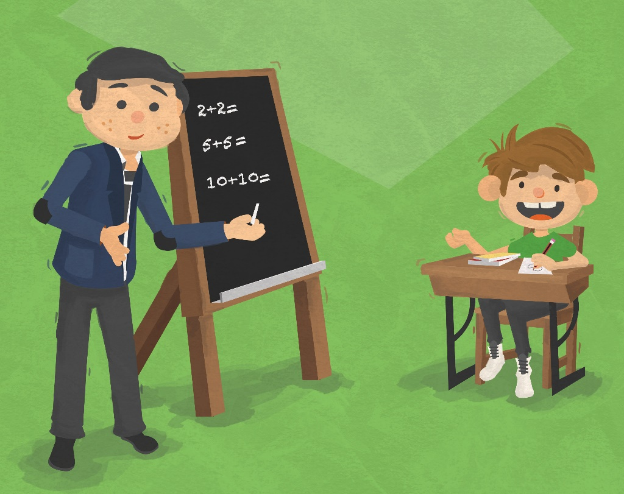

You have the right to education, and Government should make sure all young people have an equal opportunity to get to college or university.

Article 29
Aims of Education
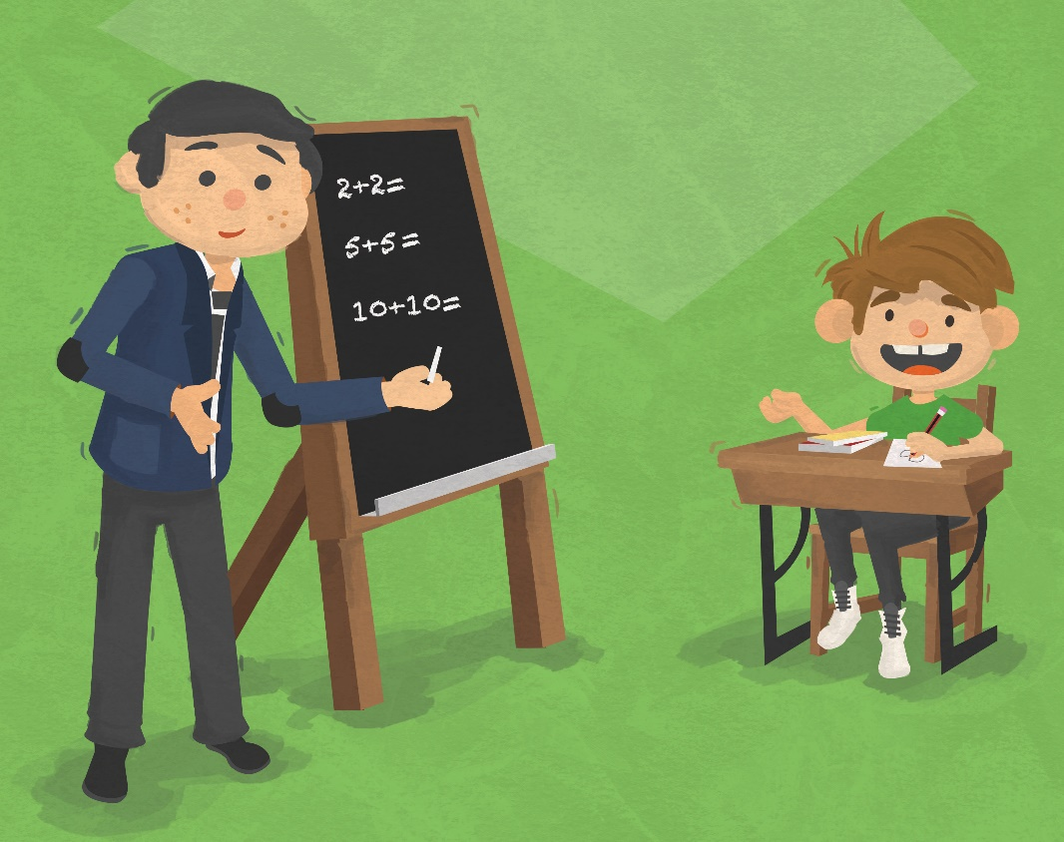

Your education should help you develop your skills and personality fully, teach you about your own and other people’s rights and prepare you for adult life.

Article 30
Minority Culture, Language and Religion
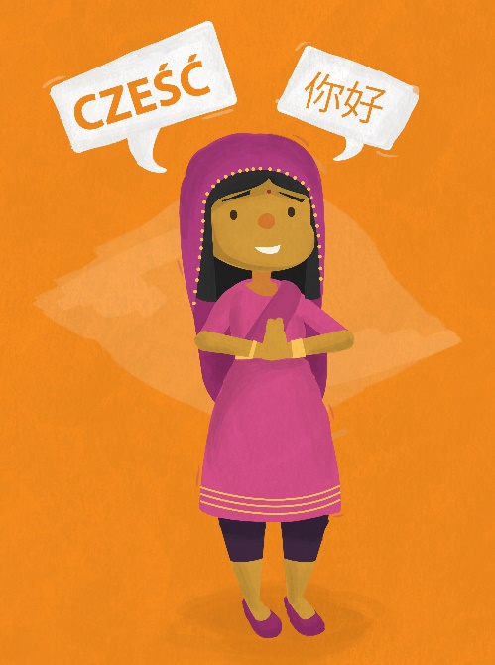

You have a right to enjoy your own culture, use your own language and practise your own religion. In Northern Ireland, there are many different communities and cultures with different languages, religions and ethnic identities.

Article 31
Rest, Play, Culture, Arts
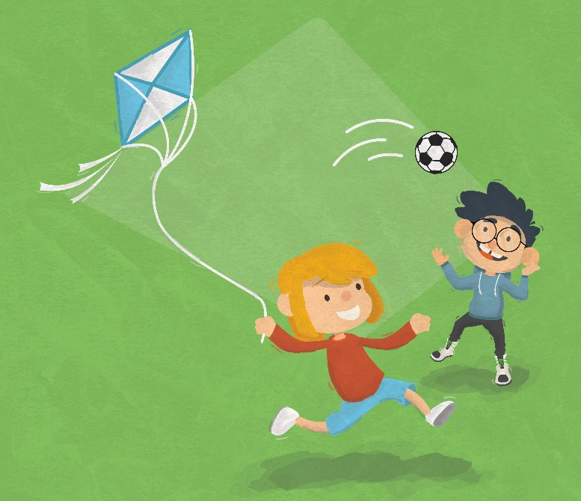

You have the right to rest and leisure, as well as to play and to have the chance to participate in a wide range of activities, including in cultural life and the arts. It is very important that you have time to rest and relax, as well as to play, meet with friends and take part in activities.

Article 32
Protection from Harmful Work
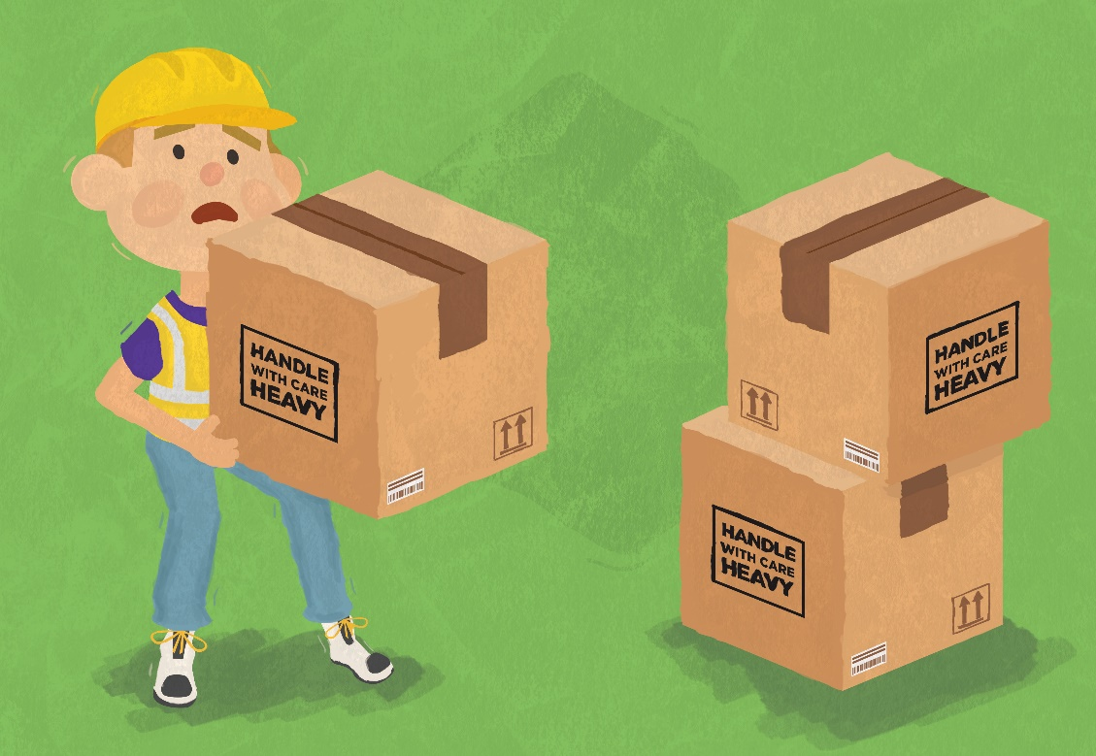

The Government must protect you from doing dangerous work, or work that could harm your health or interfere with your education.

Article 33
Protection from Harmful Drugs
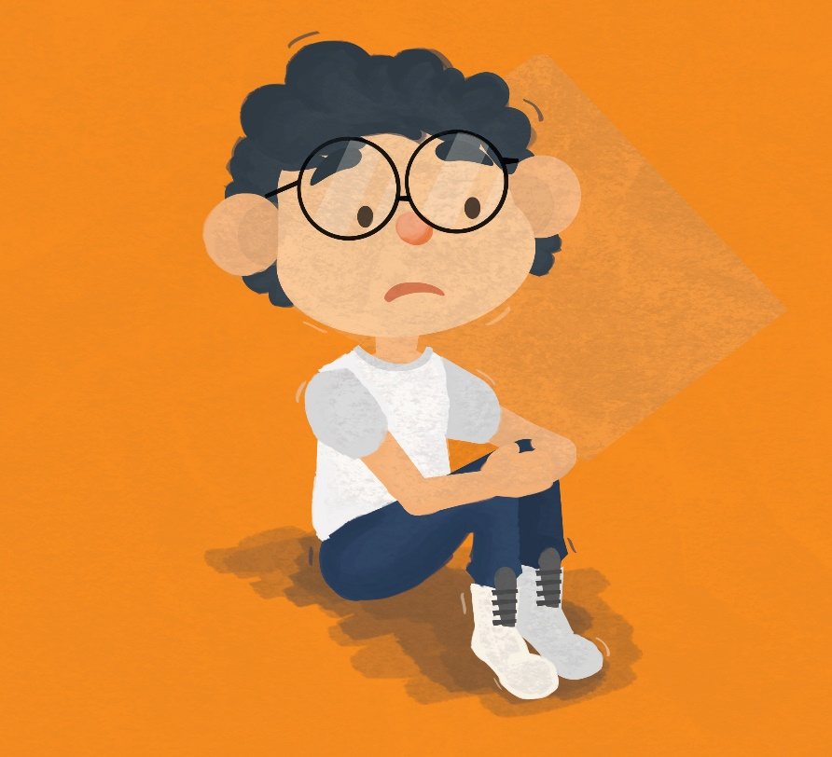

You have the right to be protected from using dangerous drugs.

Article 34
Protection from Sexual Abuse
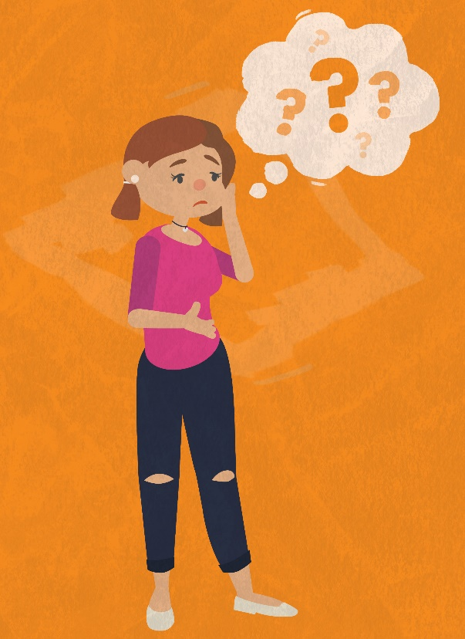

You should be protected from sexual exploitation, which is when children or young people are pressurised, forced or tricked into sexual activities in return for something else like money, drugs, alcohol, attention, debt repayment or protection.

Article 35
Prevention of Sale and Trafficking

You have a right to be protected from being abducted, trafficked or sold.

Article 36
Protection from Exploitation

You have a right to be protected from all other sorts of exploitation which can damage your welfare or development.

Article 37
Children in Detention
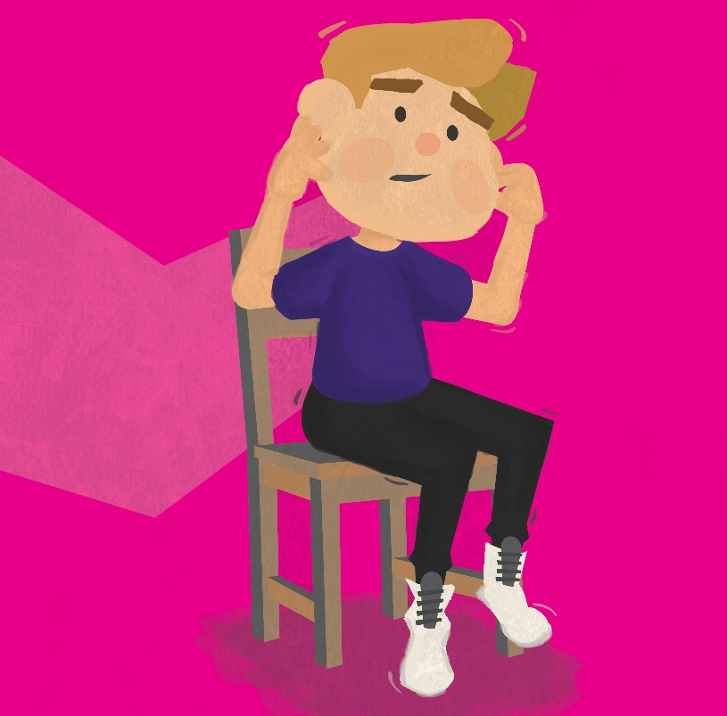
If you break the law you should not be punished in the same way as adults. You will be able to get legal help and should not be locked up unless it is absolutely necessary. You should not be tortured or treated in a cruel way.

Article 38
Protection in War

If you are under 15, you cannot be recruited into the army or take part in fighting in armed conflicts. During fighting, governments are required to protect civilian populations, particularly children who are affected.

Article 39
Recovery and Reintegration

If you have been a victim of abuse, neglect or exploitation, or of an armed conflict, you have the right to special support to help you recover.

Article 40
Children Who Break the Law

If you have been accused of committing a crime you have the right to be considered innocent until proven guilty, through proper legal procedures. These procedures should be properly adapted to reflect your individual needs as a child or young person.

Article 41
Best Law for Children Applies
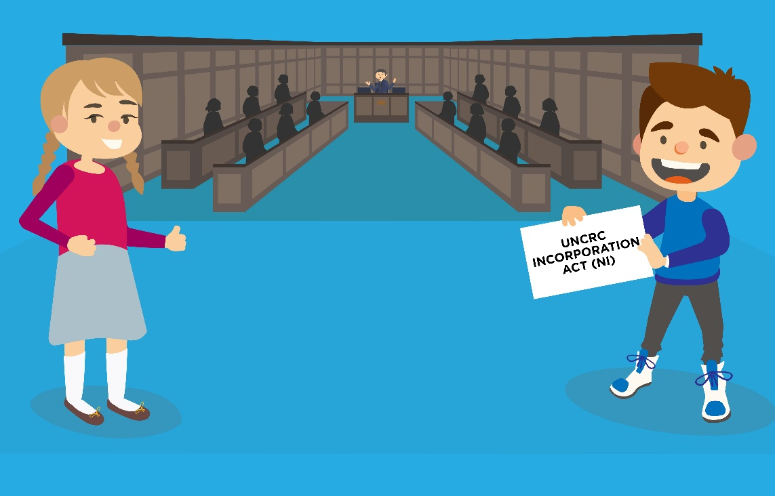

If your country’s own laws, or international laws give children more than the Convention requires, then your country should meet the higher standards in those laws.

Article 42
Everyone Must Know Children’s Rights
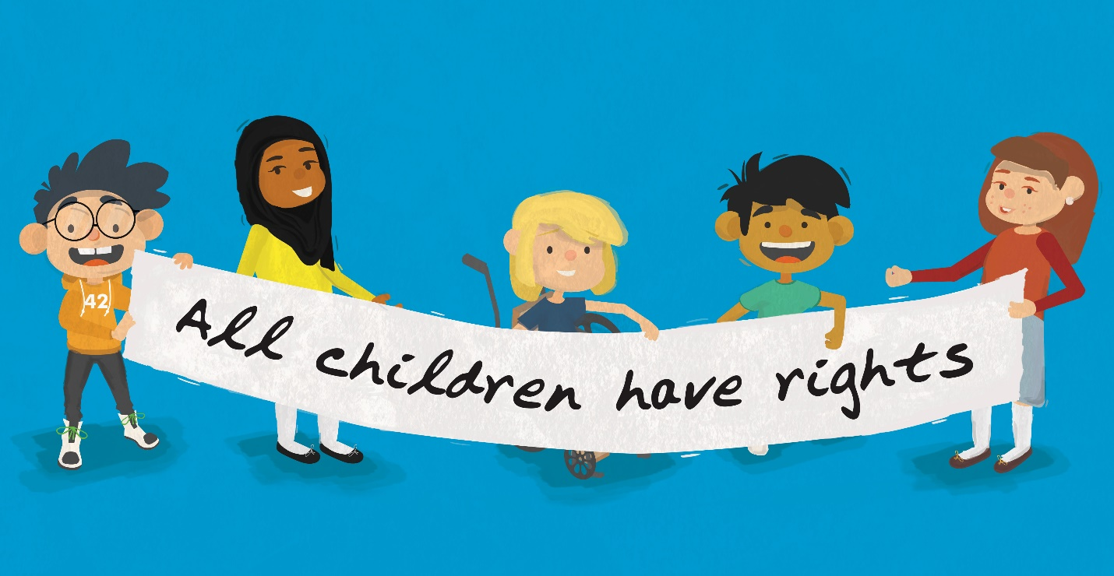

You have the right to know your rights. The Government must publicise the Convention to children, young people and adults throughout their country.

