NICCY Summary: NI Assembly Written Answers for Week Ending 21st March 2014

Goods, Facilities and Services Legislation

Strategic Policy Framework: E-Safety

Bright Start Strategic Framework for Childcare

Pupil Absence Rates

Children with English as an Additional Language

Auditor General’s Improving Pupil Attendance Follow-up Report

Auditor General: Absenteeism

Education Welfare Service: Absenteeism

Special Education: Spend

Children in Care: Further Education

Proposed MRI Scanner: The Royal Belfast Hospital for Sick Children

MRI Scanner: Royal Belfast Hospital for Sick Children

MRI Scanner: Royal Belfast Hospital for Sick Children

Welfare Reform: Householders in Negative Equity

Goods, Facilities and Services Legislation
Mr Lyttle asked the First Minister and deputy First Minister whether they have examined the legal opinion provided to the Northern Ireland Commissioner for Children and Young People by Robin Allen QC and Dee Masters BL regarding the Goods, Facilities and Services legislation.
(AQW 31540/11-15)

Mr P Robinson and Mr M McGuinness: The legal opinion has been considered in the Department. Junior Ministers have discussed aspects of the Opinion with the Equality Commission and the Commissioner for Children and Young People.

Back to Top

Strategic Policy Framework: E-Safety
Mrs Overend asked the First Minister and deputy First Minister, in light of their letter to the Minister of Health, Social Services and Public Safety asking him to draw up a strategic policy framework on e-safety, whether they hold the responsibility for co-ordinating such a cross-departmental strategy.
(AQW 31635/11-15)

Mr P Robinson and Mr M McGuinness: The development of an overarching, strategic and co-ordinated approach to e-safety is essential if we are to ensure our children can use the internet safely in all areas of their lives. We believe that while the issue of child internet safety impacts across a number of departments, the development of an Executive-wide approach needs to be informed by, and consistent with the principles and best practice which underpin the work which DHSSPS is taking forward on child protection overall. That is why Junior Ministers have written to the Minister of Health, Social Services and Public Safety asking him to take forward the co-ordination and development of a policy framework on e-safety as part of his responsibility for child protection. As we have indicated in our letter to Minister Poots, we will make the Delivering Social Change governance structures available to assist the development of such an approach.

Back to Top

Bright Start Strategic Framework for Childcare
Mr Lyttle asked the First Minister and deputy First Minister, in relation to the Bright Start Strategic Framework for Childcare, what consideration has been given to the capacity of the private sector to provide child care places in urban and rural areas of social disadvantage.
(AQW 31704/11-15)

Mr P Robinson and Mr M McGuinness: The capacity of the private sector to provide affordable childcare places in socially disadvantaged urban and rural areas was one of a number of factors considered during the development of the first phase of the Bright Start Strategy and its 15 Key First Actions. Several of the Key First Actions aim to address current market failure by creating affordable and accessible childcare services in areas where the present supply is insufficient. The performance of the Key First Actions will be kept under review over the coming months in close consultation with childcare stakeholders. This will help to inform the development of the full Bright Start Childcare
Strategy which we aim to publish towards the end of the year.

Back to Top

Pupil Absence Rates
Mr D McIlveen asked the Minister of Education what his Department is doing to improve pupil absence rates.
(AQW 31383/11-15)

Mr O’Dowd: My Department’s circular number 2013/13, Attendance Guidance and Absence Recording by Schools, which was issued to schools in June 2013 provides schools with good practice, guidance and strategies to manage pupil attendance.
My Department recommends that every school should have an attendance policy in place. Schools should refer pupils to the Education Welfare Service (EWS) for support, if appropriate, if their attendance falls below 85% or if there is a cause for concern.
Intervention by the EWS is tailored to the individual child following the assessment of their
circumstances including their needs, the parents/carer’s capacity to meet those needs and the family and environmental factors. Provision of advice and support, consideration of warnings or any onward referral is completely determined by the outcome of this assessment.
My Department also issued Attendance Matters - A Parent’s Guide to the parents and guardians of all Year 1 and Year 8 pupils last year. Response has been very positive and schools can download this from my Department’s website at www.deni.gov.uk

Back to Top

Children with English as an Additional Language
Mr Allister asked the Minister of Education what percentage of pupils in each constituency do not have English as their first language.
(AQW 31392/11-15)

Mr O’Dowd: The information requested is detailed in the table overleaf.
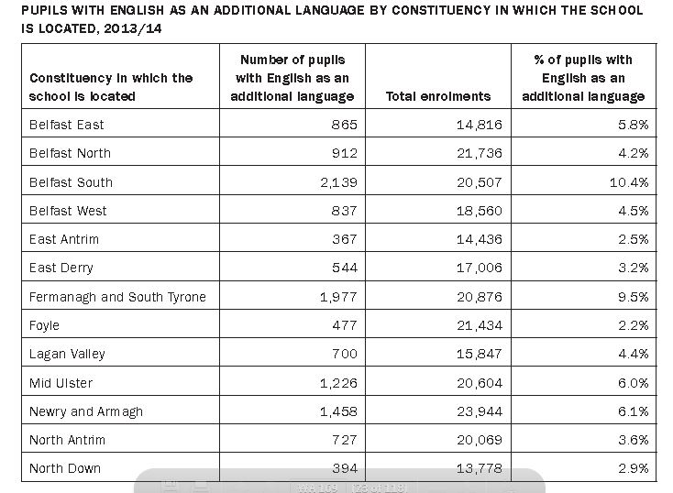

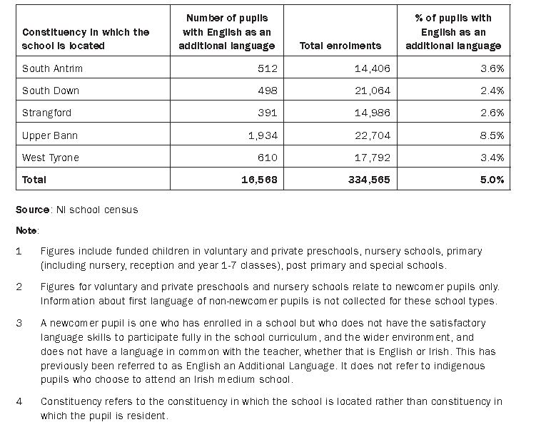

Back to Top

Auditor General’s Improving Pupil Attendance Follow-up Report
Mr Craig asked the Minister of Education, in light of the Auditor General’s Improving Pupil Attendance follow-up report that states that is unacceptable that the Education Welfare Service is discouraging schools from referring pupils who miss more than 15 per cent of school attendance, whether he plans to investigate this issue.
(AQW 31408/11-15)

Mr O’Dowd: The Northern Ireland Audit Office report Improving Pupil Attendance: follow-up report was published on 25 February 2014. I note the comments in relation to the Education Welfare Service discouraging schools from reporting pupils with greater than 15 per cent absenteeism. However, the Chief Executives of the five Education and Library Boards have provided assurances that this is not the case.

My Department’s Circular 2013/13, Attendance Guidance and Absence Recording by Schools, which was issued to schools in June 2013, advises that “where attendance difficulties exist or a pupil’s attendance falls below 85%, Education Welfare Service (EWS) will support staff and parents in developing and implementing strategies to address ore improve school attendance”.

Back to Top

Auditor General: Absenteeism
Mr Craig asked the Minister of Education for his assessment of the Auditor General’s concerns that the Education Welfare Service is discouraging schools from reporting pupils with greater than 15 per cent absenteeism; and what plans he has to encourage schools to report these pupils.
(AQW 31409/11-15)

Mr O’Dowd: The Northern Ireland Audit Office report Improving Pupil Attendance: follow-up report was published on 25 February 2014. I note the comments in relation to the Education Welfare Service discouraging schools from reporting pupils with greater than 15 per cent absenteeism. However, the Chief Executives of the five Education and Library Boards have provided assurances that this is not the case.

My Department’s Circular 2013/13, Attendance Guidance and Absence Recording by Schools, which was issued to schools in June 2013, advises that “where attendance difficulties exist or a pupil’s attendance falls below 85%, Education Welfare Service (EWS) will support staff and parents in developing and implementing strategies to address ore improve school attendance”.

Back to Top

Education Welfare Service: Absenteeism
Mr Craig asked the Minister of Education whether he has carried out a review into resourcing the Education Welfare Service to ensure that all referral cases of absenteeism are dealt with promptly.
(AQW 31410/11-15)

Mr O’Dowd: Resourcing of the Education and Welfare Service (EWS) is a matter for the Education and Library Boards (ELBs) themselves. My Department works closely with the EWS and if there are any pressures it is expected that the ELBs would bring the matter to the attention of officials.

Back to Top

Special Education: Spend
Mr Storey asked the Minister of Education how much has been spent in each Education and Library Board area on special education, in each of the last five years.
(AQW 31541/11-15)

Mr O’Dowd: The table below provides the total spent in each Education and Library Board on special education in each of the last five financial years.

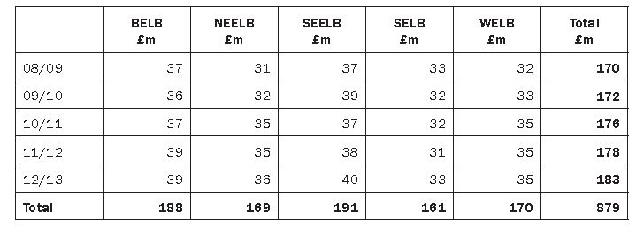

Back to Top

Children in Care: Further Education
Mr Agnew asked the Minister of Education how he is engaging in with the Minister for Employment and Learning to support children in care who are moving into further education.
(AQW 31735/11-15)

Mr O’Dowd: The joint Department of Education (DE) and Department for Employment and Learning (DEL) Preparing for Success Careers Strategy recognises the importance of enabling all young people, including children in care, to develop the skills to be able to make informed decisions about their education, training and employment options ensuring successful transition into education, training, or employment. The Strategy endorses a partnership model as the preferred model of provision. This means that careers teachers work in partnership with DEL’s careers advisers to offer advice to young people on making appropriate and informed choices on pathways that lead to higher or further education, training or employment. Schools enable learners to develop their knowledge and skills to manage their career development and make relevant informed choices.

Schools and the Careers Service have developed Partnership Agreements with over 98% of post primary schools detailing the range of services offered by the Careers Service to ensure that the appropriate level of external support is built into careers programmes and that pupils have access to impartial advice and guidance from the careers service at key transition points.

The policy lead for Looked after Children lies with the Department of Health, Social Services and Public Safety. Out of this policy the Care to Careers Regional Steering Group was formed to focus on promoting positive outcomes in education, training and employment for looked after and care experienced children and young people. My Department is represented on this Steering Group, which is co-chaired by DEL and the Health and Social Care Board.

Back to Top

Proposed MRI Scanner: The Royal Belfast Hospital for Sick Children
Mr McKinney asked the Minister of Health, Social Services and Public Safety to detail the preparatory work completed for the proposed MRI scanner for the The Royal Belfast Hospital for Sick Children.
(AQW 31749/11-15)

Mr Poots: Survey work and feasibility planning exercises have been carried out to gather the information which will inform the design process for the new MRI Unit. This included an asbestos survey to identify the requirements for asbestos removal.

Back to Top

MRI Scanner: Royal Belfast Hospital for Sick Children
Ms Maeve McLaughlin asked the Minister of Health, Social Services and Public Safety to detail the current situation with the MRI scanner at the Royal Belfast Hospital for Sick Children, including the timescales; and how much money has been invested in the private sector to provide this service.
(AQW 31899/11-15)

Mr Poots: It is planned to tender the contract for the construction of the MRI accommodation in June 2014 with commencement of work on site planned for August 2014. Completion of the MRI suite is expected at the end of March 2015. The Trust plans to make the MRI scanner operational immediately after handover.

The HSCB/Trust has confirmed that it secures MRI services in Belfast for the majority of patients from permanent funded capacity in the Belfast Trust. Where demand for services exceeds this capacity, as at present, the HSCB secures additional capacity through Belfast Trust from independent sector providers, pending the establishment of additional permanent capacity. Currently the additional activity includes private sector MRI scanners located at Musgrave Park and Mater Hospitals as part of a £2.5m initiative to improve waiting times in 2013/14.
Back to Top

MRI Scanner: Royal Belfast Hospital for Sick Children
Ms Maeve McLaughlin asked the Minister of Health, Social Services and Public Safety to outline the reasons for the delay in the operation of the MRI scanner at the Royal Belfast Hospital for Sick Children.
(AQW 31989/11-15)

Mr Poots: It is essential that all infrastructure works are undertaken in line with proper procedure whilst ensuring the safety of patients and staff. Prior to commencement of design and planned works on site, surveys had to be undertaken of the area in which the new machine is to be installed. These identified the need for additional works including the removal of asbestos as well as complex site service alterations. Completing these works, within the site of an operational hospital, presents significant challenges and required more time than planned to ensure that they are completed whilst ensuring the safety of everyone using the building. Back to Top

Welfare Reform: Householders in Negative Equity
Mr Copeland asked the Minister for Social Development how the implementation of the proposed Welfare Reform will impact upon householders in negative equity.
(AQW 31788/11-15)

Mr McCausland: Currently owner-occupiers on means-tested benefits may qualify for Support for Mortgage Interest (SMI) to help towards mortgage costs. Temporary changes to SMI were introduced from 5 January 2009. These changes reduced the qualifying period for support from 39 or 26 weeks to 13 weeks and increased the mortgage capital limit from £100,000 to £200,000. Those of working-age in receipt of Jobseekers Allowance will be entitled to SMI for a period of two years. The Chancellor announced within the Autumn Statement that the temporary changes to SMI have been extended until 2015 for working-age SMI claims. The waiting period will remain at 13 weeks and the
working-age capital limit will remain at £200,000 until 31 March 2015.

Under the proposed introduction of Universal Credit in Northern Ireland a zero earnings limit will apply with regard to SMI assistance. This means that a Universal Credit claimant who is an owner- occupier will not get any assistance with their mortgage payments, if they start working part-time. While, at first glance, the zero earnings limit might seem to be perverse logic with regard to incentivizing individuals to take up or increase part-time work, it is considered that the Universal Credit tapers and disregards will help ensure that no-one should be disadvantaged by the zero earnings rule. In particular, Universal Credit does not include a time limit on the period during which the claimant can claim for SMI assistance.

Back to Top

