NICCY Summary: NI Assembly Written Answers for Week Ending 4th April 2014

Play and Leisure Policy

Schools and Youth Services: Investment

Youth Training Review

Obesity Levels among Young People

Reductions in Legal Aid Budgets

Hydebank Wood Young Offenders Centre: Visit

Age Limit for the Use of Firearms

Fuel Poverty

Play and Leisure Policy
Mr Sheehan asked the First Minister and deputy First Minister for an update on the Play and Leisure Policy.
(AQO 5827/11-15)

Mr P Robinson and Mr M McGuinness: The Executive’s Play and Leisure Policy Statement published in 2009 has been delivered through the Play and Leisure Implementation Plan which runs until 2016. Delivery against the Plan is progressing well.
To further support the Implementation Plan and build on its achievements, Junior Ministers Bell and McCann announced on 8 October our agreement to invest up to £1.6 million over three years to enhance opportunities for play and leisure across Northern Ireland. This will be provided as a Signature Programme through the Delivering Social Change framework, details of which will be announced in summer 2014.

Back to Top

Schools and Youth Services: Investment
Mr Maskey asked the Minister of Education how much his Department has invested in schools and youth services since 2011.
(AQW 32228/11-15)

Mr O’Dowd: The amount of capital investment in schools and youth services since 2011 is follows:

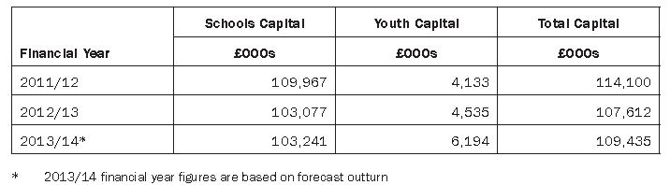

Back to Top

Youth Training Review
Mr Douglas asked the Minister for Employment and Learning for an update on the Review of Youth Training which was announced in February 2013.
(AQO 5884/11-15)

Dr Farry: The aim of the youth training review is to provide a programme at level two, of sufficient breadth and depth to enable young people between the ages of 16 and 18 to progress to an apprenticeship programme at level three, a level three further education programme, or into employment.

I announced the review of apprenticeships and youth training in February 2013. As you are aware, the review of apprenticeships published its interim report in January 2014, setting out a range of proposals for the future of apprenticeships. As the youth training review needs to take account of the impact of these recommendations, it has operated to a longer timescale. The review has progressed over the past few months, through both research and stakeholder engagement activities.

In terms of stakeholder engagement, I recently chaired a meeting of the review’s expert panel, to discuss findings and emerging issues to be addressed as part of the review. The Department also held a series of stakeholder engagement events to hear the views of employers, young people, and training providers. These events coincided with a call for submissions, which was hosted on the Department’s website.

Officials in the department have also carried out research, and engaged with experts in the OECD, to investigate models of best practice in the delivery of vocational education and training. Following the OECD’s recommendations, I recently visited the Netherlands. Key elements of best practice observed through the visit were the matching of training and qualifications to the needs of local employers, and the willingness of employers to integrate those on work placements into their wider business operations. The feedback from stakeholders will be combined with these research findings to inform the review’s interim report, which is due for publication in early Summer 2014.

Back to Top

Obesity Levels among Young People
Mr McKay asked the Minister of Health, Social Services and Public Safety to detail obesity levels among young people in each of the last five years.
(AQW 32260/11-15)

Mr Poots: The information is available from the Health Survey (NI) which has run from 2010/11 onwards.

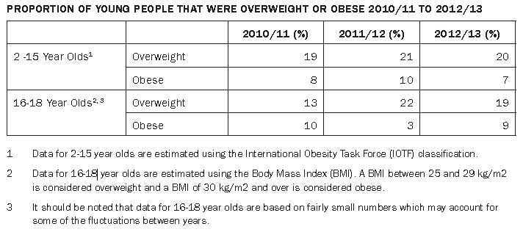

Back to Top

Reductions in Legal Aid Budgets
Mr Campbell asked the Minister of Justice how the policy of reducing the Legal Aid budget compares, in financial terms, with recently introduced changes to Legal Aid in Great Britain.
(AQW 32147/11-15)

Mr Ford: The Legal Aid landscape across Great Britain differs greatly and therefore it is not accurate to directly compare the reforms in Northern Ireland with the reforms elsewhere. In developing any reforms to legal aid in this jurisdiction my Department examines and benchmarks how legal aid is administered in England and Wales, in Scotland and in the Republic of Ireland. My officials engage with Departmental
colleagues across the jurisdictions and, where appropriate, we have tailored individual aspects of the reforms elsewhere to them to meet our specific needs.

The reforms I have introduced in relation to Criminal Legal Aid are already yielding savings in the region of £20 million per year. A further reform to Crown Court fees has been subject to consultation and may yield further savings of up to £5.6 million. Reforms to Civil Legal Aid will also deliver significant savings. The first of these changes, relating to the reform of publicly funded legal representation in the civil and family courts, will, when fully implemented, deliver savings of some £3.4 million per year.

I am committed to bringing legal aid spend within budget while ensuring that the money is targeted to ensure that the most vulnerable people in our society receive appropriate, cost effective, representation.

Back to Top

Hydebank Wood Young Offenders Centre: Visit
Mr Allister asked the Minister of Justice, pursuant to AQW 30659/11-15, to detail the outcome of the review.
(AQW 32158/11-15)

Mr Ford: The Governor of Hydebank Wood has completed his investigation into the circumstances relating to a proposed visit. This has resulted in one individual manager being given written advice. The Governor has also written to all of the establishment’s managers instructing that the specific approval of the Governor or Deputy Governor must be obtained before any offer is made to an individual or organisation to visit the establishment, or contribute to any prisoner activity.

Back to Top

Age Limit for the Use of Firearms
Mr Frew asked the Minister of Justice for an update on the proposed plan to lower the age limit for the use of firearms.
(AQW 32188/11-15)

Mr Ford: The proposal for an age limit of 12 years for the use of shotguns and certain airguns in particular circumstances is part of a package of changes on firearms on which I consulted. Agreement on all aspects of that package has not yet been reached.

Back to Top

Fuel Poverty
Mr B McCrea asked the Minister for Social Development, given that 42% of households across Northern Ireland are in fuel poverty, whether he or his Department have had any discussions on the Warm Home Discount Scheme with his counterparts in the rest of the United Kingdom.
(AQO 5902/11-15)

Mr McCausland: The Warm Homes Discount Scheme is a four-year scheme operating in Great Britain, which commenced in April 2011 and is scheduled to run to March 2015. The purpose of the scheme is to help low-income and vulnerable households with energy costs. The Scheme requires participating energy suppliers to give a rebate on their electricity bill to a specified group of their older customers on low incomes. The UK Government informs suppliers which households to support through sharing limited data between the Department for Work and Pensions and the energy suppliers.

The Warm Homes Discount Scheme is covered by legislation which does not apply in Northern Ireland. Responsibility for introducing any corresponding legislation in Northern Ireland would be a matter for the Department for Enterprise, Trade & Investment.

Back to Top

