NICCY Summary: Written Assembly Questions Friday 11th April 2014

Goods, Facilities and Services Legislation

Temporary or Time-Limited Statement of Special Educational Need

Pupils with Autism

Family High Court Judgment: Parental Alienation

Movement from Children’s to Adult Services

Consultation on Domestic and Sexual Violence

Fuel Poverty Scheme: Achieving Affordable Warmth

Goods, Facilities and Services Legislation
Mr Lyttle asked the First Minister and deputy First Minister what are the implications of the legal opinion provided to the Northern Ireland Commissioner for Children and Young People by Robin Allen QC and Dee Masters BL regarding Goods, Facilities and Services legislation.
(AQW 32660/11-15)

Mr P Robinson and Mr M McGuinness: The Equality Commission and NI Commissioner for Children and Young People used the legal advice to produce a joint policy paper to make the case for strengthening the rights of children and young people against unlawful age discrimination in the provision of goods, facilities and services. Junior Ministers met recently with the Commissioner for Children and Young People, the Chief Commissioner of the Equality Commission and Robin Allen QC to discuss the proposed extension of age discrimination legislation to the provision of goods, facilities and services. We are still considering the scope of the proposed age discrimination legislation.

Back to Top

Temporary or Time-Limited Statement of Special Educational Need
Mr P Ramsey asked the Minister of Education
- what provision is available for a temporary or timelimited statement of special educational need;
- the rationale for providing such a statement;
- how many children across each Education and Library Board area have such a statement; and
- for a breakdown of the specific reason for the temporary or time-limited statement by category.
(AQW 32238/11-15)

Mr O’Dowd: Neither special educational needs (SEN) legislation nor the Code of Practice on the Identification and Assessment of SEN make reference to either temporary or time-limited statements of SEN.

Back to Top

Pupils with Autism
Mr Hazzard asked the Minister of Education what measures his Department has taken since May 2007 to assist pupils with autism.
(AQW 32653/11-15)

Mr O’Dowd: The Department of Education (DE) remains committed to ensuring that all pupils, including those with autism, receive a high quality education that enables them to fulfil their full potential with special educational needs (SEN) provision matched to the individual needs of the child. A key factor in effectively meeting the needs of pupils with autism is ensuring that schools have the capacity to meet those needs. In this connection a key aim of the ongoing Review of SEN is to improve the capacity of schools to recognise and support children and young people’s SEN. This capacity building takes the form of a number of SEN pilot projects and the publication of a ResourceFile on SEN, developed by practitioners, which was issued to all schools in 2011. A chapter within the
Resource File is dedicated to autism and contains advice and practical materials to be used by school staff.

DE also continues to fund the Education and Library Boards’ (ELBs) inter-board autistic spectrum disorder (ASD) group to provide support to children on the autistic spectrum within each board. Each ELB’s ASD advisory service provides valued and worthwhile practical support to schools and is a resource of knowledge and skill, with the capacity to raise the standards of education and the social inclusion for children on the autistic spectrum. These ELB services are used to support children at Stages three to five of the Code of Practice on the Identification and Assessment of SEN.

Guidance materials also remain readily available to assist schools and parents in relation to autism, including:
- Autistic Spectrum Disorders – A Guide to Classroom Practice;
- Evaluating Provision for Autistic Spectrum Disorders in Schools.
In addition, the Autism Act (NI) 2011 places a duty upon the Department of Health, Social Services and Public Safety (DHSSPS) to act as the lead Department in producing, reviewing and implementing a cross-Departmental Autism Strategy. The Act also places a duty on DHSSPS to clearly detail how the needs of families and carers of children and young people with autism are to be addressed.
DE participated in the public consultation and continues to work closely with the ELBs and the Middletown Centre for Autism (MCA) in developing and delivering the DE actions contained in the Strategy. Opened in 2007 the MCA is an all-island Centre dedicated to providing educationally based support to children and young people with autism. It has recently expanded its provision of multi-disciplinary support on an outreach basis to those children referred to the Centre by the inter-board ASD Group. This support is delivered alongside a training and advisory service for educational professionals and parents of children with autism and a research and information service. The Centre’s service delivery was subject to a joint inspection in 2012 from the Education and Training Inspectorate and the Inspectorate in the south. This inspection described the quality of the service provision as “outstanding”.

Back to Top

Family High Court Judgment: Parental Alienation
Mr Swann asked the Minister of Health, Social Services and Public Safety how, and when, the Family High Court Judgment, made by Mrs Justice Parker in London on 23 December 2013 in relation to parental alienation and the consequential emotion abuse, will be conveyed to relevant officials in his Department and the Health and Social Care Trusts.
(AQW 30474/11-15)

Mr Poots (The Minister of Health, Social Services and Public Safety): In November 2010, the Department, jointly with the Department of Children and Youth Affairs in the Republic of Ireland, put in place an on-line child protection information Hub, the North South Child Protection Hub (NSCPH). The aim of the NSCPH is to make information readily available to, inter alia, front-line child protection practitioners, their managers, policy makers and researchers. The Hub includes relevant Court Judgments and my officials have been advised that the judgment issued by Justice Parker will be uploaded on to the Hub when published. This is one source of reference for such judgments; however there is an onus on professional social workers in the field of child care, like other professionals, to keep themselves as up-to-date as possible with practice developments in their field of expertise, which extends to the findings of the Family Courts. It should be noted that English judgments may not always translate seamlessly to Northern Ireland given that our legislative frameworks may be different.
Back to Top

Movement from Children’s to Adult Services
Mr McMullan asked the Minister of Health, Social Services and Public Safety for an update on the movement of services for children with a disability and special needs from children’s to adult services.
(AQW 32256/11-15)

Mr Poots: The current activity in relation to transition from HSC Children’s services to Adult services is outlined in the table below:

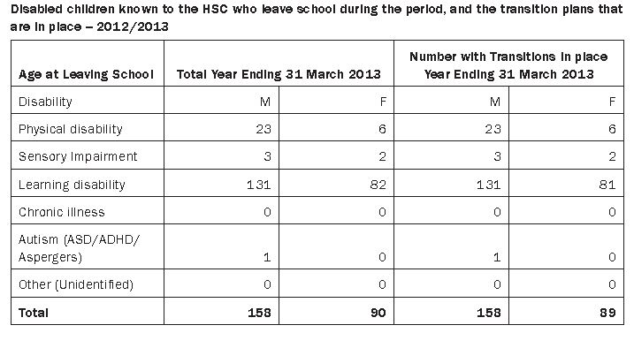
Back to Top

Consultation on Domestic and Sexual Violence
Ms Fearon asked the Minister of Justice whether he will publish a child friendly version of the consultation on Domestic and Sexual Violence to enable young people to have their input.
(AQW 32312/11-15)

Mr Ford (The Minister of Justice): As part of the public consultation on the draft strategy ‘Stopping Domestic and Sexual Violence and Abuse’ my Department has jointly with the Department of Health, Social Services and Public Safety developed and published a full strategy document and an easy access version of the document pitched at a reading age of eleven.

Justice and Health officials, with the assistance and support of members of the Regional Strategy Group, have engaged with ten groups in March who wish to respond to the document and have an interest or have been affected by Domestic and Sexual Violence and Abuse. With the help of the NSPCC and the Women’s Aid Federation two of the groups officials met with had membership between the ages of fourteen to eighteen years old.

Following the public consultation, our engagement with children and young people, and the feedback we receive from them, we plan to revise our strategy and develop a version suitable to the needs and requirements identified by this young readership. We remain committed to engaging with children and young people now and in the future on this very
important matter that affects many young people across Northern Ireland.

Back to Top

Fuel Poverty Scheme: Achieving Affordable Warmth
Mr Copeland asked the Minister for Social Development to detail the total number of households which will be taken out of Fuel Poverty should the proposals in the Affordable Warmth consultation be implemented.
(AQW 32598/11-15)

Mr McCausland: Fuel poverty is impacted by three factors, household income, cost of energy and energy efficiency of the home. According to the 2011 House Condition Survey the Fuel Poverty rate in Northern Ireland is 42%, a slight decrease from 44% in 2009. This is based on households needing to spend 10% or more of their income on household energy costs.

The 2013 Home Energy Conservation Progress Report noted that fuel poverty remains a major issue in Northern Ireland at 42% in 2011. The report noted that the problem remains primarily one of high fuel prices and low household income. However, energy efficiency works are playing their part in reducing its impact. The Fuel Poverty Strategy “Warmer Healthier Homes” resolved to work in partnership to improve the energy efficiency of low income households using a more targeted area based approach.

Research undertaken by Professor Christine Liddell (University of Ulster) in 2011 highlighted that 33,000 households need to spend 25% or more of their income on household energy.

My Department launched a Public Consultation exercise on 17 February 2014 on proposals for a new Affordable Warmth Scheme which will end on 9 May 2014. The proposed new Affordable Warmth Scheme will target this group of vulnerable householders who are in severe and extreme fuel poverty to make their homes more energy efficient and reduce their energy bills.

Back to Top

