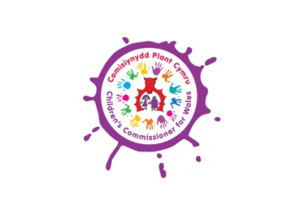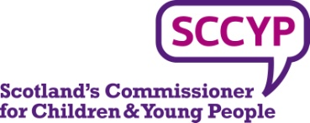

2 June 2015

**Memorandum to the Human Rights Committee prior to its examination of the UK’s seventh report under the International Protocol on Civil and Political Rights**

As the Commissioners for Children and Young People for Northern Ireland, Scotland and Wales, we are empowered to promote and protect the rights of children across the UK. We wish to draw to the attention of the Human Rights Committee, our deep concern regarding the position of the UK Government on equal protection for children from violence.

The UK Government was asked, in advance of its examination by the Human Rights Committee, to “report on measures taken to explicitly prohibit the corporal punishment of children in all settings, including in the home and alternative care settings, and repeal all relevant legal defences across the State party’s jurisdiction”[1]. We note that the UK Government’s response was: “The UK’s view is that a mild smack does not constitute violence and that parents should not be criminalised for giving a mild smack to their child…”[2].

In our view, the Government’s proposition that a mild smack “does not constitute violence” is untenable. Studies of children’s views show they find smacking painful and upsetting[3].  No government would argue that a mild smack by the carer of a vulnerable elderly person “did not constitute violence”. The Government’s concern that parents will be “criminalised” is equally unfounded.  Thresholds for criminal and civil interventions would not change and prosecutions of trivial assaults could only be pursued if they were in the public interest and the best interests of the child victim.

Our institutions are members of the European Network of Ombudspersons for Children (ENOC) which strongly supports the prohibition and elimination of all corporal punishment and other cruel or degrading punishment of children. In a position statement adopted in 2001, ENOC urged:

“As spokespeople for the children of Europe, we believe that eliminating violent and humiliating forms of discipline is a vital strategy for improving children’s status as people, and reducing child abuse and all other forms of violence in European societies. This is a long overdue reform, with huge potential for improving the quality of lives and family relationships. Hitting children is disrespectful and dangerous. Children deserve at least the same protection from violence that we as adults take for granted for ourselves”.

We commend these sentiments. Today, 46 states globally have achieved this iconic reform for their children (35 of them since 2001).

The UK Government has received repeated recommendations from the Committee on the Rights of the Child and other UN Treaty Bodies to fulfil its obligations and remove existing justification of violent punishment (the “reasonable punishment” defence in Wales and Northern Ireland and “justifiable assault” in Scotland)[4]. It has also received repeated recommendations to prohibit all corporal punishment in its UPR examinations in 2008 and 2012.

We are deeply concerned that the UK Government persists in defending these justifications for violence against children. Some support has been provided by successive governments in all four jurisdictions to promote positive, non-violent forms of discipline. But these educational efforts and effective child protection are undermined by the state of the law and the message it sends to children and adults of the acceptability of some forms of violent punishment.

**We hope the Human Rights Committee will add its voice to those of the other Treaty Bodies in recommending that all defences justifying physical punishment in Northern Ireland, Scotland and Wales should be removed with urgency.**



Tam Baillie

Scotland’s Commissioner for Children and Young People

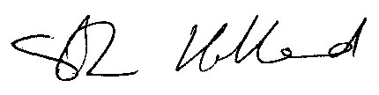

Professor Sally Holland

Children’s Commissioner for Wales

Koulla Yiasouma

Northern Ireland Commissioner for Children and Young People

1. Human Rights Committee, List of Issues for UK, 20 November 2014, CCPR/C/GBR/Q/7
2. Response to List of Issues from UK Government, 25 March 2015, CCPR/C/GBR/Q/7/Add.1, para. 161
3. C Willow and T Hyder   *It hurts you inside – children talking about smacking* (1998) National Children’s Bureau and Save the Children.  See also: E Cutting *It doesn’t sort anything: A report on the views of children and young people about the use of physical punishment* (2002) Save the Children, Scotland; G Horgan *It’s a hit, not a “smack”: A booklet about what children think about being hit or smacked by adults*  Save the Children Northern Ireland; A Crowley and C Vulliamy *Listen Up! Children Talk: About Smacking* Save the Children Wales.
4. Committee on the Rights of the Child: concluding observations on the UK’s initial report, 5 February 1995, CRC/C/15/Add.34; concluding observations on the UK’s second report, 9 October 2002, CRC/C/15.Add.188; concluding observations on the UK’s third and fourth reports, 3 October 2008, CRC/C/GBR/CO/4

   Committee on Economic, Social and Cultural Rights: concluding observations on the UK’s fourth report, 5 June 2002, E/C.12/1/Add.79; concluding observations on the UK’s fourth and fifth reports, 22 May 2009, E/C.12/GBR/CO/5

   Committee on the Elimination of Discrimination against Women: concluding observations on the UK’s fifth/sixth report, 18 July 2008, CEDAW/C/GBR/CO/6; concluding observations on the UK’s seventh report, 26 July 2013, CEDAW/C/GBR/CO/7

   Committee against Torture: concluding observations on the UK’s fifth report under the Convention against torture, 24 June 2013, CAT/C/GBR/CO/5