NICCY Summary: Written Assembly Questions week ending 27 March, 2020

Update on funding for integrated nursery provision
AQW 3590/17-22 | Mr Chris Lyttle  (APNI - East Belfast) | To ask the Minister of Education whether any existing shared and integrated education funding can be allocated to progress integrated education nursery provision.  Fresh Start funding has been made available to my Department specifically to increase the provision of shared and integrated education. 23 integrated schools will benefit from major capital investment projects through this funding. Additionally, executive funding is being used to progress a number of major capital investment projects at some integrated schools not included in the Fresh Start Programme.  Generally where a school currently includes nursery provision the nursery provision will be included in the major capital project. Since the announcement of the Fresh Start Programme in March 2016, capital funding has been identified for nursery schools on the following projects:  Millennium IPS  Mill Strand IPS  Phoenix IPS  Braidside IPS  Forge IPS  Portadown IPS  Omagh IPS  Corran IPS

Update on funding in the controlled sector
AQW 3502/17-22 | Mr Thomas Buchanan  (DUP - West Tyrone) | To ask the Minister of Education, pursuant to AQW 2406/17-22, (i) whether he agrees there is an element of discrimination against the controlled sector in that the capita per child is lower in both primary and post-primary than in any of the other sectors; and (ii) what proposals his Department has to address this, so that all schools are treated on a fair and adequate basis.  My response to AQW 2406/17-22 detailed the per pupil funding allocated to schools through the Common Funding Formula (CFF) for 2019-20. This was calculated using the total CFF allocation divided by the Full Time Equivalent pupil numbers for schools in the sectors requested.  The CFF is the Department’s mechanism for allocating budgets to schools funded through Local Management of Schools arrangements. A school’s CFF allocation will be determined by a combination of its overall enrolment, the differentiated needs of its pupils and the school’s characteristics. Therefore, schools with higher numbers of newcomer pupils or pupils with free school meal entitlement will attract additional funding regardless of sector. Similarly, smaller schools receive small schools support funding which increases the per capita funding of these schools, irrespective of sector.  Schools budgets, calculated through the CFF, are reflective of the individual circumstances of each school, and all schools are treated in a fair and adequate basis, regardless of sector.

Update on Family Parenting and Support Strategy
AQW 3464/17-22 | Ms Paula Bradshaw  (APNI - South Belfast) | To ask the Minister of Health for an update on the Family Parenting and Support Strategy, including when the consultation will take place.  The draft Strategy is currently being considered by other departments for their final views and input. It is intended to publicly consult on the draft strategy in the near future.

Update on cost of grammar schools administering Transfer tests
AQW 3448/17-22 | Mr Chris Lyttle  (APNI - East Belfast) | To ask the Minister of Education to detail the costs to grammar schools of administrating post-primary transfer tests and from what budget this cost is met.  My Department has no role in the operation or administration of the transfer tests used by selective post-primary schools nor does it provide specific funding to schools to administer these tests.  In 2016, my Department issued guidance using powers available to it under Article 16B of the Education (Northern Ireland) Order 1997. This provided that primary schools could supply support materials, carry out preparations for tests during core teaching hours, coach in exam technique and familiarise pupils with the test environment.  It is a matter for individual schools to decide whether and how to use the available guidance in line with the wishes of parents and the needs of pupils.

Update on use of C2K in Corona outbreak
AQW 3399/17-22 | Mr John Dallat  (SDLP - East Londonderry) | To ask the Minister of Education what plans his Department has to utilise the C2K network to deliver remote learning in the case of a significant coronavirus outbreak. [Priority Written]  The Education Authority is monitoring the situation in relation to COVID 19 very closely with the aim of mitigating day-to-day impact on schools and ensuring continuity of education delivery as much as possible.  In the event that school closures become necessary as part of a wider containment or delay phase, substantial capacity and provision exists via the EA Education Network service to facilitate teaching and learning outside of the classroom environment through digital and online platforms. Significant aspects of the current Education Network technologies operate online, whereby learners can access personal work areas, collaborate with their peers and teaching staff, and utilise curriculum resources based on an anytime, anywhere philosophy.  Besides the continuity of teaching and learning, schools also have a rich portfolio of communication tools at their disposal, to ensure the dissemination of critical notifications and alerts to parents, staff and other education related bodies should school closure be necessary.

Update on fees to attend post-primary schools
AQW 3364/17-22 | Mr Chris Lyttle  (APNI - East Belfast) | To ask the Minister of Education to detail the annual fees payable, voluntary or otherwise, for attendance at each post-primary school in Northern Ireland.  The Education Reform (NI) Order 1989 Article 128 (1) and (2) enshrines the right to a free education for pupils registered in grant-aided schools, with certain specific exceptions in relation to grammar schools.  Further information on the fees and charges that can and cannot be levied by boards of governors in respect of registered pupils at grant-aided schools and requests for voluntary contributions, is detailed in Chapter 19 of the Department’s Governor Guide, which can be accessed via the link below:  https://www.education-ni.gov.uk/publications/guide-governor-roles-and-responsibilities

Update on EOTAS provision
AQW 3307/17-22 | Ms Karen Mullan  (SF - Foyle) | To ask the Minister of Education for his assessment of the quality of education provision provided to young people who access Education Other Than at School (EOTAS) and to outline why there is no formal links with their previous school.  The assessment of the quality of education provision provided to young people who access Education Otherwise Than at School is formally completed through inspections carried out by the Education and Training Inspectorate who publish all their reports on https://www.etini.gov.uk/.  Internal processes are in place within EA to ensure that provision is planned, of a high standard and continuously reviewed.  Formal links with schools are encouraged and supported through a Partnership approach where a pupil remains enrolled at a mainstream school. For expelled pupils, there is no formal link with a school.

Update on number of children waiting for speech and language appointments
 | AQW 3297/17-22 | Ms Carál Ní Chuilín  (SF - North Belfast) | To ask the Minister of Health how may children and young people are waiting for speech and language appointments in each constituency.  Such appointments are not recorded on a constituency basis therefore the information requested could only be obtained at disproportionate cost. However, the number of children and young people waiting for an initial speech and language appointment in each Health and Social Care Trust is provided in the table below:  HSC Trust Children and young people waiting for an initial SLT appointment  Belfast 410  Northern 348  South Eastern 266  Southern 846  Western 519  Total 2389

Update on children reported to social services as suffering abuse
AQW 3281/17-22 | Mr Daniel McCrossan  (SDLP - West Tyrone) | To ask the Minister of Health to detail the number of children reported to social services as suffering abuse in each of the last five years.  When Social Services are notified of concerns that a child may be suffering abuse, it is recorded as a child protection referral. Abuse is categorised as neglect, physical abuse, sexual abuse, and emotional abuse. The number of child protection referrals is set out in Table 1.  Child protection figures are published both quarterly and annually on the DoH website https://www.health-ni.gov.uk/articles/child-protection-register .  Table 1: The number of Child Protection Referrals in Northern Ireland (2014/15 - 2019/20)  Number of Child Protection Referrals  2019/20* 2210*  2018/19 3139  2017/18 3407  2016/17** 4021  2015/16 4279  2014/15 4054  Sources:  “Children’s Social Care Statistics for Northern Ireland”, DoH  “Quarterly Child Protection statistics for Northern Ireland”, DoH  * The figure for 2019/20 covers only data for the first three quarters of the financial year.  ** New protocols for recording child protection referrals were introduced during 2017 in line with “Regional Agreement on the use of Electronic Recording for Referrals into Children’s Social Work Services – Northern Ireland Health and Social Care Trust – September 2017”. These may have contributed to a decrease in the number of recorded referrals.

Update on numbers of children education at home
AQW 3260/17-22 | Mr Alex Easton  (DUP - North Down) | To ask the Minister of Education how many children across Northern Ireland are currently educated at home.  As of 29 February 2020, there were 444 children and young people known to the Education Authority (EA) as being electively home educated. Please note that this figure is not the total number of home educated children in Northern Ireland, rather it is only those that the EA has been informed about through the de-registration process or because the EA has been asked for advice or support.  The actual number may be higher as parents are only required to notify the EA if their child has previously attended school or has a statement of special educational needs.  Parents may choose what they consider to be the most appropriate educational setting for their child and that can include being home schooled.

Update on DoH on patient data recording
 | AQW 3236/17-22 | Mr Mervyn Storey  (DUP - North Antrim) | To ask the Minister of Health whether his Department captures centralised, regional patient population data relating to (i) eating disorders; (ii) alcohol and drug-related brain injury; (iii) early years; (iv) intensive care; and (v) post-partum depression.  The Department of Health does not capture centralised, regional patient population data relating to any of the above per se, but has systems available to it to provide certain information with respect to hospital admissions for a full range of clinically coded health morbidities and has systems available to derive certain health-related early years information.  The Department’s Hospital Inpatient System (HIS) can provide the number of hospital admissions/ individuals hospitalised where an alcohol and drug-related brain injury was recorded. However, such information will not represent ‘population data’, as many individuals living with such a condition will be managed in a primary care setting and may not have been hospitalised within any given time frame examined. Diagnoses information in the primary care setting is largely unavailable. Additionally, hospitalisation data where an eating disorder or post-partum depression has been recorded will be more incomplete as the HIS does not cover hospitalisations within the Mental Health programme of care. Further information on such conditions may be available from individual Health & Social Care Trusts which will involve a trawl of their specific information systems.  Intensive care hospital episodes are not included in the Department’s HIS. However, information on Intensive Care, in terms of demand and capacity, may be available via systems available to the HSCB or from each of the Health & Social Care Trusts individually.  Health-related early years information for the whole child population is captured on the Child Health System by each individual Health & Social Care Trust. This information is submitted to a regional database, held within the Business Services Organisation’s data warehouse.

Update on prison population figures
AQW 3216/17-22 | Mr Doug Beattie MC  (UUP - Upper Bann) | To ask the Minister of Justice to detail the (i) male; (ii) female; and (iii) juvenile prison population for each of the last five years.  The average daily adult prison population, split by gender and the average daily population of children in custody for each of the last five financial years is outlined below.  Financial Year  2014/15 2015/16 2016/17 2017/18 2018/19  Adult Male 1,734 1,539 1,418 1,382 1,384  Adult Female 65 53 54 57 65  Children 34 25 22 21 18  Source: PRISM and Youth Justice Agency’s data management information system

Update on number of children in Woodlands JJC
AQW 3205/17-22 | Mr Gordon Dunne  (DUP - North Down) | To ask the Minister of Justice to detail the number of children and young people in the Wooodlands Juvenile Justice Centre, Bangor, in each of the last ten years.  The number of children and young people admitted to Woodlands Juvenile Justice Centre in each of the past ten years is as follows:-  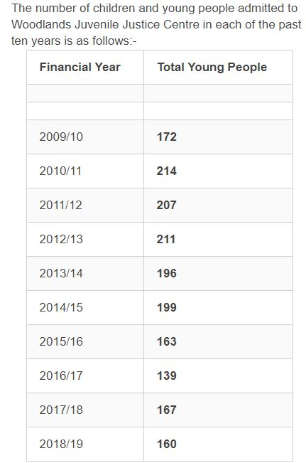  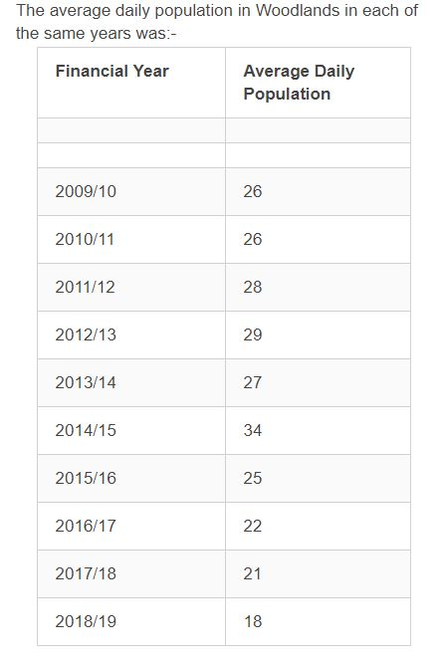

Update on respite services for under 18s
AQW 3115/17-22 | Ms Karen Mullan  (SF - Foyle) | To ask the Minister of Health to detail the range of short break overnight respite services for under 18 years, over and above family based short breaks; and how many allocated slots are available in each Health and Social Care Trust.  The number of respite beds available per Health and Social Care Trust for children are as follows:  Northern Health and Social Care Trust 10 beds  South Eastern Health and Social Care Trust 13 beds  Western Health and Social Care Trust 17 beds  Southern Health and Social Care Trust 12 beds  Belfast Health and Social Care Trust 10 beds*  * Belfast Trust has access to an additional 4 beds in a facility managed by the South Eastern Trust.

Update on early intervention strategy for mental health
AQW 2916/17-22 | Mrs Pam Cameron  (DUP - South Antrim) | To ask the Minister of Health how he intends to advance a prevention and early intervention strategy for mental health and ensure, through appropriate commissioning and funding, that access to evidence-based psychological approaches are available to meet mental health needs at all stages of a person’s life.  I have committed to developing a new, ten year Mental Health Strategy, which I will publish by the end of 2020. The Strategy will take a lifespan approach and will consider prevention and early intervention, as well as the future configuration of specialist mental health services, including psychological therapies. The Strategy will be co-produced and psychologists will be included in the co-production.

Update on process for schools to provide counselling services
AQW 1130/17-22 | Ms Joanne Bunting  (DUP - East Belfast) | To ask the Minister of Education to outline the process for schools to provide counselling services.  The Independent Counselling Service for Schools (ICSS) is accessible to all post primary aged pupils attending grant-aided post primary schools and special schools.  At any time pupils may need additional emotional support, beyond the normal pastoral care offered by teachers. They are able to self-refer or may be referred by school staff or a parent.  The ICSS is responsive to pupils’ needs, independent from and yet appropriately supportive of schools’ established pastoral care provision. Delivering an effective counselling service requires a collaborative and co-operative partnership. In the case of the ICSS, the key parties to this partnership are the School’s Senior Management Team, the counselling provider, the primary point of contact within the school staff (Key Contact for Counselling) and the counsellor.  ICSS is not available for primary school pupils. Schools can however independently select their own counselling provider, arrange for counselling and use their existing delegated budget to absorb any associated costs. They can also use funding from other sources, such as, the Extended Schools Initiative, the Big Lottery or Neighbourhood Renewal to purchase counselling support.

