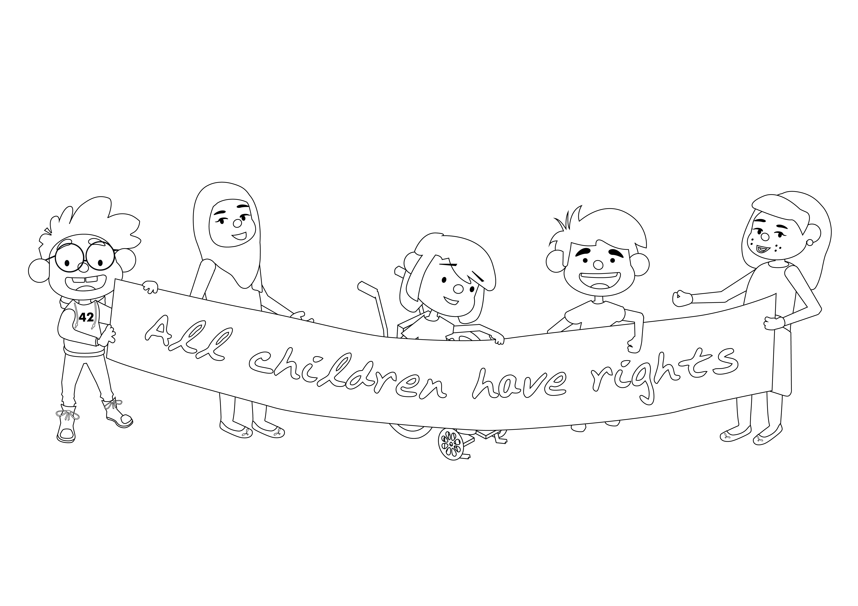



**United Nations Convention on the Rights of the Child (UNCRC)**

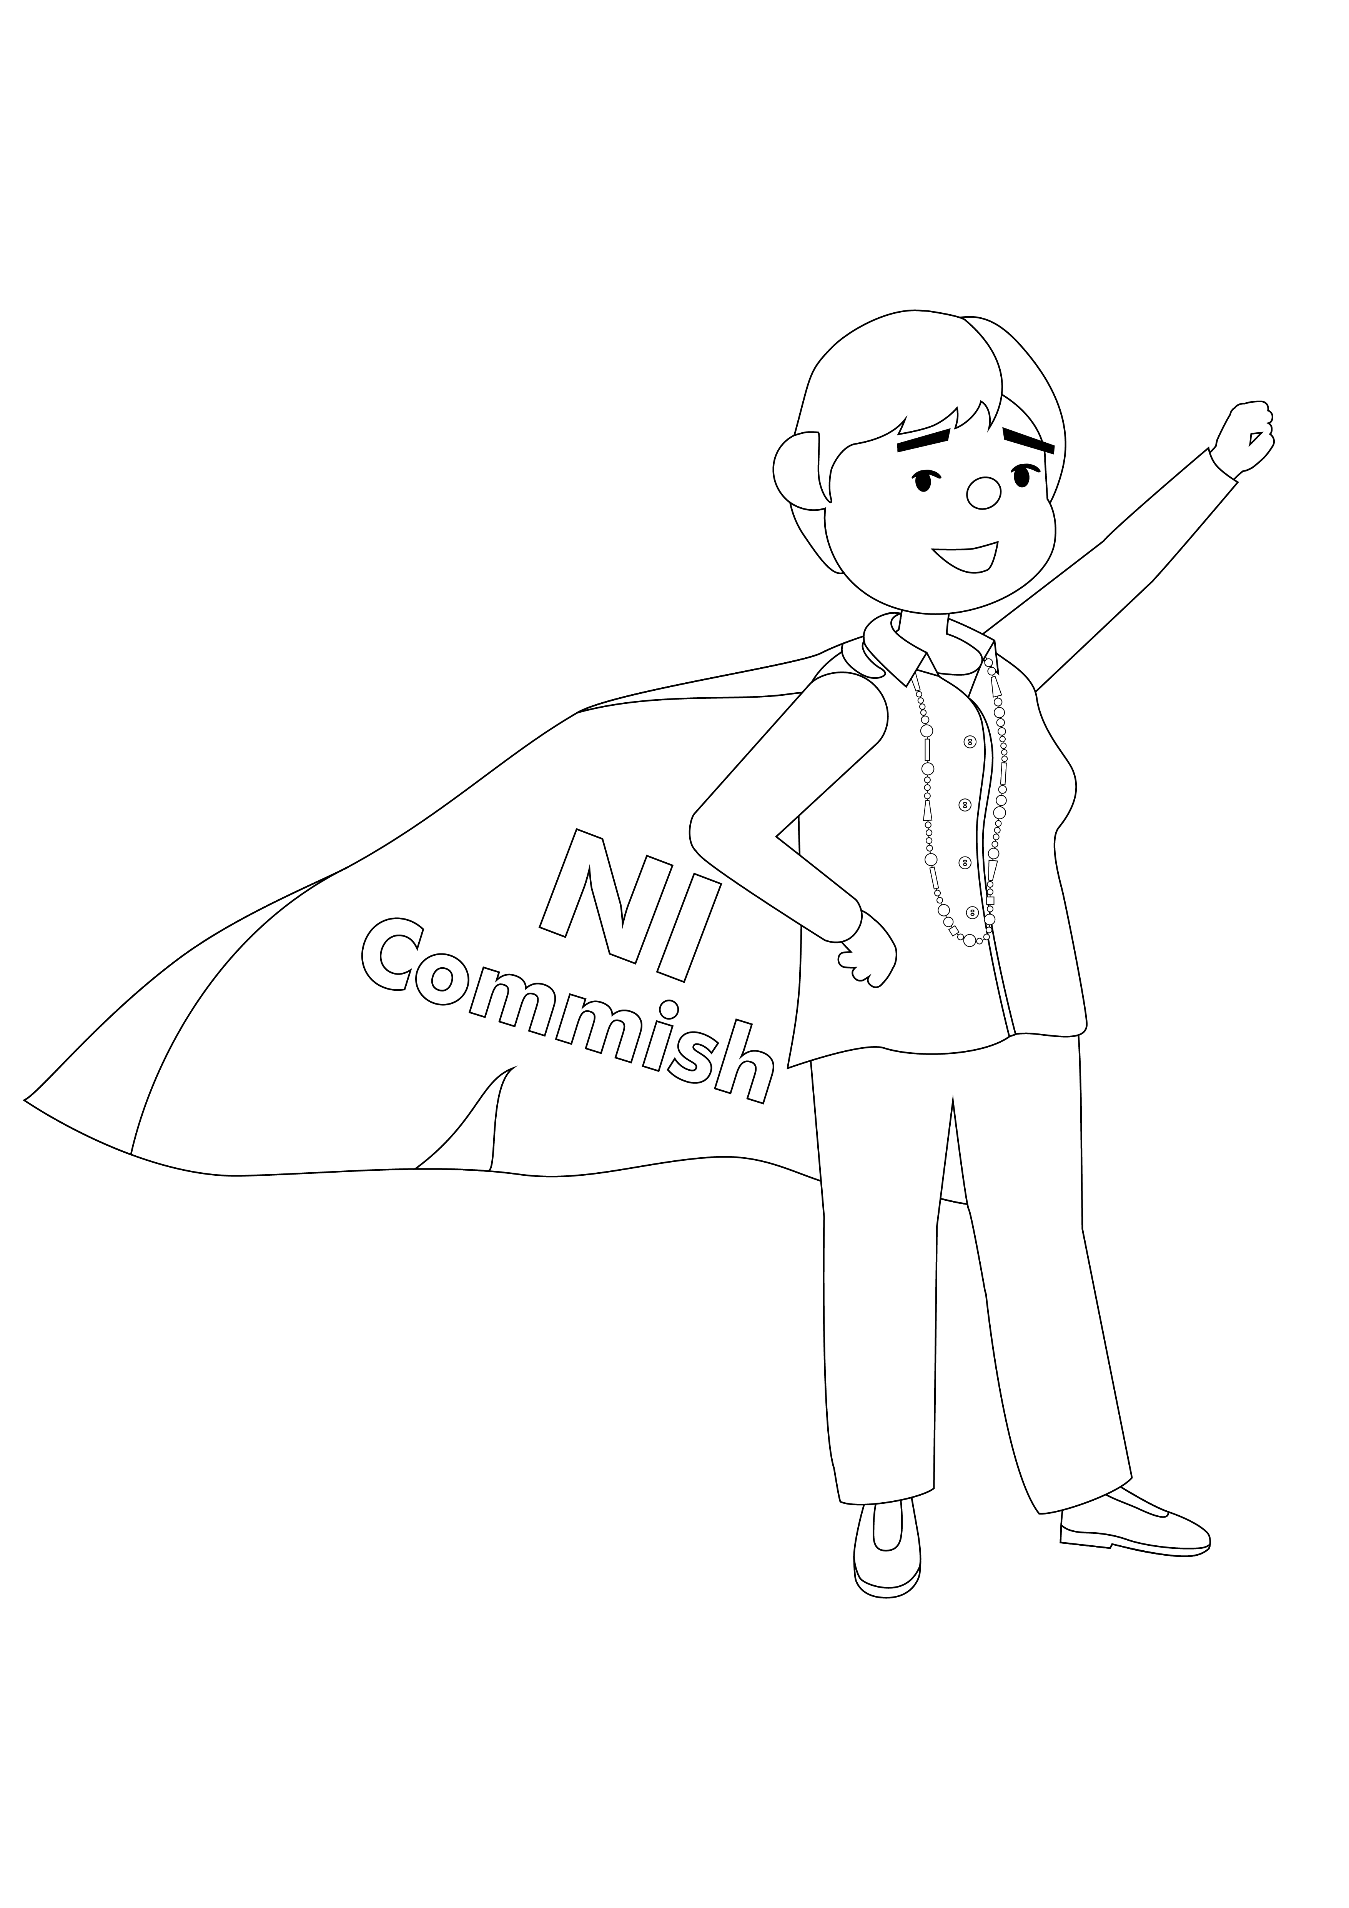Rights are promises made by the Government. Rights are about making sure you are treated well and get a fair deal.

Article 1 – **All children and young people have rights**. If you are under 18, the Convention applies to you.

**Northern Ireland Commissioner for Children and Young People**

Equality House,

7-9 Shaftesbury Square

Belfast.

BT2 7DP

T: 028 90311616

E: [info@niccy.org](mailto:info@niccy.org)

W: [www.niccy.org](http://www.niccy.org)

[Image result for twitter icon](http://www.bing.com/images/search?view=detailV2&ccid=VUA0Z6xu&id=5B2C0A7C5916018515D7E7AD655EC52F3949F17A&thid=OIP.VUA0Z6xuh2cQ4SvrGmYxqAEsDH&q=twitter+icon&simid=608033337607848497&selectedIndex=0&adlt=STRICT)@nichildcom - Follow us on Twitter

[facebook,logo,social,social network,sn](http://findicons.com/icon/220701/facebook)nichildrenscommissioner - Find us on Facebook

niccy_yp - Follow us on Instagram

**Find out more about your rights at** [**www.niccy.org**](http://www.niccy.org)

