NI Commissioner for
Children and Young People

CORPORATE PLAN
2020 – 2023

CONTENTS Page

Foreword: The Commissioner 3

Section:
- Who We Are and What We Do 5

- Statutory Duties 7
- Statutory Powers 8

- The New Corporate Strategy 9

- Context and Overview: Chief Executive 9
- PESTEL Analysis 11
- Our Sponsor Department 13
- Review of Performance 14

- Our Strategic Objectives 15

- Objective 1 - Ensure that Children’s and Young People’s rights are respected, promoted and protected in the work of all duty bearers 17
- Objective 2 – Highlight and address critical issues which adversely affect Children and Young People 19
- Objective 3 – Address breaches of Children’s and Young People’s rights 21
- Objective 4 – Raise awareness of Children’s and Young People's Rights, the UNCRC and the functions of the Commissioner 22
- Objective 5 – Promote the participation of Children and Young People in decision making processes 24
- Objective 6 – Ensure NICCY is an effective and efficient organisation 26

- Contact Details 31

FOREWORD

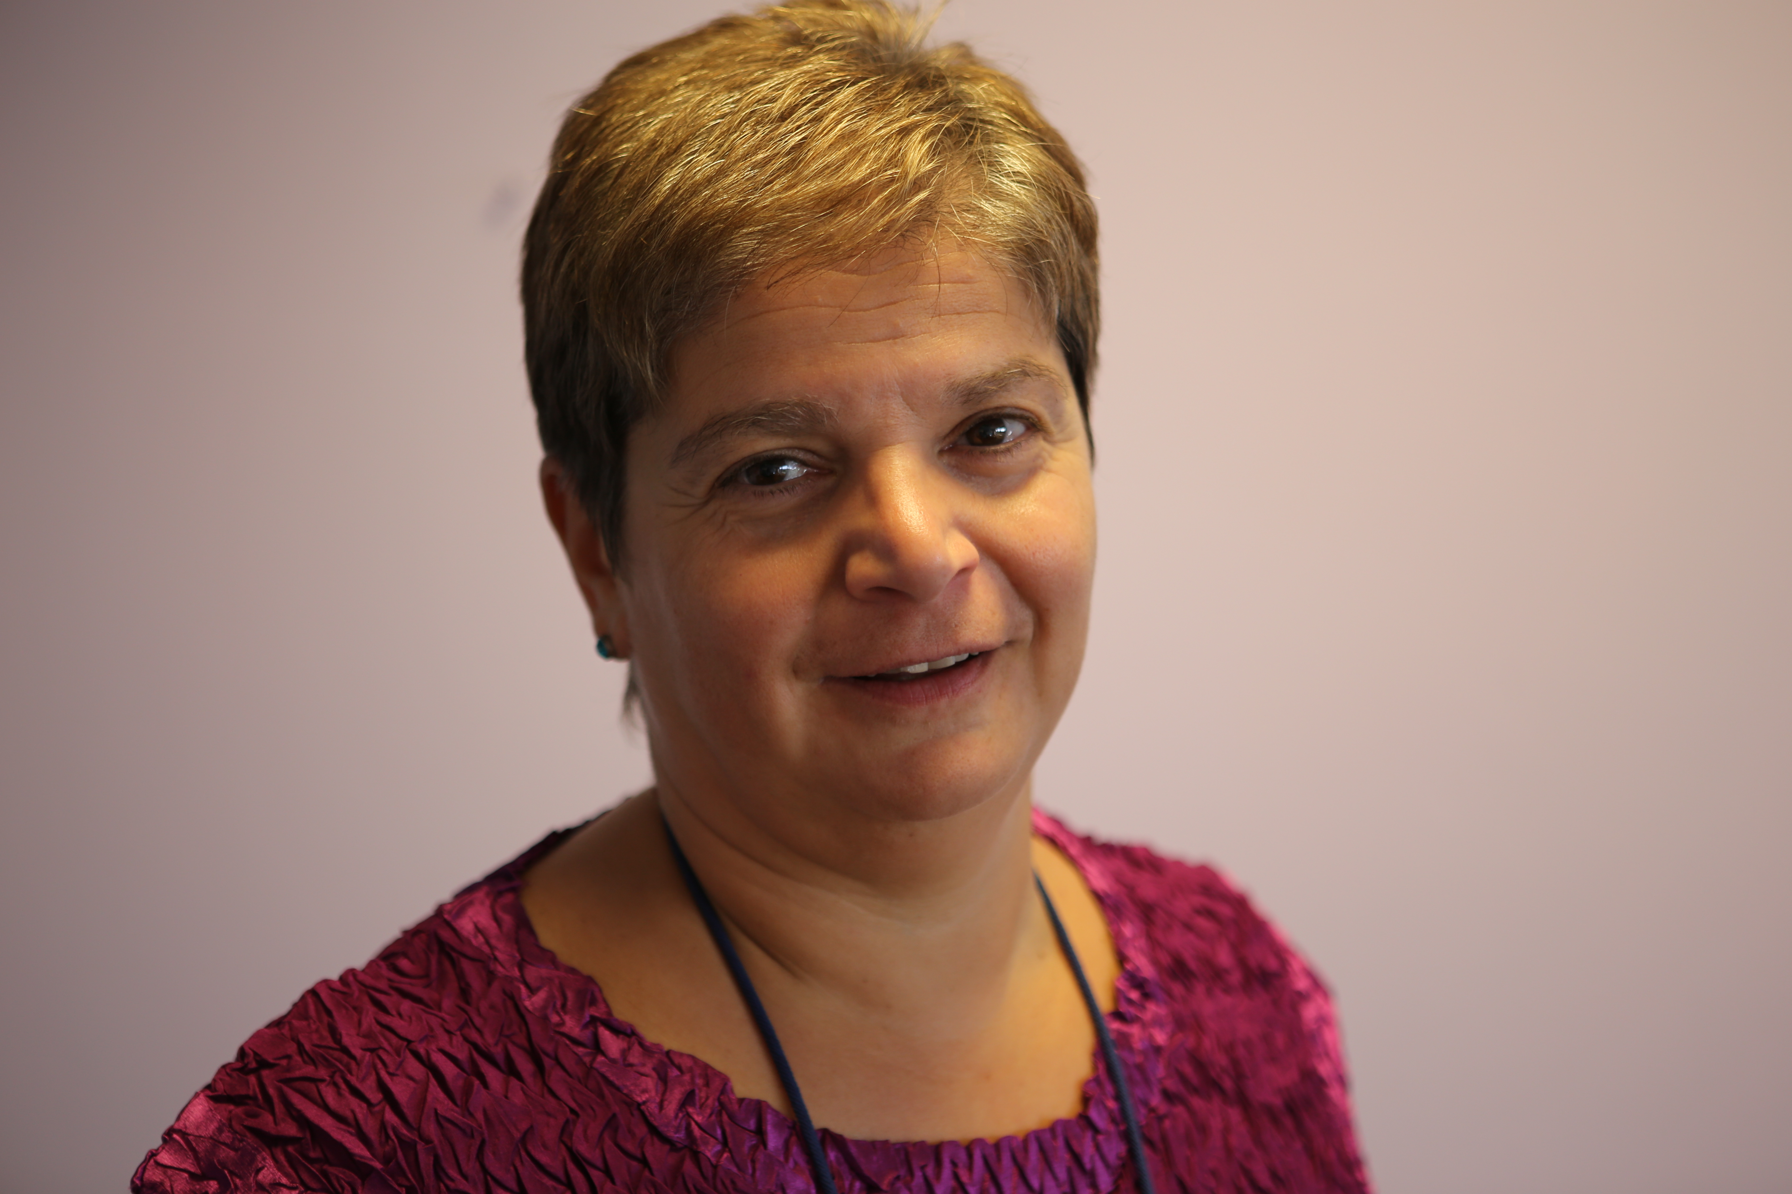
It’s hard to believe that I am now in my second term of office which will end at the beginning of March 2023 just as this Corporate Plan draws to a close.

This plan makes a number of assumptions which we have laid out and which are based on our considered assessment. However one of the biggest assumptions that I make is that we will soon have a process by which decisions are made that will progress rights for children and young people from across Northern Ireland and ensure that every child has the best start in life.

During the past four years we have worked on key priority areas and issued robust evidence based recommendations. These have been as a result of a lengthy process of making sure that we understand the experiences of those children, their parents and carers most affected, hearing from professionals working in a variety of settings, analysing available data, all within the framework of children’s rights.

It is important to us that NICCY’s work secures tangible and sustainable change which progresses the realisation of children’s rights. Therefore we anticipate that substantial resources and time in the next three years will be about supporting, monitoring and scrutinising the implementation of the key recommendations that I have issued up to March 2020. It is only by doing so that we will be able to provide clear evidence that our work is safeguarding and promoting the rights and best interests of children and young people. As you will see these processes will centre of monitoring the implementation of ‘Still Waiting’ – A Rights Based Review of Mental Health Services and Support, the Review of Special Educational Needs Provision Mainstream Schools, UN Committee on the Rights of the Child – Concluding Observations, 2016 and recommendations flowing from the Formal investigation (which will be published in 2020/21). Additionally we will also be monitoring a number of other processes.

We also undertake a series of core activities which ensure compliance with the duties and powers of the office as outlined in legislation such as ensuring children and young people know about their rights, addressing individual complaints and have voices and raising issues as and when they arise.

The above as outlined represents a significant amount of work for the next three years. However a variety of other issues have been brought to our attention either through our casework or as a result of representations made to the office. We have outlined some of them in this document such as the impact of the legacy of the conflict on today’s children and young people, homelessness and housing crisis and health waiting lists. This is by no means a comprehensive list but the issues that we consider most important and that we can make a positive contribution to.

The amount of additional work that NICCY can undertake will depend on the resource that we have as we face the same constraints as other public bodies.

I and the team at NICCY are looking forward to working with all our stakeholders in the time ahead.

Koulla Yiasouma
NI Commissioner for Children and Young People
1. WHO WE ARE AND WHAT WE DO

‘NICCY’ is the Independent Human Rights Institution (IHRI) established in 2003 under the ‘Commissioner for Children and Young People (Northern Ireland) Order 2003 to ‘safeguard and promote the rights and best interests of children and young people’. To do so, NICCY has a range of statutory duties and powers which are exercised in fulfilment of these.

The work of the Office is fundamentally guided by the United Nations Convention on the Rights of the Child (UNCRC) as well as relevant domestic, national and international legislation and conventions.

Our Mission

‘To safeguard and promote the rights and best interests of
children and young people’
[Art’ 6 (1)]

Our Vision

A Society where the rights of all children and young people
are respected and realised

The UNCRC General Principles (four) as per Articles 2, 3, 6 and 12 underpin that work. These relate to non-discrimination, best interests, survival and development and the voice of the child in the application of all UNCRC Rights.

Our Values

All of NICCY’s work is underpinned by our core values which we recently reviewed and updated. We apply these in our day to day work and seek outcomes based on their application and realisation.

- Children’s and Young People’s Rights are at the centre of all we do.

- We value and protect our independence.

- We respect and value people, promote inclusion and diversity, and challenge discrimination and inequality.

- We are open and honest and act with integrity.

- We are optimistic, striving to effect positive and lasting change.

NICCY’s Statutory Duties

Art 7(4) &(5) 2003 Order
Art 7(2) &(3) 2003 Order
Art 7(1), (5) (a) 2003 Order

NICCY’s Statutory Powers

Art 8 (2) & (6) 6)
Art 11, 12 & 14
Art 8(1) & (3) & (5)
2. THE NEW CORPORATE STRATEGY

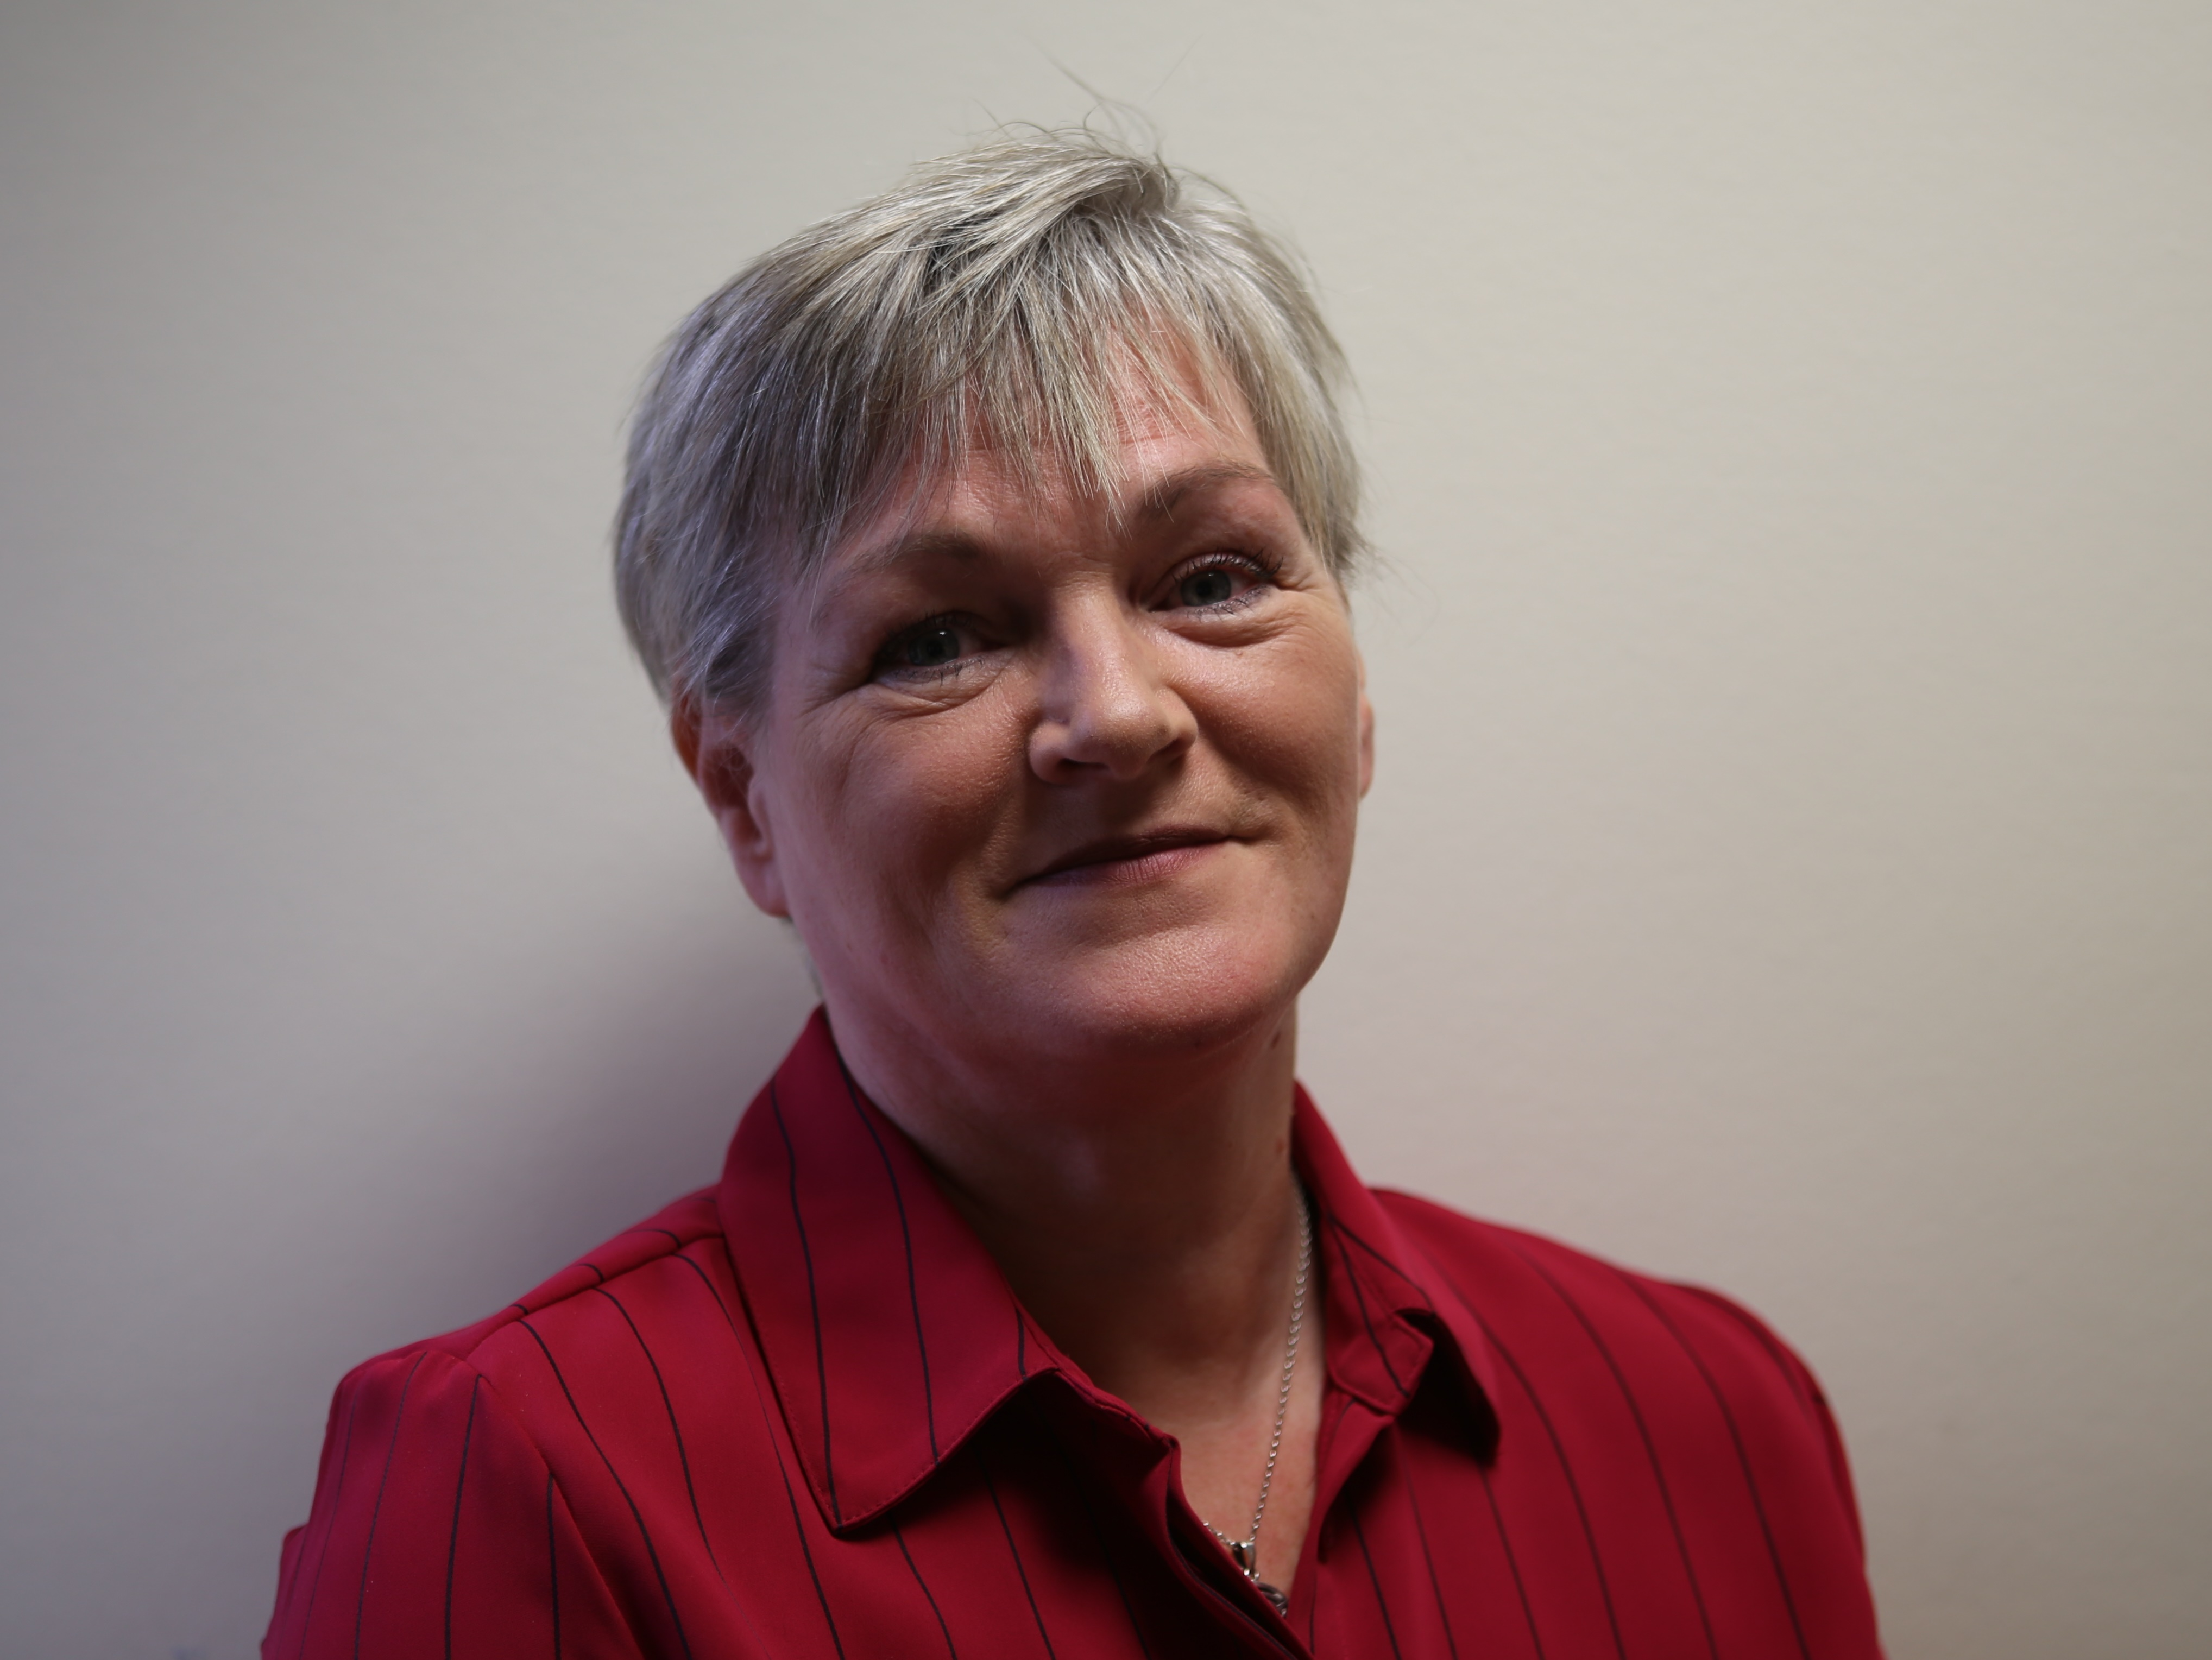
Context and Overview

Our 2020-‘23 Corporate Plan sets out our high level objectives for that period and builds on the achievements and progress of work carried out on the objectives identified in the previous plan. While the 3 year absence of a Northern Ireland Assembly and Executive has adversely impacted upon, and delayed progress on a range of relevant legislative, strategic and policy initiatives, we continued to engage with Political Parties, Government Departments and their Agencies, to address issues and move things on as/where possible in pursuing our principal aim. It is vital, now the NI Assembly is recently restored (January 2020), that we give immediate priority to the pressing issues identified and are even more vigilant in protecting and promoting the Rights of Children and Young People in Northern Ireland.

The current ‘environments’ (addressed in more detail in next section) within which NICCY operates, present us with growing challenges including increasing levels and complexities of complaints received, budgetary pressures, ongoing public sector reforms all compounded by the ‘unknowns’ (as yet) of the ‘Brexit’ transition period process. These are not underestimated and, like others, we have continued to monitor developments and respond accordingly. The ‘New Decade, New Approach’ Agreement sets out a range of key priorities for the NI Executive; we will work to address the issues facing children and young people here, mindful of that context in the remaining two year mandate.

NICCY has a duty to have due regard to the United Nations Convention on the Rights of the Child (UNCRC) which is the context for our work, while ensuring adherence/reference to relevant domestic, national and international legislation and human rights instruments. Part of our ongoing work involves monitoring progress on the implementation of the UNCRC Committee’s Concluding Observations (2016) and assessing the State’s compliance with Children’s Rights.

While we have set out our objectives in the following sections, we are as always, mindful of the need to retain ‘flexibility’, to react and respond to new and emerging developments and issues over which we maintain a ‘watching brief’, we will continue do so as and where appropriate and possible.

This triennial Corporate Plan is based on the working assumption that NICCY will receive adequate financial allocations and resources to deliver on the statutory duties of the Office and to exercise its powers in meeting these as/where necessary.

We will continue to monitor our delivery, performance and impact in implementing this Corporate Plan and subsequent Annual Business Plans as necessary, in safeguarding the Rights and Best Interests of our Children and Young People.

Mairéad McCafferty
Chief Executive

Political, Economic, Social, Technological, Environmental and Legal (PESTEL) Analysis

Political context
Despite the absence of an NI Assembly and Executive from January 2017 – January 2020 NICCY’s engagement with political parties continued. We progressed work on key priorities - issuing our first ‘Statement on Children’s Rights in NI’ in parallel with our Monitoring Table on the UNCRC Committee’s 2016 Concluding Observations. We had also obtained support from political parties on the implementation of our recommendations from ‘Still Waiting’ – our mental health review report launched in September 2017.

We welcome the restoration of the NI Assembly and Executive while recognising that their absence, delayed legislative implementation and the publication and implementation of key strategies including a Programme for Government (PfG) and the Executive’s 10 year ‘Children’s and Young People’s Strategy’ required under the Children’s Services Co-operation Act (2015).

In line with NICCY’s statutory duties we continue to keep under review the adequacy and effectiveness of law, practice and services as they impact upon children and young people and will maintain our positive working relationships with relevant political representatives, departmental officials and our wide range of stakeholders at Northern Ireland, UK and international levels, to address the key issues affecting children and young people.

We are mindful that this Corporate Plan will be delivered in a period of considerable political uncertainty and change – not least in the context of the recently restored NI Assembly and Executive, UK withdrawal from the EU i.e. ‘Brexit’ and transition period to December 2020. The full impact of ‘Brexit’ across a range of areas e.g. on rights, identity, family life, the border in Ireland, travel, transport, economy, availability of medicines, rural communities, security and policing are as yet ‘unknowns’. Northern Ireland as we know, remains in a particularly vulnerable position.

Economic context
During this period we will remain mindful of growing pressures on frontline children’s services. The ‘unknowns’ over the short and medium terms, from the economic effects of ‘Brexit’ and indeed global economic developments, will mean we have to retain flexibility to respond appropriately and change the priority areas of work in this Corporate Plan and our annual Business Plans. We will continue to monitor the impact of budgetary shortages and lack of necessary investment to effectively meet the needs of our most vulnerable children and young people in Northern Ireland.

We will liaise closely with our sponsor department DfC, to ensure the level of resource required is such that NICCY is ‘fit for purpose’ and enabled to deliver on our statutory duties. We are also open to identifying efficiencies and cost savings through closer collaboration and partnership working with others, as well as keeping under review the potential to share services. NICCY is also aware of a pending premises move in the coming few years as part of the rationalisation of the NICS estate.

Social context
The marginalisation of children and young people e.g. from economic and social disadvantage, underinvestment, poverty, sectarianism, racism, heterosexism and/or discrimination against those living with a disability are areas where NICCY will continue to work to reduce societal dysfunction where they arise. We will also collaborate with our partners in the various human rights and equality bodies here and externally, in support of the UN Committee’s Concluding Observations to promote understanding of how ‘rights based approaches’ can deliver effectively for children and society.

Technological context
Children and Young People increasingly ‘live their lives’ in the online world, while digital technological advances are welcome where they are of benefit, we must remain vigilant of potential dangers. The need for effective and appropriate regulation and oversight to protect our children and young people from exploitation, bullying, grooming and effects of EMRs while ensuring they can participate in enjoying / accessing information and technology is a key balance to be achieved. The annual conference theme (2019) of the European Network of Ombuds’ and Commissioners for Children (ENOC) reflected this – titled ‘Offline/Online: A Child’s World’, the areas of focus covered provision, protection, participation, education and regulation. The NI ‘Online Safety Strategy’ and other measures / mechanisms on this growing area will prove vital in the coming years.

Environmental context
NICCY like other NDPBs operates in a complex environment – much of which has been highlighted already. We remain aware of the various ‘environmental factors’ – financial, political, social, and indeed physical - which impact on our work and assess risk / ‘horizon scan’ on emerging issues accordingly. We will continue to ensure good practice in implementing effective controls within and across the organisation. NICCY is increasingly aware of the ongoing impacts to our physical environment locally and globally as a result of climate change - young people have also raised this with us, having been to the forefront of demands for action to address/redress these.

Legislative Context
The Commissioner’s statutory duties and powers (see earlier graphical representations) continue to be as set out in the 2003 Order including the requirement to have ‘due regard’ to the United Nations Convention on the Rights of the Child (UNCRC). Other key areas of legislation, policies and strategies as well as international recommendations such as the Concluding Observations / General Comments from the United Nations’ Committee on the Rights of the Child, which have an impact on the lives of children and young people within Northern Ireland, are kept under review as necessary.

The impact of potential legislative changes as a result of ‘Brexit’ as developments unfold, are as yet unknown; as stated earlier, NICCY is mindful of the need to retain flexibility to respond accordingly.

Our Sponsor Department – Department for Communities (DfC)
Sponsorship of NICCY rests with the Department for Communities; our relationship with DfC is set out in the Management Statement and Financial Memorandum (MSFM). Periodic meetings are held between NICCY and DfC as an accountability mechanism and include oversight of governance arrangements. The MSFM is due to be replaced with a ‘Partnership Agreement’ - progress on which is ongoing; this is to be adapted to suit the ‘corporate sole’ model of NDPBs such as NICCY.

NICCY’s remit also includes monitoring the Department’s work - in line with our legislative remit and functions – given the range of areas under the Department’s remit which impact upon children’s and young people’s lives and outcomes.

Review of the Office of the NI Commissioner for Children and Young People
NICCY’s sponsor department as required, carried out a review of the Office shortly after taking over sponsorship responsibilities. During the 3 year period following the collapse of the NI Assembly and Executive, there was no Minister in post and subsequently no actions were progressed in respect of the recommendations. It is anticipated this can now be progressed.
Review of the Legislation: Commissioner for Children and Young People Order (NI) 2003.

Since last Corporate Plan, NICCY has reviewed and updated the ‘Article 24 Report’ and re-submitted this to DfC in March 2019. NICCY was informed that as there was no Minister in post, this could not be progressed until the NI Assembly and Executive resumed.

- Report to Department for Communities under Article 24 of the Commissioner for Children and Young People (NI) Order (2003) - NICCY (March 2019); and

- Report to the Office of the First and Deputy First Ministers Under Article 24 of the Commissioner For Children And Young People (NI) Order (2003) – NICCY (April 2015).

Now that the NI Assembly and Executive are restored, it is hoped the recommendations from the Reviews can now be progressed and implemented.

Review of Performance
Over the past 3 years (2017-’20) NICCY has focused on delivering the corporate and business objectives set for the period. This period has also seen an increase in the ‘reactive work’ also necessitated as/when representation is made to the Office on issues which NICCY has also addressed.

A full review of our overall performance during each of these years, as well as our annual accounts, can be found in successive Annual Reports. These can be accessed here on our website. The range of legal complaints and casework, policy, research and participation reports and papers, monitoring and advice provided to Government Departments and Agencies are also to be found on our website.
- OUR STRATEGIC OBJECTIVES

There are a wide range of issues adversely impacting children’s and young people’s rights in Northern Ireland; NICCY has identified key priority areas. These largely reflect the same areas that were contained in our previous Corporate Plan, and have been informed by reviewing the relevant evidence, including the complaints raised with the Office each year by children and young people, their parents and carers. We have also taken cognisance of the UN Committee’s Concluding Observations and have engaged directly with children and young people in identifying the most persistent and egregious breaches of their rights requiring government action.

Given the extensive work carried out to formulate these last time, with a wide range of stakeholders – most importantly with children and young people – and recognising that while work relating to specific areas under each objective will differ or reflect progression from that already achieved, they nonetheless relate back to our core remit and functions so will remain as stated.

We will build on our work to date and continue to:

Objective 1:
Ensure that Children’s and Young People’s rights are respected, promoted and protected in the work of all duty bearers.

Objective 2:
Highlight and address critical issues which adversely affect Children and Young People.

Objective 3:
Address breaches of Children’s and Young People’s rights.

Objective 4:
Raise awareness of Children’s and Young People's Rights, the UNCRC and the functions of the Commissioner.

Objective 5:
Promote the participation of Children and Young People in decision making processes.

Objective 6:
Ensure NICCY is an effective and efficient organisation.
1. Ensure that Children’s and Young People’s Rights are respected, promoted and protected in the work of all Duty Bearers.

The UN Committee’s General Comment 5 sets out the general measures of implementation (GMIs) of the Convention on the Rights of the Child. NICCY’s role involves monitoring these and ultimately aims to have the UNCRC incorporated ‘domestically’ to ensure Government and its Agencies respect, promote and protect the rights of children and young people in their work.

The UN Committee on the Rights of the Child has also provided considerable advice on how Government delivers in a child rights compliant manner. While this is particularly critical in relation to work targeted at children, consideration of children’s rights should, from the outset, inform the development and implementation of relevant policies, services and legislation.

NICCY will work to influence Government and its Agencies to more effectively deliver in compliance with children’s rights, promoting respect for same at all levels – locally, nationally and internationally. We will deliver on a range of activities engaging with the Northern Ireland Executive and Assembly, at Westminster, through the British and Irish Network of Children’s Commissioners, through our European networks and at the UN level. We will also be developing our ‘Statement on Children’s Rights in N. Ireland’ publication during this corporate plan period

NICCY will achieve this through monitoring, advising and where necessary, holding Duty Bearers to account regarding inter-related processes:

- Statement on Children’s Rights in NI
In June 2018 NICCY issued its first ‘Statement on Children’s Rights in NI’ (SOCRNI) in parallel with our ‘UN Concluding Observations Monitoring Table’. ‘SOCRNI” focused on the identified key priorities of the Office including as stated earlier, incorporation of the UNCRC locally (i.e. in NI). The ‘Statement’ is a biennial publication and will be next issued in 2020 alongside NICCY’s UNCRC Committee’s Concluding Observations Monitoring Table;

- UN Committee on the Rights of the Child: 2016 Concluding Observations
In May 2016 a total of 156 recommendations were issued, 131 of which fall to the NI Executive to deliver in relation to children in Northern Ireland. In June 2018 NICCY issued its first ‘Monitoring Table’ of NI Departments’ progress on implementation of the Concluding Observations. This biennial publication is due to be next issued in 2020;

- UNCRC Alternative Report
NICCY will submit input to the ‘Shadow Report’ for the next periodic examination by the UN Committee on the Rights of the Child. The List of Issues is a joint report with colleague Children’s Commissioners in England, Scotland, Wales and Jersey;

- Implementation of NICCY’s Article 24 Report
Following two external Reviews of NICCY’s Legislation, this latest iteration of our Articl 24 Report is necessary to follow through on the general measures of implementation under Article 4 of UNCRC and General Comment 5;

- Children’s Services Co-operation Act 2015
This ground-breaking legislation places statutory duties on all departments and agencies to work together to deliver improved outcomes in children’s well-being - as defined by the Act and in reference to the UNCRC; NICCY will scrutinise the effectiveness of the implementation of Act;

- Children’s and Young People’s Strategy
This is the overarching mechanism for co-ordinating delivery across all statutory departments and agencies on the duties contained in the Children’s Services Co-operation Act 2015; and as such is viewed as the ‘national action plan for children’ as iterated in General Comment 5; NICCY will monitor its implementation;

- Implications of UK withdrawal from the EU (‘Brexit’) for Children’s Rights
‘Brexit’ will have significant implications for the realisation of children’s rights here, so we will work to ensure that those responsible for implementation and monitoring rights and equality compliance are aware of these, and that they protect children from any ‘diminution of rights’ or detrimental impacts. This will be a cross-cutting focus across all our work in this period and may require review of business plan targets; and

- Child Rights Impact Assessments (CRIAs)
Article 4 of the UNCRC requires all Governments to conduct impact assessments on all legislation, policies and strategiesand services to determine their impact on the realisation of children’s rights. We will work through the European Network of Ombudsmen for Children (ENOC) in drafting a Position Statement including Calls on CRIAs and will advise relevant authorities in Northern Ireland on their production.

- Highlight and address critical issues which adversely affect Children and Young People.
Over the past three years we have provided advice and challenge to government departments in relation to the following key areas, however, there had not been an NI Executive in place. Given this, and the protracted nature of these issues, it is important that we continue to address these issues, to ensure that there is an adequate response to the evidence and advice. Therefore in this Corporate Plan we will build on and develop our work by following up on the advice already provided, and drawing on our statutory powers to maximise the impact of our work. This work will also be underpinned by the principles of prevention and early intervention; supporting government to identify and provide effective early support to all children and young people, particularly those who are at risk of poor outcomes.

We will focus our proactive work and advice to government on the following key areas:

- Tackling Child Poverty: we will continue to work with others raise awareness of the economic and social rights of children, and focus on advising government on actions to lift families on low income out of poverty, including strengthening social security provisions e.g. in relation to Welfare Reform mitigations. We will develop an updated policy position on child poverty in Northern Ireland, and advise government on the development and implementation of an Anti-Poverty Strategy;
- Improving Mental Health and Wellbeing: our ‘Still Waiting’ Report launched in September 2018, made 50 recommendations regarding the changes required to improve the adequacy and effectiveness of services to support the mental health of children and young people. We will continue to work with statutory and other agencies to ensure that they are implemented and achieve improvements in mental health outcomes for children including provision of counselling in primary schools;
- Overcoming Educational Inequalities and Promoting Inclusion: to ensure that the right to an effective education is realised for all children and young people, particularly those at risk of underachieving. This includes looked after children; Roma and Traveller children; newcomer children; children with a disability, children with additional needs, children from disadvantaged backgrounds, and those entitled to free school meals. We will focus on two areas:
  - Overseeing the monitoring and implementation of our Review of SEN provision (publication 2020), to ensure that children with special educational needs are provided with the support and services they need so that their personality, talents and abilities are developed to the full; and
  - On the requirements for transformational reform of the education system with a focus on securing greater efficiency in delivery costs, raising standards, access to the curriculum for all pupils, and the prospects of moving towards a single education system, in line with the priorities identified under the ‘New Decade, New Approach’ Agreement.
- Addressing the Legacy of the Conflict: We will focus on three areas:
(a). Addressing coercive control, abuse and exploitation of children and young people by criminal gangs;
(b). Continuing to advise relevant authorities/bodies on matters relating to the Legacy of the Conflict; and
(c) advising government on respecting the right of children and young people to participate fully in the cultural and artistic life of their communities, protecting their right to celebrate their identity in a positive and safe manner.
- Challenging Discrimination: we will continue to use our powers to provide robust challenge to ensure children and young people do not experience discrimination in relation to the provision of goods, facilities or services and to ensure that equal protection against assault applies to them as it does to adults.
- Strengthening Safeguarding Provisions: we will monitor the statutory mechanisms in place to safeguard children and young people e.g. in relation to child sexual exploitation and the implementation of the findings of the Review of Serious Sexual Offences, the development of a NI specific ‘Barnahus’ (Child House) Model; and the use of restraint and seclusion.
- Addressing Issues in Youth Justice: we will monitor, advise and challenge government on the implementation of outstanding recommendations (Youth Justice Review 2011), those from the UNCRC Committee’s Concluding Observations; on the application of the ‘Best Interests’ principle across the youth justice system; we will advise and challenge government to raise the minimum age of criminal responsibility in accordance with acceptable international standards; we will continue our focus on ‘Stop and Search’ and on removing the JJC as a ‘place of safety’.
- Homelessness: It is stated that in NI 15,000 children are experiencing housing insecurity. We will focus on the issues facing families and children) by:
  - Addressing the reality of the lives of families and children experiencing housing insecurity;
  - An examination of processes in relation to 16 and 17 year olds; and
  - Addressing the numbers and causes of 18 – 21 year old Care Leavers and young people with a disability, who are homeless and rough sleeping.
- Migrant / Trafficked Children, Children Subject to Immigration Control and Newcomer Children: we recognise that many children who have come to live in Northern Ireland may have particular vulnerabilities that result in their marginalisation, victimisation and/or exploitation. Therefore they require our particular focus and support of the Office to ensure their rights are safeguarded and promoted;
- Health Waiting Lists: NI has the highest waiting times of any jurisdiction in the UK however, there are even more concerning figures for children’s health services e.g. waiting times for paediatric cardiology appointments in some Trusts are 149 weeks and 213 weeks for paediatric general surgery. We will explore the impact of this on the lives of children and provide recommendations to government on addressing waiting lists; and
- Children’s Rights and the Environment: At the 2016 Day of General Discussion on children’s rights and the environment, the key finding was that any matter relating to the environment must be considered through the lens of children’s rights. Over subsequent years, environmental issues (including climate change, resource depletion, pollution, protecting natural spaces and wildlife) have come to take centre stage, but the connection with children’s rights remains unexplored. We will support a youth led initiative to explore the child rights implications of environmental matters, engaging a wide range of children and young people and supporting them to promote their calls.

- Address breaches of Children’s and Young People’s Rights.

The 2003 Order confers a range of powers upon the Commissioner. These powers are the ‘tools’ which enable the Commissioner to fulfil her duties.

They include the power to assist with complaints to, or about, relevant authorities and the power to bring, assist with, or intervene in, legal proceedings.

It is these powers which we shall utilise to challenge breaches of Children’s and Young People’s rights through:

- Complaints Handling (casework) to, or against, relevant authorities, when the matter has yet to be resolved - in line with the requirements of our legislation – across a range of areas;

- Conducting Independent Investigations where breaches of the rights of children and young people are alleged, and where internal complaints processes have been exhausted - in line with the requirements of the legislation;

- Formal Investigations into cases / complaints which require formal use of NICCY’s powers including cases which expose systemic failings adversely impacting on Children’s Rights;

- Bringing, Intervening in, or Assisting with, Legal Proceedings in challenging breaches of children’s and young people’s rights through a range of measures;

- Holding Government to Account when they fail to protect children’s rights;

- Providing Advice to ensure the implementation of children’s rights in legislation; and

- Processing Protected Disclosures in line with the ‘Public Interest Disclosure (Prescribed Persons) Order 2014. (Public Interest Disclosure (Northern Ireland) Order 1998 as subsequently amended).

- Raise awareness of Children’s and Young People's Rights, the UNCRC and the functions of the Commissioner.

NICCY has a duty to promote awareness of children’s and young people’s rights, the UNCRC and to create an understanding of the role and functions of the Commissioner and the Office. Communicating our work, what we do - and listening to what others tell us in the process - is a key priority for the Office. Our Stakeholder Engagement Strategy supports the implementation of our Corporate Plan 2020-‘23.

Our strategic approach to this work over the next three years will focus on:

Children and Young People:
- Meeting directly with children and young people across Northern Ireland to raise their awareness of their rights and NICCY, and to hear from them about the issues affecting them;
- Producing materials and supporting guidance for use by those who work with children and young people to raise their own and children’s and young people’s awareness of their rights and of NICCY; and
- Publishing a range of awareness-raising materials for children and young people, and producing young people’s versions of each significant piece of work we complete.

Parents, Guardians and Carers:
- Meeting directly with parents, guardians and carers across Northern Ireland to raise their awareness of children’s rights and NICCY, and to hear from them about the issues affecting them and their children and young people; and
- Producing materials and supporting guidance for parents, guardians and carers to raise their awareness of their rights and of NICCY.

Professionals and Practitioners:
- Publishing reports on specific child’s rights issues, and issuing guidance for statutory departments and agencies on implementing children’s rights;
- Giving speeches and presentations at events to raise awareness of children’s rights issues and the actions required to realise these; and
- Providing training and awareness raising on children’s rights and our findings to targeted groups of professionals working with children and young people to support implementation of NICCY’s advice and recomme.

Political Representatives:
- Meeting directly with political representatives working at all levels to raise their awareness of their rights and NICCY, and to provide advice on implementing children’s rights.

General Public:
- Raising awareness of NICCY and children’s rights with the general public through media engagement, attending public events across Northern Ireland.

Media:
- Working directly with media representatives in a variety of media (written/audio/visual) to raise awareness of childrens’ and young people’s rights and NICCY as well as to ensure balanced portrayals of children and young people.

- Promote the participation of Children and Young People in decision making.

The participation of children and young people is key to the implementation of the United Nations Convention on Rights of the Child. Evidence highlights the lack of consistency in existing participation mechanisms in schools, at community, local government and national levels. There is also an absence of evidencing the impact of engagement with children and young people in the development of legislation, policies, strategies, action plans and service delivery.

NICCY is required to take reasonable steps to seek the views of children and young people and their parents in the work of the Office. The UN Concluding Observations (2016) reiterated the requirement by Government to actively and meaningfully ensure the participation of children and young people in having a say in decisions that affect their lives. This will be achieved through:

- Advising the NI Assembly, NI Executive, Departments and their agencies in the development of meaningful participation structures, policies and practice, specifically but not limited to the development of:
  - A policy driven pupils’ voice mechanism e.g. schools’ councils and associated inspection processes;
  - Regional engagement processes e.g. youth organisations including mechanisms to engage with marginalised young people;
  - Bespoke youth engagement aligned to statutory agencies to support legislative, strategy and policy obligations;
  - Robust and effective Community Planning Partnerships’ participation procedures; and
  - A Northern Ireland Youth Assembly.

- Seeking the views and experiences of children and young people, especially those with lived experience in adverse circumstances and those who may be most marginalised, including younger children, throughout our work, about the issues affecting them;

- Creating opportunities for children and young people to have a direct say in decisions affecting them, including supporting them to campaign on issues affecting children in Northern Ireland;

- Progress n respect of lowering the voting age to 16 (aligining with political education programmes).

- Developing and supporting NICCY’s Youth Panel to:
  - Advise NICCY on priority areas of work including how we communicate with children and young people;
  - Inform NICCY’s work about issues facing children and young people; and
  - Explore creative and innovative ways to campaign for change for children and young people across Northern Ireland.

- Ensure NICCY is an effective and efficient Organisation.

We will ensure effectiveness and efficiency in maximising our organisational performance by delivering on our strategic objectives as detailed in our annual Business Plans; through robust systems of corporate governance, internal controls and accountability mechanisms; sound financial management, appropriate staffing levels, professional performance and reporting to achieve greatest impact within organisational resources.

We will do this through:

- Delivery on our Annual Business Plan objectives and targets based on this 3 year Corporate Plan utilising organisational resources – Human, Financial and Physical - to best effect, including collaborative working with relevant partners;

- Accurate Monitoring and Reporting on NICCY’s performance and impact through laying of the Annual Report and Accounts before NI Assembly, Quarterly Reports to our Sponsor Department, internal reporting and periodic reports / updates to stakeholders;

- Efficient Corporate Governance Systems across financial management and systems of internal controls, robust risk management, internal and external audits and relevant reviews;

- Effective Performance Management across all functional areas i.e. Corporate Services (including Human Resources and Communications), Legal and Investigations, and Policy, Research and Participation;

- Prompt implementation and/or updating of relevant guidance, recommendations and legislative changes to policies, procedures and practice as directed and necessary;

- Accreditation with Investors in People and building on accreditation achieved as we progress through the IiP ‘journey’ including learning and development opportunities for our Staff; and

- Corporate Social Responsibility activities e.g. shared services ensuring appropriate ‘value for (public) money’, sharing of expertise as well as environmentally friendly policies and practices.

- Work with other Organisations with similar remits, when appropriate, to enhance the work of NICCY by adding to, the safeguarding or promotion of the Rights and Best Interests of Children and Young People.
Indicative Budget Requirements 2020-2023.

Expenditure Area | 2020-21 | 2021-22 | 2022-23
Salaries | £1,240,370 | £1,255,875 | £1,271,575
Operating Costs | £165,000 | £173,250 | £181,900
Premises | £132,000 | £138,600 | £140,350
Capital | £5,000 | £5,000 | £5,000
Depreciation | £8,000 | £9,000 | £10,000
Programme Costs  - Corporate  - Policy & Participation  - Legal & Investigations  - Communications | £99,630 | £104,600 | £109,830
Total [Annual] | £1,650,000 | £1,686,325 | £1,718,655

Contact Details:

NI Commissioner for Children and Young People (NICCY)
Equality House
7-9 Shaftesbury Square
Belfast
BT2 7DP

Tel: 028 9031 1616
Email: info@niccy.org
Website: www.niccy.org
Facebook: www.facebook.com/nichildrenscommissioner
Twitter: @nichildcom
Instagram: NICCY_YP

If you would like to discuss any aspect of this Corporate Plan, please contact our Chief Executive Mairéad McCafferty via 028 9031 1616 or Mairead@niccy.org

Please contact our Communications Staff at NICCY if you require alternative formats of this document.

Implementing paragraph 49(c) of the 2016 UNCRC Concluding Observations.
UNCRC Committee’s 2016 Concluding Observations: No. 14; General Comment 24.
Concluding Observations iro lowering the voting age to 16.

