NI Commissioner for
Children and Young People

CORPORATE PLAN
[2021-2023]

CONTENTS Page

Foreword: The Commissioner 3

Section:
- Who We Are and What We Do 5

- Statutory Duties 7
- Statutory Powers 8

- The New Corporate Strategy 9

- Context and Overview: Chief Executive 9
- PESTEL Analysis 11
- Our Sponsor Department 14
- Review of Performance 16

- Our Strategic Objectives 17

- Objective 1 - Ensure that Children’s and Young People’s rights are respected, promoted and protected in the work of all duty bearers 19
- Objective 2 – Highlight and address critical issues which adversely affect Children and Young People 22
- Objective 3 – Address breaches of Children’s and Young People’s rights 25
- Objective 4 – Raise awareness of Children’s and Young People's Rights, the UNCRC and the functions of the Commissioner 26
- Objective 5 – Promote the participation of Children and Young People in decision making processes 28
- Objective 6 – Ensure NICCY is an effective and efficient organisation 30

- Budget Requirements 2021-2023 32

- Contact Details 33
FOREWORD
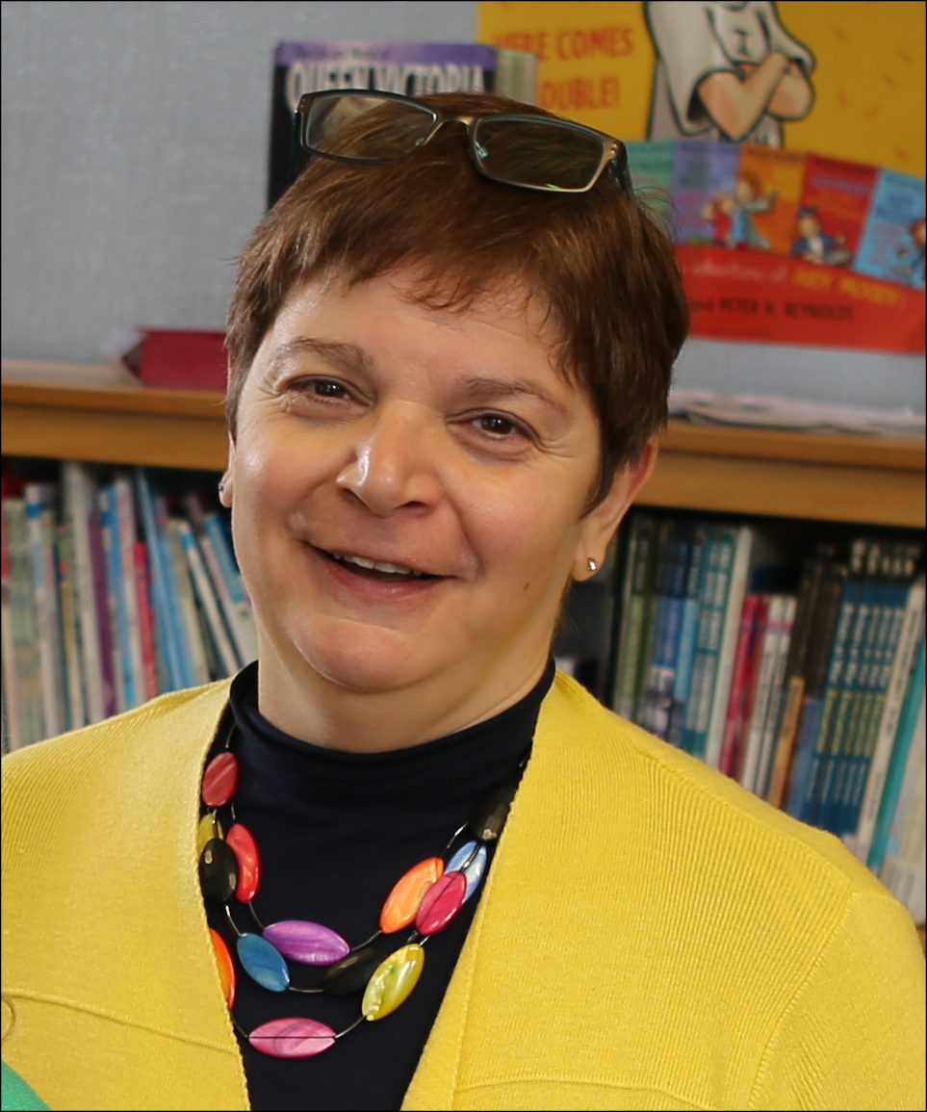
My term as Commissioner for Children will end in March 2023 just as this Corporate Plan draws to a close.

We have revised the Corporate Plan that was issued last year to take into account the extraordinary events that have occurred. At the beginning of 2020 when NICCY’s Corporate Plan was being finalised there was huge optimism that the return of the NI Assembly with it’s ambitious New Decade New Approach plan would herald swift and significant progress in the realisation of children’s rights in Northern Ireland. I stand by that assessment but events overtook us and the Covid-19 pandemic has changed everything. There is no aspect of children’s lives that has not been impacted on, by remote learning and the limited opening of schools for all, by the reconfiguration of health services to address this health emergency, by the loss of family income and economic uncertainty and finally by the deteriorating mental well-being of many of children and young people exacerbated by grief, uncertainty and fear for the future which is no longer the one that we promised them.

NICCY has endeavoured to continue to progress our stated priorities and goals but, in most cases, from a very different perspective – addressing the impact of the Pandemic. We have revised the Corporate Plan because there will be no going back to “normal” post-pandemic. It’s effect will be felt in the lives of children, young people and the wider community for years to come and we have to adjust accordingly. I caution against any attempt to separate the impact of or learning from Covid from mainstream processes – there is no Covid and non-Covid. The Pandemic and it’s effects are the now mainstream for the foreseeable future and it’s lessons must be carefully considered and incorporated into everything we do.

This plan makes a number of assumptions which we have laid out and which are based on our considered assessment. However one of the biggest assumptions that I make is that we will learn from this pandemic. As the effects of school closures and a shrinking economy are felt, the fragility of the lives of children and young people who are vulnerable or are living with disadvantage have become apparent. This has highlighted the structural changes that are required if we are to truly give all our children the best start in life. We have to make their rights a reality.

During the past four years we have worked on key priority areas and issued robust evidence based recommendations. These have been as a result of an in-depth process of making sure that we understand the experiences of those children, their parents and carers most affected, hearing from professionals working in a variety of settings, analysing available data, all within the framework of children’s rights.
It is important to us that NICCY’s work secures tangible and sustainable change which progresses the realisation of children’s rights. Therefore we anticipate that substantial resources and time in the next two years will be about supporting, monitoring and scrutinising the implementation of the key recommendations that I have issued up to March 2021, as well as learning the lessons from the pandemic. It is only by doing so that we will be able to provide clear evidence that our work is indeed ‘safeguarding and promoting the rights and best interests of children and young people’. As you will see these processes will centre on our stated core priorities such as the implementation of recommendations from our two major reviews – Still Waiting (mental health) and Too Little Too Late (SEN in mainstream schools) the majority of which have been accepted by government and incorporated into their improvement processes, but also through continuing to work on safeguarding, youth justice, poverty, education inequalities, waiting lists, homelessness and the environment. We also undertake a series of core activities which ensure compliance with the duties and powers of the office as outlined in legislation, such as ensuring children and young people know about their rights and have a voice, addressing individual complaints and raising issues as and when they arise.

Another significant area of work will be preparing and participating in the UN Committee on the Rights of the Child examination of the UK Government on their progress to implement the UNCRC. Again we anticpate that there will be a focus on Covid but also on a range of other issues particularly how we have implemented the recommendatons from the 2016 Examination, many of which remain outstanding such as raising the age of criminal responsibility, removing the defence of reasonable chastisement, addressing and abolishing the use of restraint.

The above as outlined represents a significant amount of work for the next two years. However a variety of other issues have been brought to our attention either through our casework or as a result of representations made to the office. We have outlined some of these in this document such as the impact of the legacy of the conflict on today’s children and young people, homelessness and housing crisis and health waiting lists. This is by no means a comprehensive list but are the issues that we consider most important and that we can make a positive contribution to. The amount of additional work that NICCY can undertake will depend on the resource that we have as we face the same constraints as other public bodies.

Children and young people have demonstrated their resilience and optimism during these difficult times and we have a duty to them to reflect that back. Therefore inspite of the enormity of the work, I am optimistic that together we can make a tangible difference to the lives of children and young people in Norhtern Ireland. I and the team at NICCY are looking forward to working with all our stakeholders in the time ahead.

Koulla Yiasouma
NI Commissioner for Children and Young People
1. WHO WE ARE AND WHAT WE DO

‘NICCY’ is an Independent Human Rights Institution (IHRI) established in 2003 under the ‘Commissioner for Children and Young People (Northern Ireland) Order 2003 to ‘safeguard and promote the rights and best interests of children and young people’. To do so, NICCY has a range of statutory duties and powers which are exercised in fulfilment of these.

The work of the Office is fundamentally guided by the United Nations Convention on the Rights of the Child (UNCRC) as well as relevant domestic, national and international legislation and conventions.

Our Mission

‘To safeguard and promote the rights and best interests of
children and young people’
[Art’ 6 (1)]

Our Vision

A Society where the rights of all children and young people
are respected and realised

The UNCRC General Principles (four) as per Articles 2, 3, 6 and 12 underpin that work. These relate to non-discrimination, best interests, survival and development and the voice of the child in the application of all UNCRC Rights.

Our Values

All of NICCY’s work is underpinned by our core values which we recently reviewed and updated. We apply these in our day to day work and seek outcomes based on their application and realisation.

- Children’s and Young People’s Rights are at the centre of all we do.

- We value and protect our independence.

- We respect and value people, promote inclusion and diversity, and challenge discrimination and inequality.

- We are open and honest and act with integrity.

- We are optimistic, striving to effect positive and lasting change.

NICCY’s Statutory Duties

Art 7(4) &(5) 2003 Order
Art 7(2) &(3) 2003 Order
Art 7(1), (5) (a) 2003 Order

NICCY’s Statutory Powers

Art 8 (2) & (6) 6)
Art 11, 12 & 14
Art 8(1) & (3) & (5)
2. THE NEW CORPORATE STRATEGY

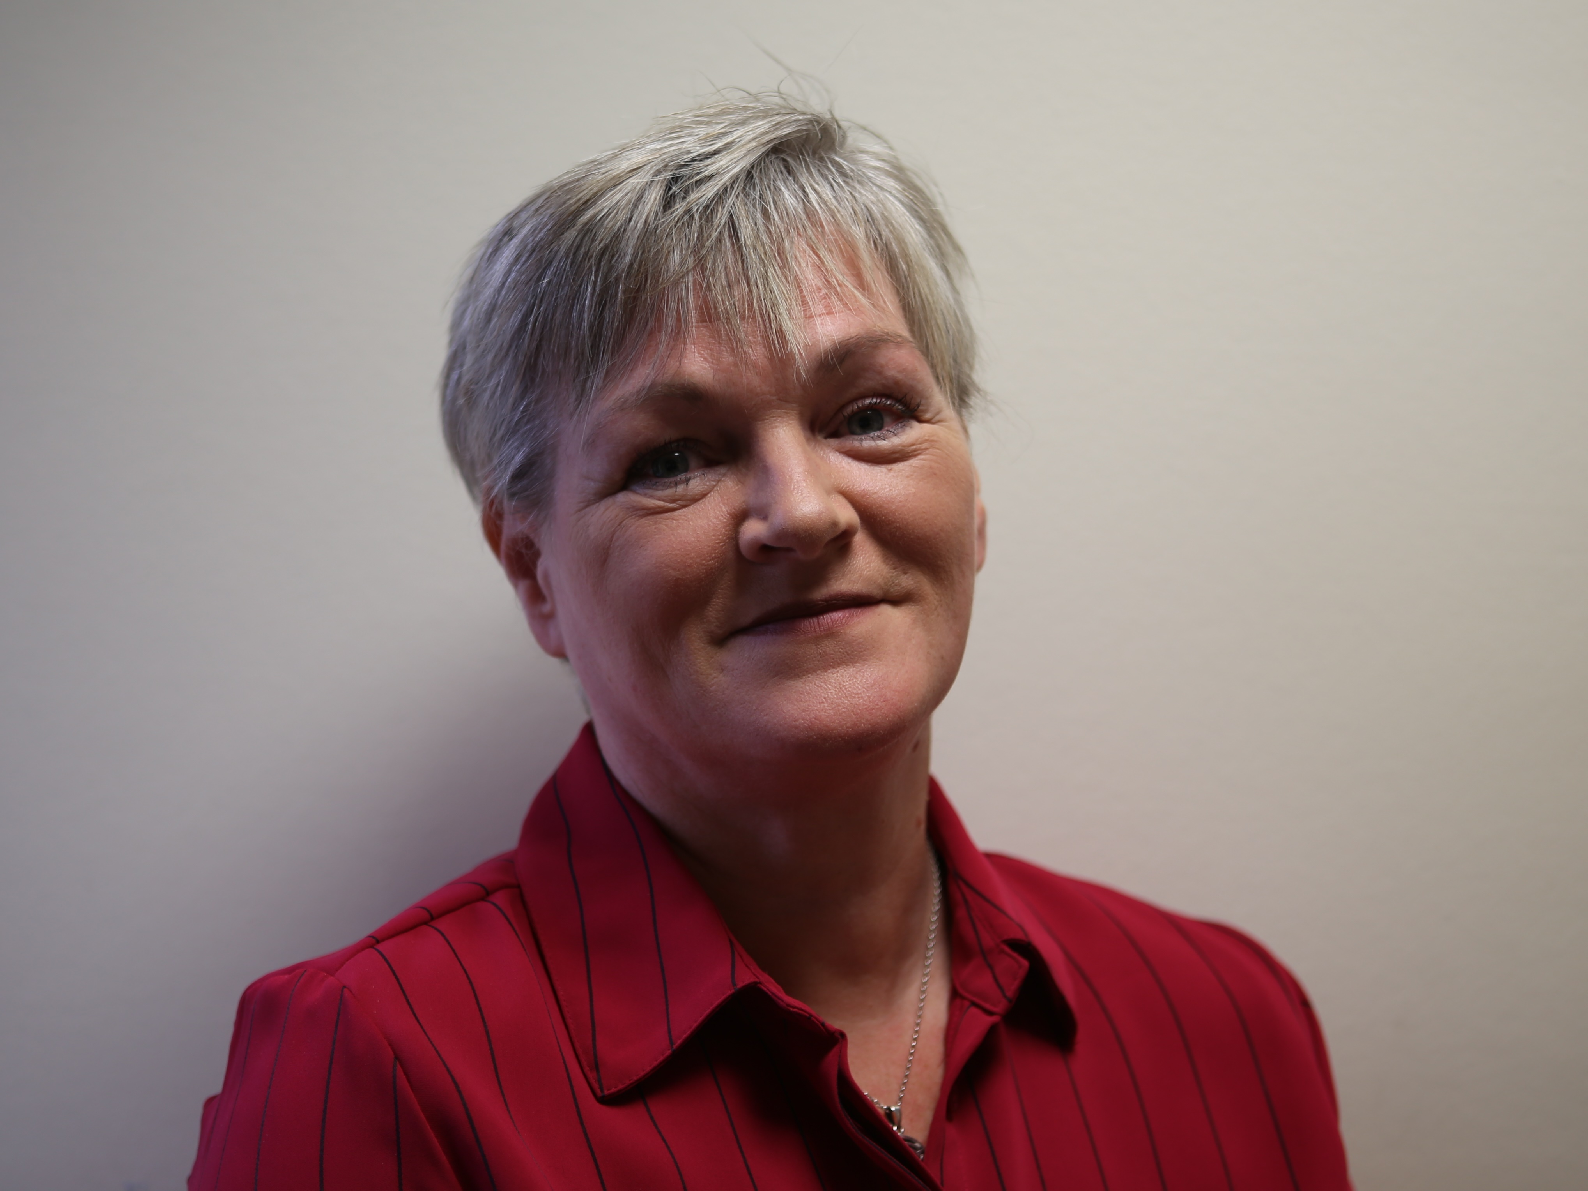
Context and Overview

Our 2020-‘23 Corporate Plan II sets out our high level objectives for the period and builds on the achievements and progress of work carried out on the objectives identified in the previous plan. The initial plan has been revised and updated for years 2021-‘23 to reflect the advent of ‘Covid-19’ which has significantly impacted not only our population – including our children, young people and families - but all organisations working within such an environment faced by the range of lockdowns and restrictions necessary in attempts to protect public health. While the 3 year absence of a Northern Ireland Assembly and Executive had adversely impacted upon, and delayed progress on a range of relevant legislative, strategic and policy initiatives, we continued to engage with political parties, Government Departments and their Agencies, to address issues and move things on as/where possible in pursuing our principal aim. It is vital, since the NI Assembly ’resumed’ in January 2020, that we give immediate priority to the pressing issues identified and are even more vigilant in protecting and promoting the Rights of Children and Young People in Northern Ireland.

The current ‘environments’ (addressed in more detail in next section) within which NICCY operates, present us with challenges never before experienced, in the global threat to public health from what is commonly referred to as Covid-19 (‘SARSCoV-2’). While the series of ‘lockdown’ restrictions and ‘temporary modifications’ introduced in response to the pandemic have severely impacted on daily life, we are also mindful of the need to continue to deliver on NICCY’s remit in a changed/changing world.

The challenges identified before the advent of Covid-19 still remain however, they have been thrown into sharp relief since. There are many unknowns as we move through this unprecedented period therefore we will address our identified priorities in a context which is ever evolving retaining the flexibility to respond to these and be proactive in addressing the challenges brought about by Covid-19. Our priorities include the impact of Covid-19 on children’s and young people’s health, education, access to services resulting in increasing levels and complexities of complaints being received. Public sector reforms and Government budgetary pressures are all compounded by the ‘further unfolding unknowns’ of the impact of the UK/EU ‘Brexit’ Deal. These are not underestimated and, like others, we have/will continue to monitor developments and respond accordingly. The ‘New Decade, New Approach’ Agreement also set out the range of key priorities of the NI Executive and we welcome the intention to produce a multi year Programme for Government and associated budgets. We will work to address the issues facing children and young people here, mindful of these contexts in the remaining period of this mandate and beyond.

NICCY has a duty to have due regard to the United Nations Convention on the Rights of the Child (UNCRC) which informs the basis for our work, while ensuring adherence/reference to relevant domestic, national and international legislation and human rights instruments. Part of our ongoing work involves monitoring progress on the implementation of the UNCRC Committee’s Concluding Observations (2016) and assessing the State’s compliance with Children’s Rights. We have also (in November 2020) finalised our joint submission with the other UK Children’s Commissioners, to the UN Committee on the Rights of the Child in advance of their next periodic examination of the UK State Party.

While we have set out our objectives in the following sections, we are as always, and particularly given the impact of Covid-19, mindful of the need to retain necessary ‘flexibility’, to react and respond to new and emerging developments and issues, which we have done in updating this Corporate Plan as well as continuing do so as and where appropriate and possible.

This triennial Corporate Plan is based on the working assumption that NICCY will receive adequate financial allocations and resources annually via our Sponsor Department (Department for Communities) to deliver on the statutory duties of the Office and to exercise its powers in meeting these as/where necessary.

We will continue to monitor our delivery, performance and impact in implementing this Corporate Plan and subsequent Annual Business Plans as necessary, in ‘Safeguarding and Promoting the Rights and Best Interests of our Children and Young People’.

Mairéad McCafferty
Chief Executive
Political, Economic, Social, Technological, Environmental and Legal (PESTEL) Analysis

The Covid-19 Pandemic
Since our triennial Corporate Plan was submitted in early 2020, the global health crisis brought about by the Corona virus pandemic, has impacted every aspect of daily life in Northern Ireland. Government public health responses resulting in ‘lockdown restrictions’ impacting across all sectors and services has changed life for the population. ‘Social (physical) distancing’, ‘self isolation’, ‘cocooning’ of our vulnerable people, school closures, retail closures, business shutdowns, public sector office closures, private sector closures, connecting with others via the online world, working from home, ‘meetings’ and interactions held online, severly reduced air, sea and land transport services, etc have all become commonplace. NICCY’s role is made more important given the impact on our children and young people and indeed wider society here. We have therefore updated our Corporate Plan for the subsequent 2 years (2021-23) to reflect the impact of Covid-19 and to include focused work on this and its impact on children and young people.

Political context
Given the advent of Covid which has necessitated such above mentioned measures (enabled by the Coronavirus Act 2020), the organisation has continued to deliver on our Business Plan however, it was necessary to also revise this during 2020 given the impact of Covid across our key priority areas of work.

The NI Assembly and Executive ‘resumption’ in January 2020 (following proroguement of 3 years) was welcomed as was the ‘New Decade, New Approach’ Deal which set out the key priorities for the NI Government. The global crisis facing Governments meant however, a refocusing and redeploment of resources as it did for many across all sectors and areas of life. Our NI Executive and government Departments responded accordingly.

We recognise that their absence, delayed legislation, publication and implementation of key strategies. Since ‘restoration’, plans for a new multi year PfG (just issued for consultation in Jan’ ‘2021) include a specific and vital focus on ‘giving our children the best start in life’ as a key outcome. The publication by the NI Executive of the 10 year ‘Children’s and Young People’s Strategy’ required under the Children’s Services Co-operation Act (2015) at this time is also much welcomed. We will provide advice on these and the CYPS Delivery Plan in due course.

Despite the ‘absence’ of our Assembly, NICCY’s engagement with political parties continued on advancing important rights issues We progressed work on key priorities - issuing our second ‘Statement on Children’s Rights in NI’ in parallel with our Monitoring Table on the UNCRC Committee’s 2016 Concluding Observations which updates on progress by all NI Departments.

In line with NICCY’s statutory duties we continue to keep under review the adequacy and effectiveness of law, practice and services as they impact upon children and young people – particularly during this ‘crisis period’ - and will maintain our positive working relationships with relevant political representatives, departmental officials and our wide range of stakeholders at Northern Ireland, UK and international levels, to address the key issues affecting children and young people.

We are mindful that this Corporate Plan will be delivered in a period of considerable political uncertainty and change given the Covid pandemic and also in the context of the UK’s withdrawal from the EU ’completed’ at end December 2020. The full impact of ‘Brexit’ across a range of areas e.g. on rights, identity, family life, the border in Ireland, travel, transport, economy, availability of medicines, rural communities, security and policing are as yet ‘unknowns’. Northern Ireland as we know, remains in a particularly vulnerable position.

Economic context
During this period we will remain mindful of growing pressures on frontline children’s services. The ‘unknowns’ over the short and medium terms, from the economic effects of Covid and government’s response, ‘Brexit’ and indeed global economic developments, have meant we needed to retain flexibility to respond appropriately as we have done and made changes to the priority areas of work outlined in this Corporate Plan and in our annual Business Plans. We will continue to monitor the impact of reallocation of government resourcing, potential budgetary shortages and lack of necessary investment to effectively meet the needs of our most vulnerable children and young people in Northern Ireland.

We will also liaise closely with our sponsor department DfC, to ensure the level of resource required is such that NICCY is enabled to deliver on our statutory duties. We also remain open to identifying efficiencies and cost savings through closer collaboration and partnership working with others, as well as keeping under review the potential to share services. NICCY is also aware of a pending premises move in the coming few years as part of the rationalisation of the NICS estate.

Social context
The isolation resulting from lockdown restrictions during the past year has adversely impacted many including our children and young people and most particularly their mental health. This in an existing context of marginalisation of children and young people e.g. through economic and social disadvantage, underinvestment, poverty, sectarianism, racism, heterosexism and/or discrimination against those living with a disability where NICCY’s work is more important than ever. We will also collaborate with our partners in the various human rights and equality bodies here and externally, in support of the UN Committee’s Concluding Observations to promote understanding of how ‘rights based approaches’ can deliver effectively for children and society. The most recent (November 2020) ‘Position Statement’ from the European Network of Ombuds’ and Commissioners for Children (ENOC) on ‘Child Rights Impact Assessments’ has been disseminated to all our NI Ministers and Government Departments. It is hoped this will inform decision making, legislation and strategy development as we go forward, initial response are encouraging.

Technological context
This pandemic has necessitated many to engage via online media, connect with friends and family, and conduct business online – particularly when having to work from home - over various IT platforms. Children and Young People as we know increasingly ‘live their lives’ in the online world, while digital technological advances are welcome where they are of benefit, we must remain vigilant of potential dangers. The need for effective and appropriate regulation and oversight to protect our children and young people from exploitation, bullying, grooming and effects of EMRs while ensuring they can participate in enjoying / accessing information and technology is a key balance to be achieved. The annual conference theme (2019) of the European Network of Ombuds’ and Commissioners for Children (ENOC) reflected this – titled ‘Offline/Online: A Child’s World’, the areas of focus covered provision, protection, participation, education and regulation. The NI ‘Online Safety Strategy’ and other measures / mechanisms on this growing area will prove vital in the coming years.

Environmental context
NICCY like other NDPBs operates in a complex environment – much of which has been highlighted already. We remain aware of the various ‘environmental factors’ – financial, political, social, and indeed physical - which impact on our work and assess risk / ‘horizon scan’ on emerging issues accordingly. We will continue to ensure good practice in implementing effective controls within and across the organisation. NICCY is increasingly aware of the ongoing impacts to our physical environment locally and globally as a result of climate change - young people have also raised this with us, having been to the forefront of demands for action to address/redress these. We have included this in our Business Plan going forward.

Legislative Context
The Commissioner’s statutory duties and powers (see earlier graphical representations) continue to be as set out in the 2003 Order, including the requirement to have ‘due regard’ to the United Nations Convention on the Rights of the Child (UNCRC). Other key areas of legislation, policies and strategies as well as international recommendations such as the Concluding Observations / General Comments from the United Nations’ Committee on the Rights of the Child, and other relevant UN Committees which have an impact on the lives of children and young people within Northern Ireland, are kept under review as necessary.

The impact of potential legislative changes as a result of ‘Brexit’ as developments unfold, are as yet largely unknown though we are seeing disruption at ports in relation to imports/exports. We issued a further paper on this in December 2020. As stated earlier, NICCY is mindful of the need to retain flexibility to respond accordingly.

We are mindful of delayed legislation and strategies which are now being progressed within the existing timeframe of this electoral mandate period; those relevant for children and young people will require focus and provision of advice from us as necessary.

Our Sponsor Department – Department for Communities (DfC)
Sponsorship of NICCY rests with the Department for Communities; our relationship with DfC is set out in the Management Statement and Financial Memorandum (MSFM). Periodic meetings are held between NICCY and DfC as an accountability mechanism and include oversight of governance arrangements. The MSFM is due to be replaced with a ‘Partnership Agreement’ - progress on which is ongoing; this is to be adapted to suit the ‘corporate sole’ model of NDPBs such as NICCY.

NICCY’s remit also includes monitoring the Department’s work - in line with our legislative remit and functions – given the range of areas under the Department’s remit which impact upon children’s and young people’s lives and outcomes.

Review of the Office of the NI Commissioner for Children and Young People
NICCY’s sponsor department as required, carried out a review of the Office shortly after taking over sponsorship responsibilities. During the 3 year period following the collapse of the NI Assembly and Executive, there was no Minister in post and subsequently no actions were progressed in respect of the recommendations. In ‘New Decade, New Approach’ a ‘Review of ALBs’ was included; Department of Finance is leading on this with input from Sponsor Departments..

Review of the Legislation: Commissioner for Children and Young People Order (NI) 2003.
Since last Corporate Plan, NICCY has reviewed and updated the ‘Article 24 Report’ and had re-submitted this to DfC in March 2019. NICCY was informed that as there was no Minister in post, this could not be progressed until the NI Assembly and Executive resumed. A meeting was subsequently held with the Minister for Communities and a commitment made to progress this.

- Report to Department for Communities under Article 24 of the Commissioner for Children and Young People (NI) Order (2003) - NICCY (March 2019); and

- Report to the Office of the First and Deputy First Ministers Under Article 24 of the Commissioner For Children And Young People (NI) Order (2003) – NICCY (April 2015).

It is hoped the recommendations from the Reviews can now be progressed and implemented.

Review of Performance
Over the past Corporate Plan period (2017-’20) NICCY has focused on delivering the corporate and business objectives set for the period. This period had also seen an increase in the ‘reactive work’ also necessitated as/when representation is made to the Office on issues which NICCY has also addressed. During the past year (year 1 of next Corporate Plan period, we have responded to the Covid pandemic as an organisation but more importantly within remit in addressing children’s rights issues across the range of areas impacted where ‘temporary modifications’ were introduced under the ‘Coronavirus Act 2020’ e.g. in education, schooling, mental health, youth justice, looked after children, and on safeguarding.

A full review of our overall performance during each of these years, as well as our annual accounts, can be found in successive Annual Reports. These can be accessed here on our website. The range of legal complaints and casework including legal proceedings are set out in our Annual Complaints and Legal Report. Our Policy & Research publications particularly our ‘Too Little, Too Late’ SEN Report published in March 2020 and our Participation reports and papers, monitoring and Advices provided to Government Departments and Agencies are also to be found on our website. Further links to these are available in our SOCRNI 2 Report referenced earlier.
- OUR STRATEGIC OBJECTIVES

There are a wide range of issues adversely impacting children’s and young people’s rights in Northern Ireland; NICCY has identified key priority areas. While these largely reflect the same areas in our previous Corporate Plan, we have now included focus on Covid-19 and a programme of work specifically on this. The key priorities have been informed by reviewing the relevant evidence, including the complaints raised with the Office each year by children and young people, their parents and carers and issues raised by stakeholders. We have also taken cognisance of the UN Committee’s Concluding Observations and have engaged directly with children and young people in identifying the most persistent and egregious breaches of their rights requiring government action.

Given the extensive work carried out to formulate these last time, with a wide range of stakeholders – most importantly with children and young people – and recognising that while work relating to specific areas under each objective will differ or reflect progression from that already achieved, they nonetheless relate back to our core remit and functions so will remain as stated.

We will build on our work to date and continue to:

Objective 1:
Ensure that Children’s and Young People’s rights are respected, promoted and protected in the work of all duty bearers.

Objective 2:
Highlight and address critical issues which adversely affect Children and Young People.

Objective 3:
Address breaches of Children’s and Young People’s rights.

Objective 4:
Raise awareness of Children’s and Young People's Rights, the UNCRC and the functions of the Commissioner.

Objective 5:
Promote the participation of Children and Young People in decision making processes.

Objective 6:
Ensure NICCY is an effective and efficient organisation.
1. Ensure that Children’s and Young People’s Rights are respected, promoted and protected in the work of all Duty Bearers.

The UN Committee’s General Comment 5 sets out the general measures of implementation (GMIs) of the Convention on the Rights of the Child. NICCY’s role involves monitoring these and ultimately aims to have the UNCRC incorporated ‘domestically’ to ensure Government and its Agencies respect, promote and protect the rights of children and young people in their work.

The UN Committee on the Rights of the Child has also provided considerable advice on how Government delivers in a child rights compliant manner. While this is particularly critical in relation to work targeted at children, consideration of children’s rights should, from the outset, inform the development and implementation of relevant policies, services and legislation. The ‘Child Rights Impact Assessment’ framework produced by ENOC could and should be used to do so.

NICCY will work to influence Government and its Agencies to more effectively deliver in compliance with children’s rights, promoting respect for same at all levels – locally, nationally and internationally. We will deliver on a range of activities engaging with the Northern Ireland Executive and Assembly, at Westminster, through the British and Irish Network of Children’s Commissioners, through our European networks and at the UN level.

NICCY will achieve this through monitoring, advising and where necessary, holding Duty Bearers to account regarding inter-related processes:

- Statement on Children’s Rights in NI
In June 2018 NICCY issued its first ‘Statement on Children’s Rights in NI’ (SOCRNI) in parallel with our ‘UN Concluding Observations Monitoring Table’. ‘SOCRNI’ focuses on the identified key priorities of the Office including as stated earlier, incorporation of the UNCRC locally (i.e. in NI). Our second ‘Statement’ was published in 2020 alongside NICCY’s Monitoring Table of NI Departments’ progress on UNCRC Committee’s Concluding Observations;

- UN Committee on the Rights of the Child: 2016 Concluding Observations
In May 2016 a total of 156 recommendations were issued, 131 of which fall to the NI Executive to deliver in relation to children in Northern Ireland. In June 2018 NICCY issued its first ‘Monitoring Table’ of NI Departments’ progress on implementation of the Concluding Observations. Our second was published in November 2020;

- UNCRC Alternative Report
NICCY has submitted input to the ‘Shadow Report’ for the next periodic examination of the UK State Party by the UN Committee on the Rights of the Child. The List of Issues was a joint report with colleague Children’s Commissioners in England, Scotland, and Wales;

- Implementation of NICCY’s Article 24 Report
Following two external Reviews of NICCY’s Legislation, this latest iteration of our Articl 24 Report is necessary to follow through on the general measures of implementation under Article 4 of UNCRC and General Comment 5;

- Children’s Services Co-operation Act 2015
This ground-breaking legislation places statutory duties on all departments and agencies to work together to deliver improved outcomes in children’s well-being - as defined by the Act and in reference to the UNCRC; NICCY will scrutinise the effectiveness of the implementation of Act;

- Children’s and Young People’s Strategy
This is the overarching mechanism for co-ordinating delivery across all statutory departments and agencies on the duties contained in the Children’s Services Co-operation Act 2015; and as such is viewed as the ‘Northern Ireland Action Plan for Children’ as iterated in General Comment 5; NICCY will monitor its implementation now that the NI Executive have published it:

- Implications of UK withdrawal from the EU (‘Brexit’) for Children’s Rights
‘Brexit’ will have significant implications for the realisation of children’s rights here, so we will work to ensure that those responsible for implementation and monitoring rights and equality compliance are aware of these, and that they protect children from any ‘diminution of rights’ or detrimental impacts. This will be a cross-cutting focus across all our work in the coming period and may require review of business plan targets;

- Child Rights Impact Assessments (CRIAs)
Article 4 of the UNCRC requires all Governments to conduct impact assessments on all legislation, policies and strategiesand services to determine their impact on the realisation of children’s rights. We have worked through the European Network of Ombudsmen for Children (ENOC) to agree a Position Statement including Calls to Government on CRIAs and will continue to disseminate and advise relevant authorities in Northern Ireland on their production; and

- Covid-19 Pandemic
This additional area of work has been necessary given the advent of the global health pandemic, which for Northern Ireland meant ‘lockdown restrictions’ since mid March 2020. The NI Executive has introduced a range of measures following the introduction of the Coronvirus Act 2020. NICCY has found it necessary, given the range of issues and concerns in relation to the impacts in education, health and social care, youth justice, on families, family income levels and family life being presented to the Office to divert resource and time to respond to these. We will therefore be producing a comprehensive report on the impact of Covid-19 and government’s response to this.

- Highlight and address critical issues which adversely affect Children and Young People.
Over the three years when NI had no Assembly in place, we provided advice and challenge to government departments in relation to the following key areas.. Since the resumption of the Assembly and NI Executive and the protracted nature of these issues, we have continued to address these issues, to ensure that there is an adequate response to the evidence and advice. Therefore in this Corporate Plan we will build on and develop our work by following up on the advice already provided, and drawing on our statutory powers to maximise the impact of our work. This work will also be underpinned by the principles of prevention and early intervention; supporting government to identify and provide effective early support to all children and young people, particularly those who are at risk of poor outcomes.

We will focus our proactive work and advice to government on the following key areas:

- Tackling Child Poverty: we will continue to work with others raise awareness of the economic and social rights of children, and focus on advising government on actions to lift families on low income out of poverty, including strengthening social security provisions e.g. in relation to Welfare Reform mitigations. We will develop an updated position on child poverty in Northern Ireland and, as a member of the DfC Anti-Poverty Strategy Co-design Group, advise government on the development and implementation of an Anti-Poverty Strategy;
- Improving Mental Health and Wellbeing: our ‘Still Waiting’ Report launched in September 2018, made 50 recommendations regarding the changes required to improve the adequacy and effectiveness of services to support the mental health of children and young people. We will continue to work with statutory and other agencies to ensure that they are implemented , producing Monitoring Reports on an annual basis, and achieve improvements in mental health outcomes for children including provision of counselling in primary schools;
- Overcoming Educational Inequalities and Promoting Inclusion: to ensure that the right to an effective education is realised for all children and young people, particularly those at risk of underachieving. This includes children in care; Roma and Traveller children; newcomer children; children with a disability, children with additional needs, children from disadvantaged backgrounds, and those entitled to free school meals. We will focus on two areas:
  - Overseeing the monitoring and implementation of our Review of SEN provision (publication 2020), to ensure that children with special educational needs are provided with the support and services they need so that their personality, talents and abilities are developed to the full; and
  - On the requirements for transformational reform of the education system with a focus on securing greater efficiency in delivery costs, raising standards, access to the curriculum for all pupils, and the prospects of moving towards a single education system, in line with the priorities identified under the ‘New Decade, New Approach’ Agreement.
- Addressing the Legacy of the Conflict: We will focus on three areas:
(a). Addressing coercive control, abuse and exploitation of children and young people by criminal gangs;
(b). Continuing to advise relevant authorities/bodies on matters relating to the Legacy of the Conflict; and
(c) advising government on respecting the right of children and young people to participate fully in the cultural and artistic life of their communities, protecting their right to celebrate their identity in a positive and safe manner.
- Challenging Discrimination: we will continue to use our powers to provide robust challenge to ensure children and young people do not experience discrimination in relation to the provision of goods, facilities or services and to ensure that equal protection against assault applies to them as it does to adults;
- Strengthening Safeguarding Provisions: we will monitor the statutory mechanisms in place to safeguard children and young people e.g. in relation to child sexual exploitation and the implementation of the findings of the Review of Serious Sexual Offences, the development of a NI specific ‘Barnahus’ (Child House) Model; and the use of restraint and seclusion;
- Addressing Issues in Youth Justice: we will monitor, advise and challenge government on the implementation of outstanding recommendations (Youth Justice Review 2011), those from the UNCRC Committee’s Concluding Observations; on the application of the ‘Best Interests’ principle across the youth justice system; we will advise and challenge government to raise the minimum age of criminal responsibility in accordance with acceptable international standards; we will continue our focus on ‘Stop and Search’ and on removing the JJC as a ‘place of safety’;
- Homelessness: It is stated that in NI 15,000 children are experiencing housing insecurity. We will focus on the issues facing families and children) by:
  - Addressing the reality of the lives of families and children experiencing housing insecurity;
  - An examination of processes in relation to 16 and 17 year olds; and
  - Addressing the numbers and causes of 18 – 21 year old Care Leavers and young people with a disability, who are homeless and rough sleeping.
- Migrant / Trafficked Children, Children Subject to Immigration Control and Newcomer Children: we recognise that many children who have come to live in Northern Ireland may have particular vulnerabilities that result in their marginalisation, victimisation and/or exploitation. Therefore they require our particular focus and support of the Office to ensure their rights are safeguarded and promoted;
- Health Waiting Lists: NI has the highest waiting times of any jurisdiction in the UK however, there are even more concerning figures for children’s health services e.g. waiting times for paediatric cardiology appointments in some Trusts are 149 weeks and 213 weeks for paediatric general surgery. We will explore the impact of this on the lives of children and provide recommendations to government on addressing waiting lists; and
- Children’s Rights and the Environment: At the 2016 Day of General Discussion on children’s rights and the environment, the key finding was that any matter relating to the environment must be considered through the lens of children’s rights. Over subsequent years, environmental issues (including climate change, resource depletion, pollution, protecting natural spaces and wildlife) have come to take centre stage, but the connection with children’s rights remains unexplored. We will support a youth led initiative to explore the child rights implications of environmental matters, engaging a wide range of children and young people and supporting them to promote their calls.

- Address breaches of Children’s and Young People’s Rights.

The 2003 Order confers a range of powers upon the Commissioner. These powers are the ‘tools’ which enable the Commissioner to fulfil her duties.

They include the power to assist with complaints to, or about, relevant authorities and the power to bring, assist with, or intervene in, legal proceedings.

It is these powers which we shall utilise to challenge breaches of Children’s and Young People’s rights through:

- Complaints Handling (casework) to, or against, relevant authorities, when the matter has yet to be resolved - in line with the requirements of our legislation – across a range of areas;

- Conducting Independent Investigations where breaches of the rights of children and young people are alleged, and where internal complaints processes have been exhausted - in line with the requirements of the legislation;

- Formal Investigations into cases / complaints which require formal use of NICCY’s powers including cases which expose systemic failings adversely impacting on Children’s Rights;

- Bringing, Intervening in, or Assisting with, Legal Proceedings in challenging breaches of children’s and young people’s rights through a range of measures;

- Holding Government to Account when they fail to protect children’s rights;

- Providing Advice to ensure the implementation of children’s rights in legislation; and

- Processing Protected Disclosures in line with the ‘Public Interest Disclosure (Prescribed Persons) Order 2014. (Public Interest Disclosure (Northern Ireland) Order 1998 as subsequently amended).

- Raise awareness of Children’s and Young People's Rights, the UNCRC and the functions of the Commissioner.

NICCY has a duty to promote awareness of children’s and young people’s rights, the UNCRC and to create an understanding of the role and functions of the Commissioner and the Office. Communicating our work, what we do - and listening to what others tell us in the process - is a key priority for the Office. Our Stakeholder Engagement Strategy supports the implementation of our Corporate Plan 2020-‘23.

Our strategic approach to this work over the next three years will focus on:
Children and Young People:
- Meeting directly with children and young people across Northern Ireland to raise their awareness of their rights and NICCY, and to hear from them about the issues affecting them;
- Producing materials and supporting guidance for use by those who work with children and young people to raise their own and children’s and young people’s awareness of their rights and of NICCY; and
- Publishing a range of awareness-raising materials for children and young people, and producing young people’s versions of each significant piece of work we complete.

Parents, Guardians and Carers:
- Meeting directly with parents, guardians and carers across Northern Ireland to raise their awareness of children’s rights and NICCY, and to hear from them about the issues affecting them and their children and young people; and
- Producing materials and supporting guidance for parents, guardians and carers to raise their awareness of their rights and of NICCY.

Professionals and Practitioners:
- Publishing reports on specific child’s rights issues, and issuing guidance for statutory departments and agencies on implementing children’s rights;
- Giving speeches and presentations at events to raise awareness of children’s rights issues and the actions required to realise these; and
- Providing training and awareness raising on children’s rights and our findings to targeted groups of professionals working with children and young people to support implementation of NICCY’s advice and recommendations.
Political Representatives:
- Meeting directly with political representatives working at all levels to raise their awareness of their rights and NICCY, and to provide advice on implementing children’s rights.

General Public:
- Raising awareness of NICCY and children’s rights with the general public through media engagement, attending public events across Northern Ireland.

Media:
- Working directly with media representatives in a variety of media (written/audio/visual) to raise awareness of childrens’ and young people’s rights and NICCY, as well as to ensure balanced portrayals of children and young people.

- Promote the participation of Children and Young People in decision making.

The participation of children and young people is key to the implementation of the United Nations Convention on Rights of the Child. Evidence highlights the lack of consistency in existing participation mechanisms in schools, at community, local government and national levels. There is also an absence of evidencing the impact of engagement with children and young people in the development of legislation, policies, strategies, action plans and service delivery.

NICCY is required to take reasonable steps to seek the views of children and young people and their parents in the work of the Office. The UN Concluding Observations (2016) reiterated the requirement by Government to actively and meaningfully ensure the participation of children and young people in having a say in decisions that affect their lives. This will be achieved through:

- Advising the NI Assembly, NI Executive, Departments and their agencies in the development of meaningful participation structures, policies and practice, specifically but not limited to the development of:
  - A policy driven pupils’ voice mechanism e.g. schools’ councils and associated inspection processes;
  - Regional engagement processes e.g. youth organisations including mechanisms to engage with marginalised young people;
  - Bespoke youth engagement aligned to statutory agencies to support legislative, strategy and policy obligations;
  - Robust and effective Community Planning Partnerships’ participation procedures; and
  - A Northern Ireland Youth Assembly.

- Seeking the views and experiences of children and young people, especially those with lived experience in adverse circumstances and those who may be most marginalised, including younger children, throughout our work, about the issues affecting them;

- Creating opportunities for children and young people to have a direct say in decisions affecting them, including supporting them to campaign on issues affecting children in Northern Ireland;
- Developing and supporting NICCY’s Youth Panel to:
  - Advise NICCY on priority areas of work including how we communicate with children and young people;
  - Inform NICCY’s work about issues facing children and young people; and
  - Explore creative and innovative ways to campaign for change for children and young people across Northern Ireland.

- Ensure NICCY is an effective and efficient Organisation.

We will ensure effectiveness and efficiency in maximising our organisational performance by delivering on our strategic objectives as detailed in our annual Business Plans; through robust systems of corporate governance, internal controls and accountability mechanisms; sound financial management, appropriate staffing levels, professional performance and reporting to achieve greatest impact within organisational resources.

We will do this through:

- Delivery on our Annual Business Plan objectives and targets based on this 3 year Corporate Plan period utilising organisational resources – Human, Financial and Physical - to best effect, including collaborative working with relevant partners;

- Accurate Monitoring and Reporting on NICCY’s performance and impact through laying of the Annual Report and Accounts before NI Assembly, Quarterly Reports to our Sponsor Department, internal reporting and periodic reports / updates to stakeholders;

- Efficient Corporate Governance Systems across financial management and systems of internal controls, robust risk management, internal and external audits and relevant reviews;

- Effective Performance Management across all functional areas i.e. Corporate Services (including Human Resources and Communications), Legal and Investigations, and Policy, Research and Participation;

- Prompt implementation and/or updating of relevant guidance, recommendations and legislative changes to policies, procedures and practice as directed and necessary;

- Accreditation with Investors in People and building on accreditation achieved as we progress through the IiP ‘journey’ including learning and development opportunities for our Staff;

- Corporate Social Responsibility activities e.g. shared services ensuring appropriate ‘value for (public) money’, sharing of expertise as well as environmentally friendly policies and practices;

- Work with other Organisations with similar remits, when appropriate, to enhance the work of NICCY by adding to, the safeguarding or promotion of the Rights and Best Interests of Children and Young People; and

- Develop our Annual Business Plan 2021-22 - Progress the work in our triennial Corporate Plan 2020-’23 now revised and updated to reflect the impact of Covid-19 to cover the next 2 year period (2021-23) and build on the achievements of our first year Business Plan in this second business year. We have reviewed our Business Plan2020-21 and submitted this to our sponsor department as necessary.
Budget Requirements 2021-2023.

Expenditure Area | 2021-22 | 2022-23
Salaries | £1,258,065 | £1,283,225
Operating Costs | £135,935 | £140,000
Premises | £147,000 | £147,000
Capital | £0 | £5,000
Depreciation | £20,000 | £20,000
Programme Costs  - Corporate  - Policy & Participation  - Legal & Investigations  - Communications | 108,000 | £110,000
Total [Annual] | £1,669,000 | £1,705,225
Business Case submitted to cover additional costs for IT System Upgrade. | +  £11k | +  £11k
Total Required | £1,680,000 | £1,716,225

NB: See previous iteration of our triennial Corporate Plan 2020-23 for 3 year budget which also reflects above figures.

Contact Details:

NI Commissioner for Children and Young People (NICCY)
Equality House
7-9 Shaftesbury Square
Belfast
BT2 7DP

Tel: 028 9031 1616
Email: info@niccy.org
Website: www.niccy.org
Facebook: www.facebook.com/nichildrenscommissioner
Twitter: @nichildcom
Instagram: NICCY_YP

If you would like to discuss any aspect of this Corporate Plan, please contact our Chief Executive Mairéad McCafferty via 028 9031 1616 or Mairead@niccy.org

Please contact our Communications Staff at NICCY if you require alternative formats of this document.

Implementing paragraph 49(c) of the 2016 UNCRC Concluding Observations.
UNCRC Committee’s 2016 Concluding Observations: No. 14; General Comment 24.

